mpn

## Contents

Contents 1

General Information 7

Information 7

Office Directory 7

Call Center Chain of Command 7

Front Counter Chain of Command 8

Procedures for Accepting Documents at the Front Counter 8

Contact for Borrowers 10

Frequently Called Numbers 10

2018-19 Disbursement Dates 11

File Update Request Example 12

E-mail Inbox Procedures 13

MyLSU 13

Cost 14

2018-2019 Estimated Direct Costs 15

Undergraduate: 15

Graduate: 16

Vet Med: 17

Law 17

Enrollment Deposit Waiver 18

FAFSA 22

Basic Information 22

Types of Title IV Aid offered from the FAFSA 23

How to Sign FAFSA 24

Student and Parent: 24

FAFSA TIPS 24

Paper FAFSA Application 27

Cost of Attendance (COA) 27

BDGT Screen Shot 28

COST Screen Shot 29

Expected Family Contribution (EFC) 30

Screen Shots for Reference 32

Status of FAFSA 36

FAFSA Reject Codes on Demi/Verbiage 40

RAGG 40

RAPP 40

RCAL 40

RCIT 40

RCOA 40

RDDL 40

RDEF 41

RDEN 41

RDEP 41

RDHS 41

RDRC 41

RDRP 41

RENR 42

REXT 42

RHSG 42

RMAP 42

RNAR 42

RNMT 42

RNRA 43

RNSL 43

ROLD 43

ROTH 43

RPAC or RPEL 43

RPDH 43

RREF 44

RRES 44

RSDH 44

RSEP 44

RSPR 44

RSSR 44

RSU 45

RUEH 45

RWIT 45

2018-2019 FAFSA Reject Codes on COMM 45

Verification 52

Basic Information 52

Descriptions for MyLSU for 2018-2019 53

Descriptions for MyLSU 2018-2019 58

Sample Verification Documents 64

Screens 65

ANEC 65

AWRD 65

BDGT 65

CHCK 66

COMM 67

CORR 67

DEMI 68

DFLD 68

DLPL 68

DRLN 69

EFCC 70

ISIP 70

ISIS 71

NSLD 72

PACK 73

PELL 73

PSCH 74

SAPS 74

SCHL 75

STUU 76

TOPS 76

VERY 76

xabs> info 77

Xabs>sawd 78

xtis>vdet 78

Xtis>vbil 79

Grants 80

Types of Grants 80

Pelican Promise 81

Budgets 82

Budget Chart 82

Loans 82

Types of Loans 82

Annual Loan Limit Chart 85

Aggregate Loan Limits 86

2018-2019 Loan Periods and Disbursement Dates 87

Screen Shots 88

Campus Jobs 89

Federal Work Study 89

Chancellor’s Student Aide 90

Retention 90

Job Types 90

Change of Jobs 91

Denying the Award 91

Special Considerations 91

Satisfactory Academic Progress (SAP) 92

What is Satisfactory Academic Progress (SAP)? 92

Policy 93

Appeal Process 93

Screen Shots 94

Appeal Review Dates 96

SAP Appeal Form 97

SAP Policy Overview with MyLSU Screen Shots 97

Resignation 112

Official and Unofficial 112

Policy 113

Repeated Coursework 113

Policy 113

Enrollment Status 113

Policy 113

Class Attendance 113

Policy 113

TOPS stamp

General Information 114

Retention requirements: 114

Using TOPS for the summer semester: 115

Screen Shot 116

TOPS Brochure 116

TOPS Summer Form 116

TOPS Exception Form 116

Scholarships 116

General Scholarship Information 116

How to Apply for a Scholarship 118

Entering Freshman Resident Scholarship Programs 118

The information listed below can also be found by clicking here. 118

STAMPS Leadership Scholars 118

Chancellor’s Alumni Scholars 118

LSU Alumni Association’s Global Leaders 119

LSU Distinguished Freshman Award 119

Flagship Scholars Award 119

LSU Academic Scholars Award 119

Tiger Excellence Scholars Award 120

Pelican Promise 120

*Additional Scholarship Opportunities* 120

LSU Senior College Scholarships 120

Board of Supervisors Scholarship 120

Fee Exemptions for Sons and Daughters of Deceased Faculty Members 120

Legislative Act 353 120

ROTC Scholarships 121

City-Year Program Undergraduate Application Fee Waiver 121

The Chafee Educational and Training Voucher 121

Entering Freshman Nonresident Scholarship Programs 121

STAMPS Leaderships Scholars 121

Chancellor’s Alumni Scholars 122

LSU Alumni Association’s Global Leaders 122

LSU Distinguished Freshman Award 122

Flagship Scholars Award 123

LSU Academic Scholars Award 123

Tiger Excellence Scholars Award 123

*Additional Scholarship Opportunities* 123

LSU Senior College Scholarships 123

Board of Supervisors Scholarship 124

Fee Exemptions for Sons and Daughters of Deceased Faculty Members 124

Legislative Act 353 124

ROTC Scholarships 124

City-Year Program Undergraduate Application Fee Waiver 124

Retention Requirements 124

Entering Freshman Scholarship Chart 127

Transfer Scholarships 127

International Students 129

Scholarships: 129

Federal Aid: 130

International Services at LSU: 130

# General Information

## Information

* If you are asking a student to email [financialaid@lsu.edu](mailto:financialaid@lsu.edu) or their counselor, be sure to ask to them to include their LSU ID number
* Never give out
  + Social security numbers
    - The person can say the SSN and you can verify that we have that number in the system
  + LSU ID number to anyone
    - The LSU ID number on the student’s MyLSU account under Directory Information 🡪 LSU ID
  + GPA to anyone
  + Tax information
  + Direct lines

## Office Directory

* You can access the Office Directory on the share by clicking here.

## Call Center Chain of Command

Call Center

Student Workers

Any questions or difficult calls

Financial Aid Counselor

When to ask the student/parent to email a counselor:

Any situations you believe may be considered a special situation, i.e. loss of job or parent, dependency override, etc. Direct student to counselor.

## Front Counter Chain of Command

Front Counter

Student Workers

When to ask the student/parent to email a counselor:

Any situations you believe may be considered a special situation, i.e. loss of job or parent, dependency override, etc. Direct student to counselor designated by student last name. If the student’s counselor is available, please see if they are available to sit with the student.

Any questions or difficult students

Please see if a counselor is available.

When a student is asking about dropping a course or resigning:

Please see if a counselor is available.

## Procedures for Accepting Documents at the Front Counter

In general, near 8:00 am every morning, the student workers will need to open and unlock the front counter.

After getting the keys, the student-worker should be unlocking the cabinets, changing the date stamp to the appropriate date, and setting up for their shift.  At the end of the student worker’s shift, the student should be taking all submitted documents and putting them in their appropriate place before leaving. If the students have any questions as to where the documents go, they can use the reference below, or ask one of the counselors until they are comfortable.

**Resignations:**

As a reminder, the student-worker should call the counselor on duty to sign off on the resignation.

If the student is resigning and the card is brought on the behalf of the student, or someone is “walking it over”, the student should put the resignation card in Tammy’s box.

**Verification Documents:**

All 2019-2020 verification documents, 2019-2020 appeals, 2019-2020 plus loan applications, or 2019-2020 other information that you need in the student’s file should be placed in the appropriate basket in the drawer at the front counter. Loretta will come down to the basket multiple times a day to pick up the information.

**SAP Appeal Forms:**

Students should only be submitting SAP appeals for the current semester and we should only be accepting current SAP appeal forms. These forms should be submitted to Loretta for processing. They can be placed in the basket in the drawer at the front counter.

**Miscellaneous Documents:**

There may be some miscellaneous documents that students are now turning in. There may be scholarship forms, which should be submitted to Scholarships after the student-worker’s shift. There may be some documents that are not a formal document we requested that the students are looking to submit.  The student-worker may try to ask the student what the document is, as it may be something their counselor is expecting. In that case, that document can be submitted to that student’s counselor at the end of the shift.

* All documents should be **date stamped and initialed** by the student-worker that accepts the documents. All documents submitted for the student should be stapled together. For example all Verification Documents for the 19-20should be stapled together and all scholarship documents should be stapled together. Please no paper clips, as they do not always insure that all submitted documents are processed together.

At the end of the day, or 4:30, the student-worker at the front counter can store all office supplies such as date stamp in one of the lockable cabinets. The student-worker can lock the drawer and filling cabinet with the two keys at the front counter. The student-worker should also collect all documents submitted from their shift and put them in the appropriate place mentioned above.

## Contact for Borrowers

|  |  |  |
| --- | --- | --- |
| **Contact for Borrowers** | | |
| General Federal Student Aid Information | 800-433-3243 | [www.studentaid.ed.gov](http://www.studentaid.ed.gov) |
| Direct Loan Servicing Center | 800-848-0979 | [www.dl.ed.gov](http://www.dl.ed.gov) |
| Direct Loan Consolidation Center | 800-557-7392 | [www.loanconsolidation.ed.gov](http://www.loanconsolidation.ed.gov) |
| Federal Student Aid Ombudsman | 877-557-2575 | [www.ombudsman.ed.gov](http://www.ombudsman.ed.gov) |
| Direct Loan Information |  | [www.direct.ed.gov](http://www.direct.ed.gov) |
| Online Direct Loan MPN | 800-557-7394 | studentloans.gov |
| Online Direct Loan Entrance Counseling | 800-557-7394 | studentloans.gov |
| Online Direct Loan and FFEL Exit Counseling | 800-557-7394 | www.nslds.ed.gov |
| COD School Relations Center – Applicant Services (Parent/Graduate Plus Loan) | 800-848-0978 | Press 4 and then Press 4 again |

## Frequently Called Numbers

|  |  |  |
| --- | --- | --- |
| **Frequently Called Numbers** | | |
| Admissions | 8-1175 | 1146 Pleasant Hall |
| Athletics | 8-8001 | Athletic Administration Bldg |
| Bursar Operations | 8-3357 | 125 Thomas Boyd |
| Career Services | 8-2162 | 1502 Patrick F. Taylor Hall |
| Graduate School | 8-2311 | 114 W. David Boyd |
| Independent Study | 8-2500 | 1225 Pleasant Hall |
| ISO | 8-3191 | 101 Hatcher |
| Law School | 8-5292 | Law Center |
| Orientation | 8-2634 | 137 Johnston |
| PAWS Help | 8-0100 |  |
| Perkins | 8-3092 | 204 Thomas Boyd |
| Registrar | 8-1686 | 112 Thomas Boyd |
| Residential Life | 8-8663 | 99 Grace King |
| TOPS (LOSFA) | 1-800-259-5626 ext 1012 | 602 N 5th St, BR 70802 |
| UCAC | 8-8281 | 150 Himes |
| UCFY | 8-6822 | 150 Allen |

## 2019-20 Disbursement Dates

**2019-2020 Disbursement Dates**

Our office disburses grants, loans, and scholarships (not Go Grant or TOPS) 10 days prior to the first day of class each semester. The dates listed below are the scheduled disbursement dates for the 2018-2019 academic year. The funds will credit to the student’s billing statement (fee bill) on this date if the following criteria are met:

* Completed Registration for the appropriate semester
* Enrolled in the appropriate hours for the program
* Completed the necessary information for the loan to disburse (entrance counseling and master promissory note)
* Meeting SAP if federal aid (1-passing, 2-warning, 4-probation, 5-restablish max time, 0-restablish grade/pace)

If the above criteria are not met, we will continue to disburse funds every business day after the scheduled disbursement date for that semester. A student will receive a refund of the overage after the disbursement date within 2-3 business days, if direct deposit is selected, or 3-5 business days by paper check. The paper check is mailed out by the Office of Bursar Operations.

|  |  |  |
| --- | --- | --- |
| **Disbursement Dates** | | |
| **Academic Level** | **Semester** | **Date** |
| LAW STUDENTS | Summer | 05/27/2019 |
| Fall | 08/09/2019 |
| Fall-Students Enrolled Summer | 08/12/2019 |
| Spring (**\*Waiting for 1s/20 grades)** | 01/07/2020 |
| VET STUDENTS | Summer **(*Waiting for 2s/19 Grades)** | 05/24/2019 |
| Fall | 08/12/2019 |
| Spring | 01/03/2020 |
| UNDERGRADUATE & GRADUATE STUDENTS | Summer | 05/24/2019 |
| Fall | 08/16/2019 |
| Spring | 01/03/2020 |

## File Update Request Example

**File Update Request**

**Financial Aid and Scholarships**

Name: __________________________________________ Date: __________________________

LSU ID Number: ________________________

**Please check the box that applies:**

* Update my status from: **Freshman to Sophomore**

(You must have earned at least 30 hours to be considered for additional aid.)

* Update my status from: **Sophomore to Junior**

(You must have earned at least 60 hours to be considered for additional aid.)

* Update my status from: **Senior to** **Graduate/Professional**

(You must be admitted to the graduate/professional school to be considered for additional eligibility.)

* Please consider me for the financial aid I initially declined: _____________________.

(List aid)

* I would like to be considered for the following aid:

___ Work Study ___ PLUS Loan (parent loan) ___Student Loan ___Grad PLUS

* My new expected graduation date is ________________. Please award additional aid for the following semester(s).
  + Fall ____ Number of hours enrolled
  + Spring ____ Number of hours enrolled
* I would like to cancel my student aid for the following semester(s): _________ Yr. _____.

Please list any other request/information update(s) not covered in the choices above:

**Enrollment Management Employee’s Signature:** ______________________________________

## E-mail Inbox Procedures

To Log in:

1. Go to [mail.lsu.edu](http://www.mail.lsu.edu)
2. Log in ID: [financialaid@lsu.edu](mailto:financialaid@lsu.edu) and password (ask Ms Aimee for most recent password)

Delete Emails:

* Resignation emails
* Failure to send emails
* Junk emails
  + Advertisements
  + Just web address in body
  + Etc.

Flags:

* Yellow 🡪 to upload verification documents, appeals, loan applications, etc.
* Blue 🡪 General question about email
* Green 🡪 Forward email to counselor
* Red 🡪 Question for Jessica or Amy about email

When forwarding the email to a counselor:

* Tell the student/parent “I will forward your email to a financial aid counselor. Please allow 3-5 business days for a response.”

Start with the earliest emails and work your way to the most recent.

Questions concerning scholarships, scholarship retention, scholarships requirements, etc. can be forwarded to the Scholarships Office at [scholarships@lsu.edu](mailto:scholarships@lsu.edu). You can just forward the email; you don’t have to tell the student you are forwarding it.

Questions about admissions, requirements, academic transcripts, etc. you can forward to the Admissions Office. If the email is just about Admissions questions, you can just forward to Admissions. If they have Admissions and Financial Aid questions answer the question(s) and tell them you are forwarding the email to Admissions to answer their admissions inquiry.

Questions concerning a fee bill, billing statement, refund, fee costs, etc. would be sent to the Bursar’s Office.

For all other emails, use ID number/SSN/name to find student in system and see what the issue is. If you can’t find the student or there is more than one with that name ask the student to provide their full name and LSU ID number so that we can access their account.

### MyLSU

To view requested verification documents:

Financial Services 🡪 Financial Aid 🡪 Verification Documents

Select the academic year and click Process Request

To view financial aid and accept awards:

Financial Services 🡪 Financial Aid 🡪 Student Aid and Scholarships

Select the academic year and click Process Request

Student will then have to certify they have read our SAP policy

To view SAP status or print appeal form:

Financial Services 🡪 Financial Aid 🡪 Satisfactory Academic Progress Policy

**Out of Office Message:**

Thank you for contacting LSU’s Financial Aid and Scholarships Office in the Office of Enrollment Management. We are experiencing a high volume of e-mails due to peak processing time. Please allow three to five business days for a response to your e-mail. You may check the status of your financial aid by logging on to your MyLSU account, clicking financial services, and financial aid.

Thank you for your patience during our busy season.

### Cost

* All Rates based upon **minimum** full-time hours for each program.
* Anticipate that these rates will increase with the start of the new academic year, and mention that to students/parents when providing these figures.
* The Board of Supervisors determines the tuition rates, and determines these rates prior to the semester. Fall tuition rates are determined in July, Spring tuition fees are determined in Nov/Dec, and Summer tuition rates are determined in March/April.
* For specific rates, please reference:
  + - <http://www.lsu.edu/bgtplan/Tuition-Fees/fee-schedules.php>
  + Please reference for rates outside of the standard costs listed below:
    - * <https://www.dineoncampus.com/lsu/residents>

* + - * <https://www.dineoncampus.com/lsu/commuters>
      * <http://www.lsu.edu/reslife/incoming/rates/index.php>

## 2019-2020 Estimated Direct Costs

* **All Rates Based upon minimum full-time hours for each program.**
* **The Housing Rate for UG Students is based upon a two-student hall bath.**
* **The Meal Plan for UG Students is based upon the 12 Tiger Meal Plan.**

### Undergraduate:

Estimated yearly cost is an estimate of the cost for the upcoming academic year based on the actual cost for the current academic year. The estimated cost below is based on the 2018-19 academic year and is subject to change.

|  |  |  |
| --- | --- | --- |
| **Estimated Yearly Cost: 2019-20** | **Louisiana Resident** | **Non-Louisiana Resident** |
| **Tuition & Fees** | $11,950 | $28,627 |
| **Housing** | $7,388 | $7,388 |
| **Meal Plan** (12 Tiger Meals) | $4,184 | $4,184 |
| **TOTAL** | **$23,522** | **$40,199** |

|  |  |  |
| --- | --- | --- |
| **Cost of Attendance: Fall 2019 and Spring 2020** | **Louisiana Resident** | **Non-Louisiana Resident** |
| Student Living in a Residence Hall | $33,898 | $50,575 |
| Student Living in an Apartment | $35,184 | $51,861 |
| Student Living with Parent/Family | $28,302 | $44,979 |

|  |  |  |
| --- | --- | --- |
| **Cost of Attendance: Summer 2019 (Session A or Sessions A&B)** | **Louisiana Resident** | **Non-Louisiana Resident** |
| **Student Living in a Residence Hall** | **$9,666** | **$13,878** |
| **Student Living in an Apartment** | **$10,056** | **$14,268** |
| **Student Living with Parent/Family** | **$8,660** | **$12,872** |

|  |  |  |
| --- | --- | --- |
| **Cost of Attendance: Summer 2019 (Session B)** | **Louisiana Resident** | **Non-Louisiana Resident** |
| Student Living in a Residence Hall | $7,643 | $11,855 |
| Student Living in an Apartment | $7,781 | $11,993 |
| Student Living with Parent/Family | $6,958 | $11,170 |

### Graduate:

Estimated yearly cost is an estimate of the cost for the upcoming academic year based on the actual cost for the current academic year. The estimated cost below is based on the 2018-19 academic year and is subject to change.

|  |  |  |
| --- | --- | --- |
| **Estimated Yearly Cost: 2019-20** | **Louisiana Resident** | **Non-Louisiana Resident** |
| **Tuition & Fees** (9 credit hours per semester) | $12,528 | $29,443 |

|  |  |  |
| --- | --- | --- |
| **Cost of Attendance: Fall 2019 and Spring 2020** | **Louisiana Resident** | **Non-Louisiana Resident** |
| Student Living in a Residence Hall | $34,249 | $51,164 |
| Student Living in an Apartment | $35,535 | $52,450 |
| Student Living with Parent/Family | $28,653 | $45,568 |
| **Cost of Attendance: Summer 2019 (Session A or Sessions A&B)** | **Louisiana Resident** | **Non-Louisiana Resident** |
| Student Living in a Residence Hall | $7,946 | $12,194 |
| Student Living in an Apartment | $8,336 | $12,584 |
| Student Living with Parent/Family | $6,940 | $11,188 |
| **Cost of Attendance: Summer 2019 (Session B)** | **Louisiana Resident** | **Non-Louisiana Resident** |
| Student Living in a Residence Hall | $5,923 | $10,171 |
| Student Living in an Apartment | $6,061 | $10,309 |
| Student Living with Parent/Family | $5,238 | $9,486 |

### Vet Med:

Estimated yearly cost is an estimate of the cost for the upcoming academic year based on the actual cost for the current academic year. The estimated cost below is based on the 2018-19 academic year and is subject to change.

|  |  |  |
| --- | --- | --- |
| **Estimated Yearly Cost: 2019-20** | **Louisiana Resident** | **Non-Louisiana Resident** |
| **Tuition & Fees** (12 credit hours per semester) | $27,392 | $56,492 |

|  |  |  |
| --- | --- | --- |
| **Cost of Attendance: Fall 2019 and Spring 2020** | **Louisiana Resident** | **Non-Louisiana Resident** |
| Student Living in an Apartment | $53,019 | $82,119 |
| Student Living with Parent/Family | $46,137 | $75,237 |

|  |  |  |
| --- | --- | --- |
| **Cost of Attendance: Summer 2019** | **Louisiana Resident** | **Non-Louisiana Resident** |
| Student Living in an Apartment | $5,322 | $5,322 |
| Student Living with Parent/Family | $3,926 | $3,926 |

### Law

* Please direct law students to the LSU Law Center website for the most accurate tuition figures.

<https://www.law.lsu.edu/admissions/tuitionfees/>

The average yearly cost of attendance at LSU Law for the 2018-2019 school year is as follows:

|  |  |
| --- | --- |
| **2018-2019, Fall and Spring** | |
| Tuition and Fees (**Resident**) | $23,659.90 |
| Room and Board | $15,074.00 |
| Books | $2,576.00 |
| Personal Expenses | $2,514.00 |
| Transportation on campus | $2,906.00 |
| **Total** | **$46,729.90** |

# Enrollment Deposit Waiver

LSU has an Enrollment Deposit fee of $200 for incoming freshmen due by May 1st. This is not an additional fee charged to students; it is taken out of the fees they will be charged for the fall semester. The student should pay the enrollment deposit on their admission portal.

To determine in mainframe if a student has paid the enrollment deposit, go to XADM 🡪 ENRL. If there is a date for commitment date, the student has paid.

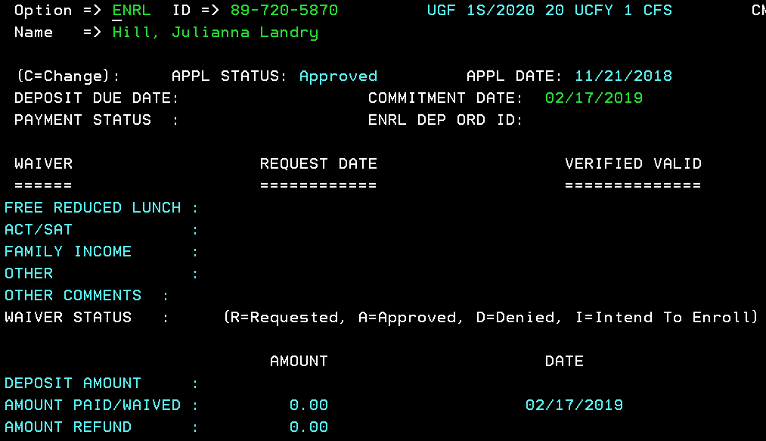

# FAFSA

## Basic Information

Issue Date: October 1, 2018 (2019-2020 FAFSA)

Applicable Semesters: Summer 2019, Fall 2019, and Spring 2020

Who: UG, Grad, Law, Vet Med Students Interested in Title IV, Federal Aid

Where: [www.fafsa.gov](http://www.fafsa.gov)

When: Complete each year, available October 1 annually.

What: Title IV, Financial Aid

School Code: 002010 (Louisiana State University- Agriculture & Mechanical College)

Which Parent:

• If your parent is widowed or single, answer the questions about that parent.

* If your parents are same sex and have been legally married, answer the questions about both parents
* If your biological parents are divorced or separated but live in the same home, answer the questions about both biological parents

• If your widowed parent is remarried as of today, answer the questions about that parent and your stepparent.

• If your parents are divorced or separated, answer the questions about the parent you lived with more during the past 12 months. (If you did not live with one parent more than the other, give answers about the parent who provided more financial support during the past 12 months or during the most recent year that you actually received support from a parent.) If this parent is remarried as of today, answer the questions about that parent and your stepparent.

Do Not Use: Grandparents, foster parents, legal guardians, aunts and uncles are not considered parents on this form unless they have legally adopted you. If your parents are living and married to each other, answer the questions about them.

## 

## Types of Title IV Aid offered from the FAFSA

Federal Grants

* Pell Grant
* Supplemental Education Opportunity Grant (SEOG)
* TEACH Grants

Federal Loans

* Federal Subsidized Stafford Loan
* Federal Unsubsidized Stafford Loan
* Federal Parent Plus Loan
* Federal Graduate Plus Loan

Federal Work Study

* Federal Work Study

## How to Sign FAFSA

## Student and Parent:

* Both parents and students will be issued a FSA ID to sign the FAFSA electronically.

## FAFSA TIPS

Some Programs are limitedly funded, so to increase your chances of being considered for programs with limited funds, complete and submit the FAFSA as soon after **October 1** as possible, and submit all verification documents requested as quickly as possible.

* Read all instructions.
* Provide only the information requested on the FAFSA.
* Use your legal name — not nicknames — and your correct social security number.
* "You" and "your" refer to the student. Sections that refer to you, the student, are yellow. Sections that refer to your parents are purple.
* If your parents are divorced, you must use the information for the parent you lived with most in the last 12 months. If that parent is remarried, you must also include the stepparent's income. Be sure to provide the information requested about your parents.
* Make sure you include #002010 on your list of school codes. Also, if you were required to provide parental information, a parent is also required to sign the FAFSA.
* If you complete the FAFSA electronically, don't forget to sign using your PIN (Personal Identification Number). You (the student) will need a PIN as well as your parent.  These are two separate PIN numbers.
* Allow 2-3 weeks for your FAFSA to be processed. If after 4 weeks you have not received a Student Aid Report (SAR) from the Federal Processor, call them at 1-800-433-3243 (1-800-4FEDAID).
* Make a copy of your completed FAFSA for your records.
* On the FAFSA, you have a tips section while completing this application. If you are unsure, it will guide you to what the application is asking for on the tax return, etc. See screen shot below.

As you go through the FAFSA, each question will have a help and hints side bar, which explains exactly what the FAFSA is asking.

**FAFSA Online Help:**

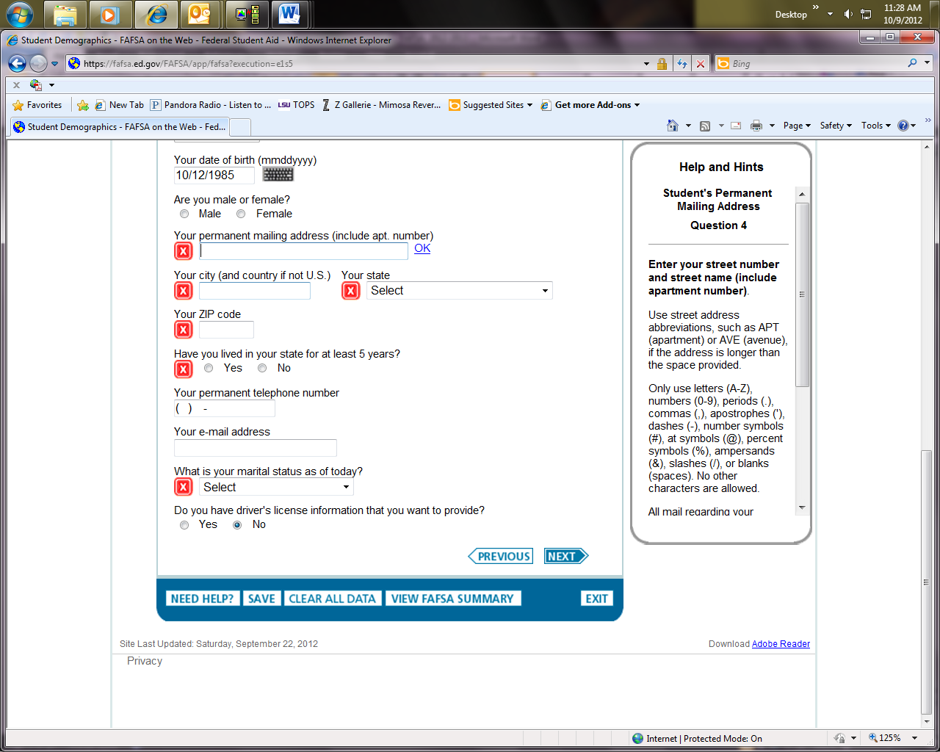

**FAFSA Online Live Chat Tool:**

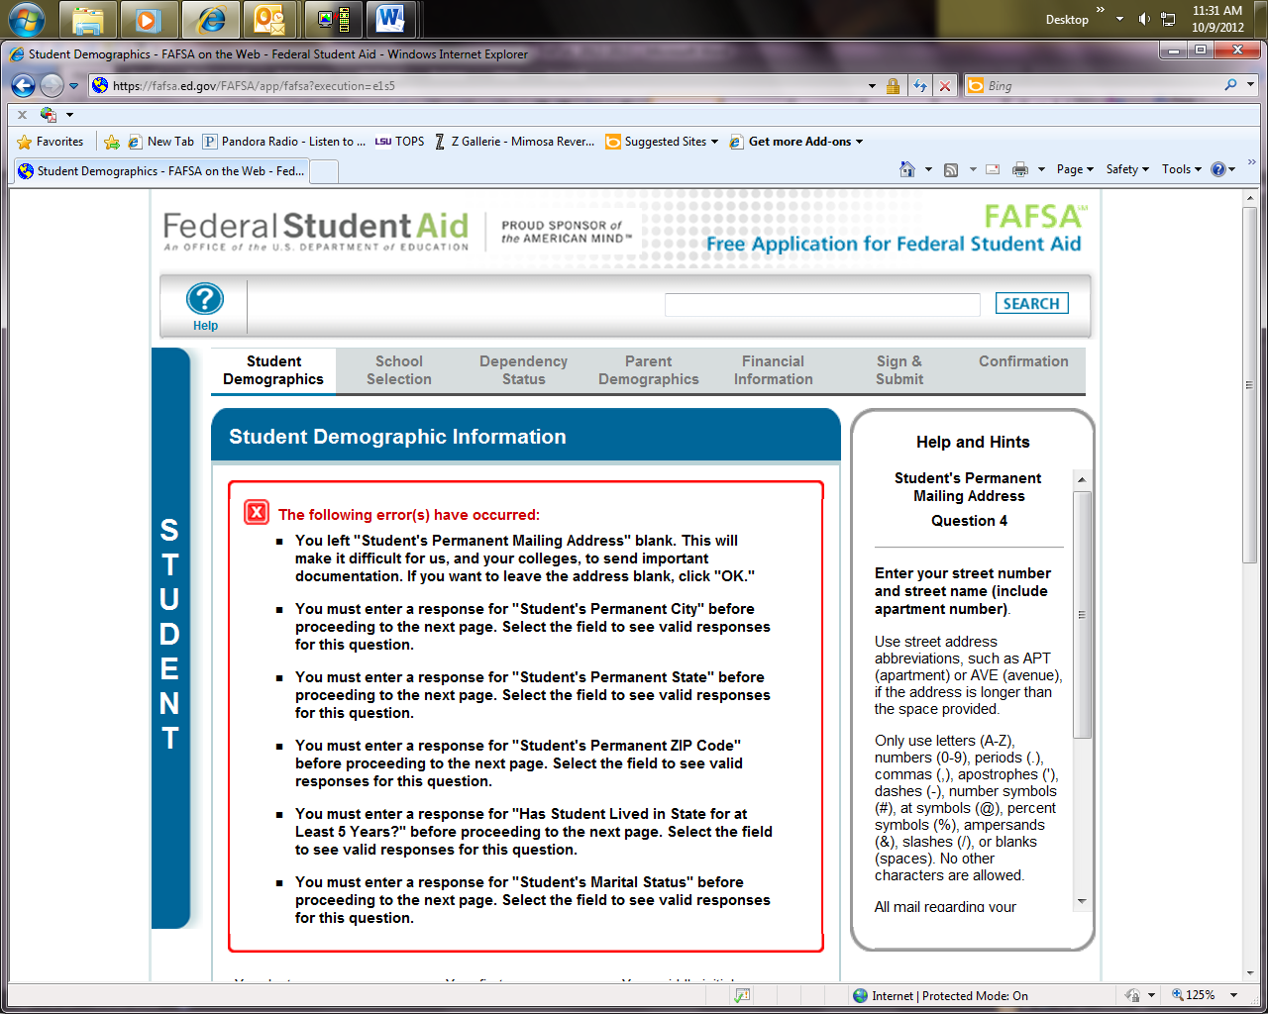

To Access on the Online Chat Tool on FAFSA, click “Help” in the upper left corner.

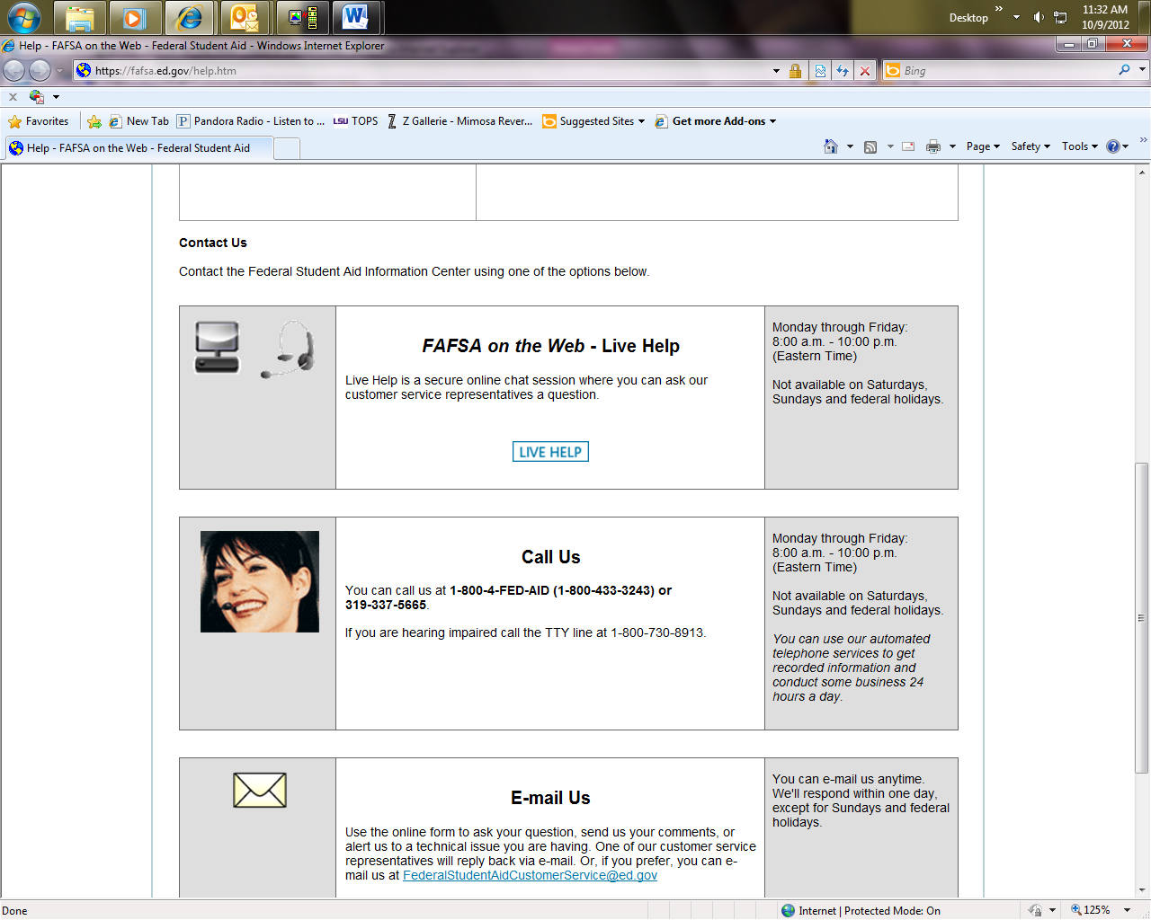

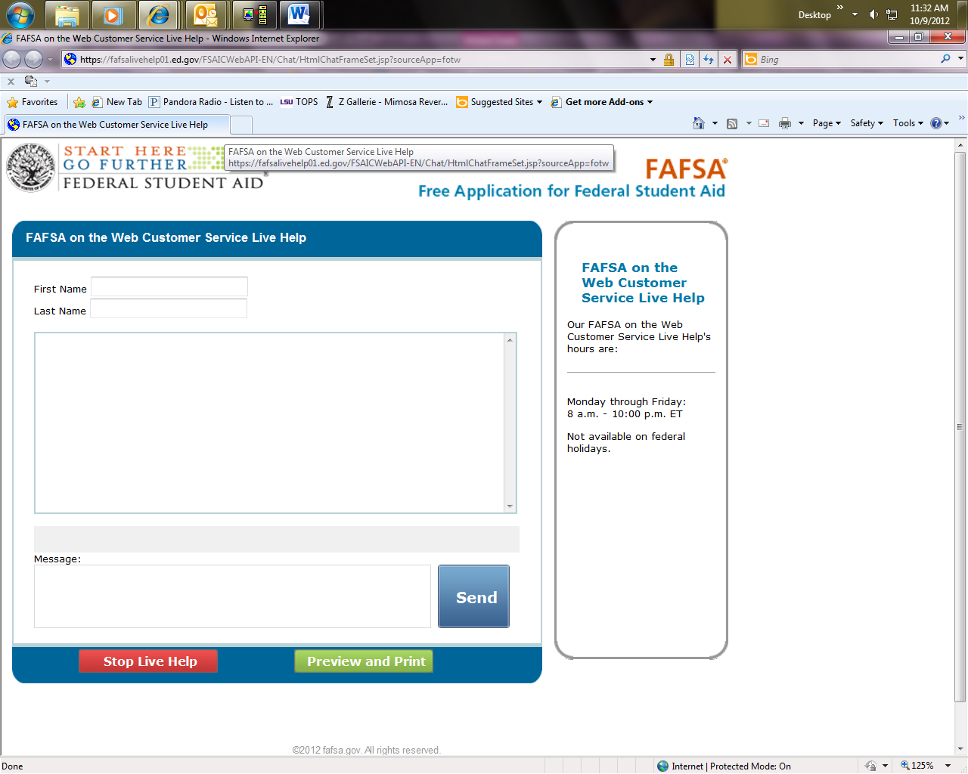

**Within the Online Chat with a Representative of FAFSA, you can simply just type in your question, and any issues you may have with your FAFSA.**

## Cost of Attendance (COA)

Cost of attendance is an estimate of the total expenses for a student attending LSU

* The total figure includes:
  + Tuition and fees
  + Room and board (dorm and meal plan costs for an on campus student, or housing and food allowances for an off campus student)
  + Books
  + Transportation (on or off campus)
  + Miscellaneous expenses
* The portions that the student will owe to the university are tuition and fees. If the student will live on campus, he or she will also owe room and board fees to the university. The Office of Enrollment Management uses the cost of attendance when calculating aid eligibility.
* Students and parents should only use the cost of attendance to build a budget for the academic year and determine how much aid the student will need.
* These figures are only an estimate, and these rates will vary from student to student. Each student and/or parent will want to use these as estimates, but build a specific budget for their own expected educational costs.

## BDGT Screen Shot

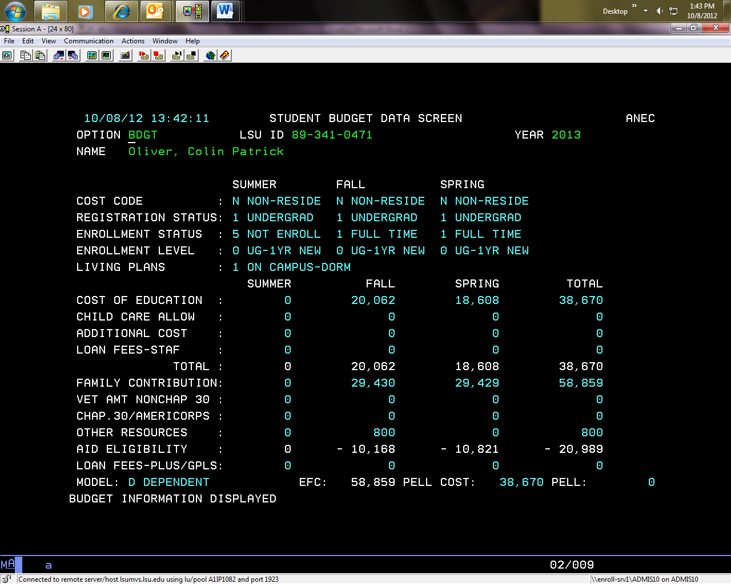

* The Budgeted Cost above, is based upon the factors of:
  + A non-resident of Louisiana
  + Undergraduate Student
  + Full Time for Fall and Spring, and not enrolled for Summer
  + Living in an on-campus dorm
  + With an on-campus transportation budget
  + Personal/Miscellaneous Expenses
* This will vary for each student, but based upon those factors on BDGT, that is how we calculate their COA or Cost of Attendance.
* Each semester will have its own COA, which is highlighted above in the rectangle box.
* Students **cannot** be awarded above their Cost of Attendance.

## COST Screen Shot

You can change the student status:

1=UG 4= Law School

3 = LSU Online

2=Grad 5= Vet Med

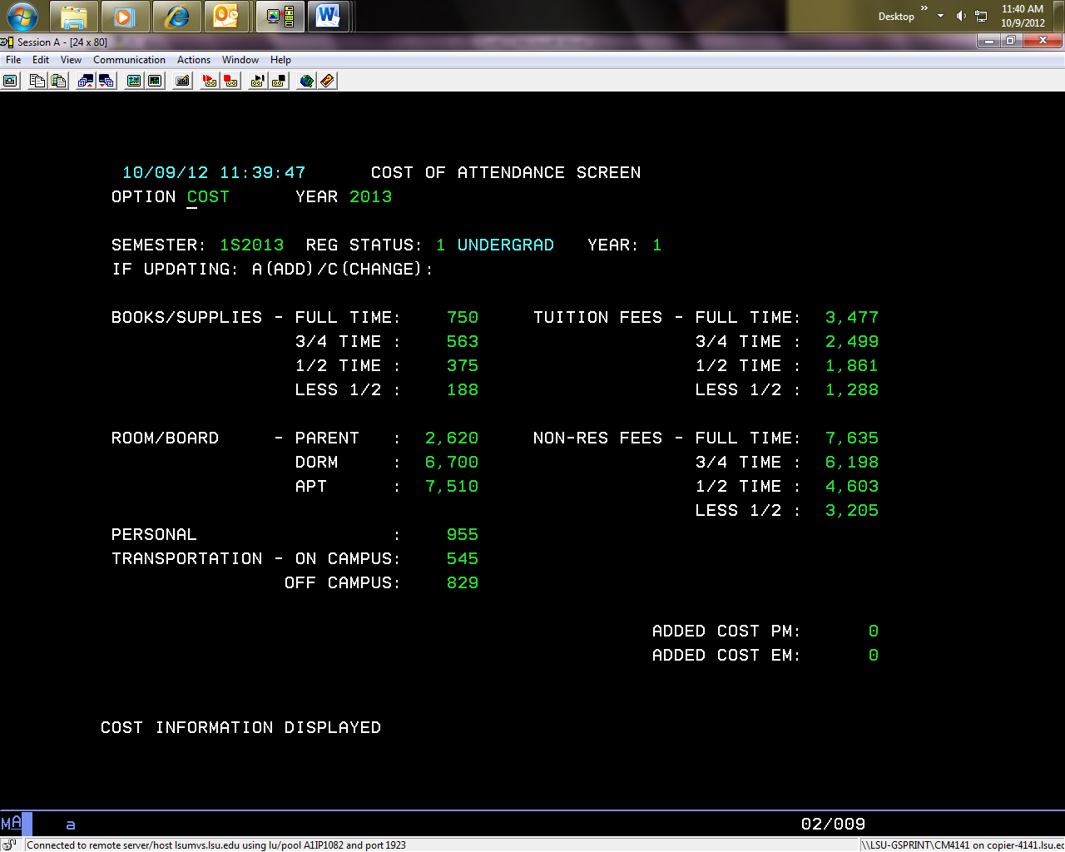

You can change the semester to determine the COA for a specific Semester.

The above Screen reflects which figures are used to calculate a student’s COA by semester. This is for the Fall Semester, for an undergrad.

You would simply add each section that is applicable to the student, and that would be their COA for the semester. For Example, a student who is a Resident, living off-campus, and is full-time we would use:

Books/Supplies: $750

Tuition/Fees: $3,477

Room/Board: $7,510

Personal: $955

Transportation: $829

Total: **$13,521**

As you can see this **$13,521** figure matches BDGT for Fall:

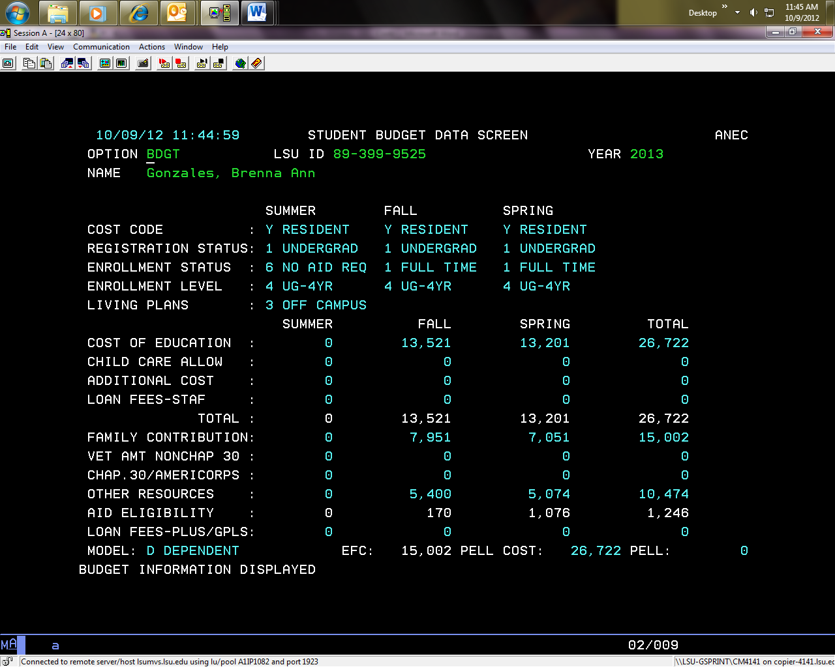

* Keep in Mind:
  + The Cost of Attendance is an estimate. It is merely a figure we use to determine a student’s financial aid eligibility for the semester and/or academic year.
  + It is **not** a number we award in financial aid to students.
  + It is **not** a number we expect the student/parents to pay each year and/or semester.
  + It may be an overestimate/underestimate for some students, as it will vary from student to student.
  + We **cannot** award financial aid above the COA for the semester and/or academic year.

## Expected Family Contribution (EFC)

Here is how the U.S. Department of Education defines the EFC:

* The Expected Family Contribution (EFC) is a measure of your family’s financial strength and is calculated according to a formula established by law. Your family's taxed and untaxed income, assets, and benefits (such as unemployment or Social Security) are all considered in the formula. Also considered are your family size and the number of family members who will attend college or career school during the year.

The information you report on your Free Application for Federal Student Aid (FAFSA) is used to calculate your EFC. Schools use the EFC to determine your federal student aid eligibility and financial aid award.

**Note:** Your EFC is **not** the amount of money your family will have to pay for college **nor** is it the amount of federal student aid you will receive. It is a number used by your school to calculate the amount of federal student aid you are eligible to receive.

For more information about the EFC, see *Funding Education Beyond High School: The Guide to Federal Student Aid* at: [http://studentaid.ed.gov/students/publications/student_guide/index.html](http://www.fafsa.ed.gov/help/fftoc01g.htm)

**What we use it for:**

Federal regulations state that the need based resources a student receives during an academic year cannot exceed his or her need based eligibility, which is based on the cost of attendance (budget) for that year minus the estimated family contribution (EFC) minus resources.

Cost of Attendance – EFC – Resources = Financial Need

**Need based resource examples are the following:**

* Fee Exemptions/Waivers
* Scholarships
* AmeriCorps
* Vocational Rehabilitation
* TOPS
* Other Gift Aid

**Need based financial aid examples are the following:**

* Federal Pell Grant (PELL)
* SEOG Grant (SEOG)
* Go Grant (GOGT)
* Pelican Promise (X135 and/or x159)
* Work Study (CWSP)
* Subsidized Stafford Loan (DSUB)

## Screen Shots for Reference

ISIP- Parents FAFSA Information

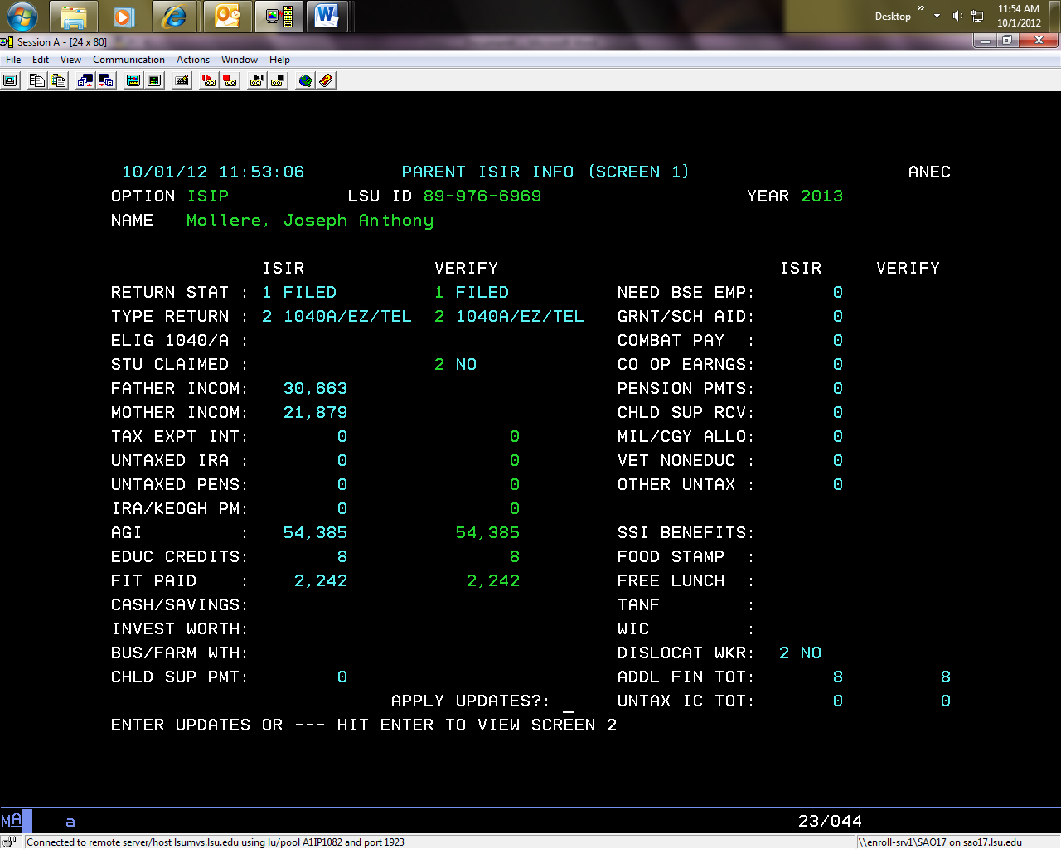

**\*\*\*IMPORTANT REMINDERS!**

* **Only speak to those parents listed on ISIP, Screen 2**
* **DO NOT provide Tax Information/Figures to Student and/or Parent from these screens**

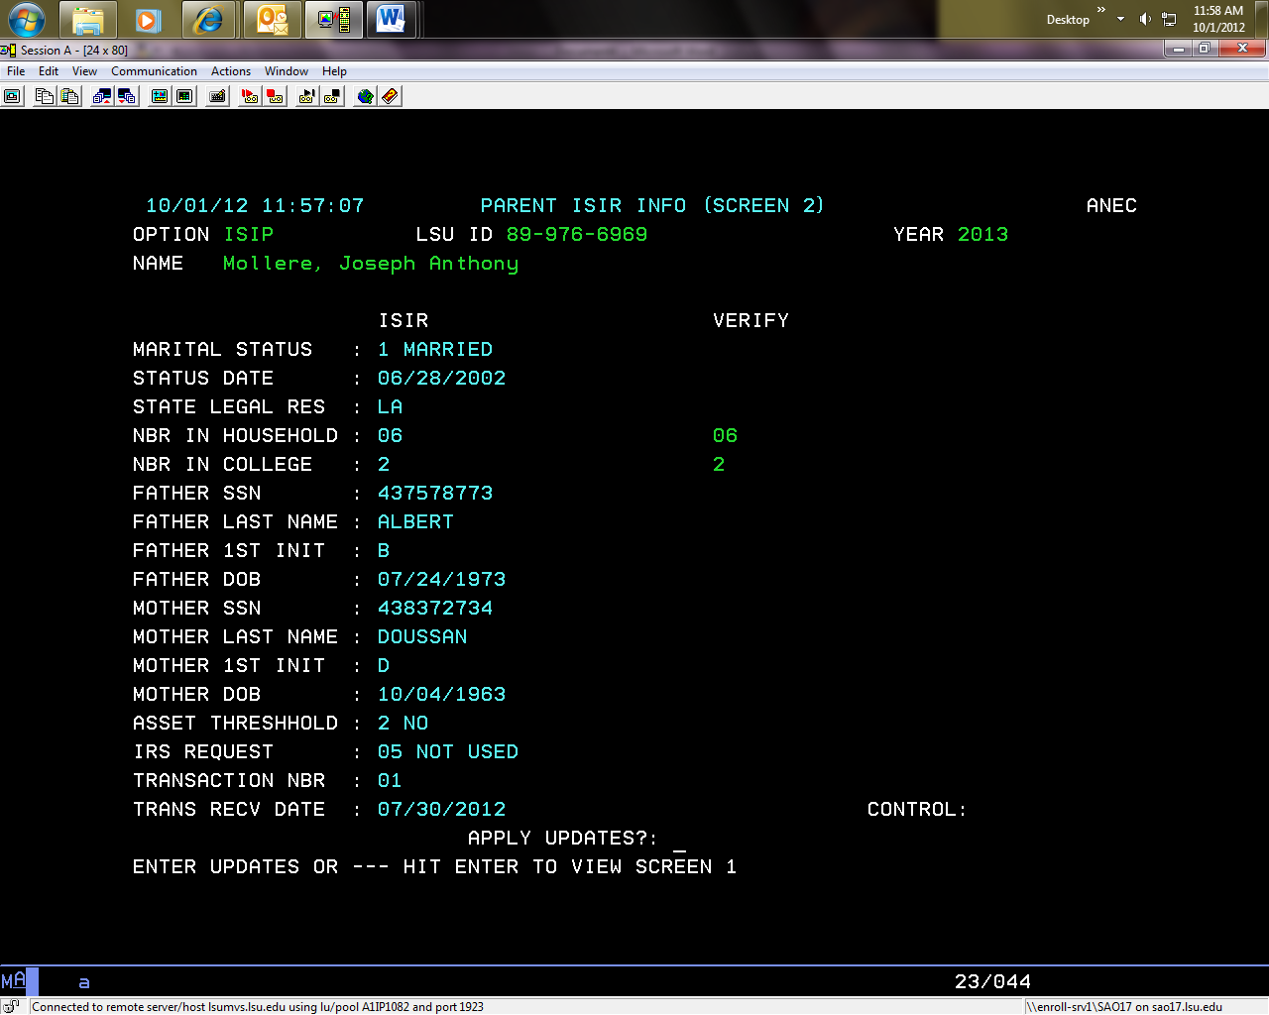ISIS- Student’s FAFSA Information

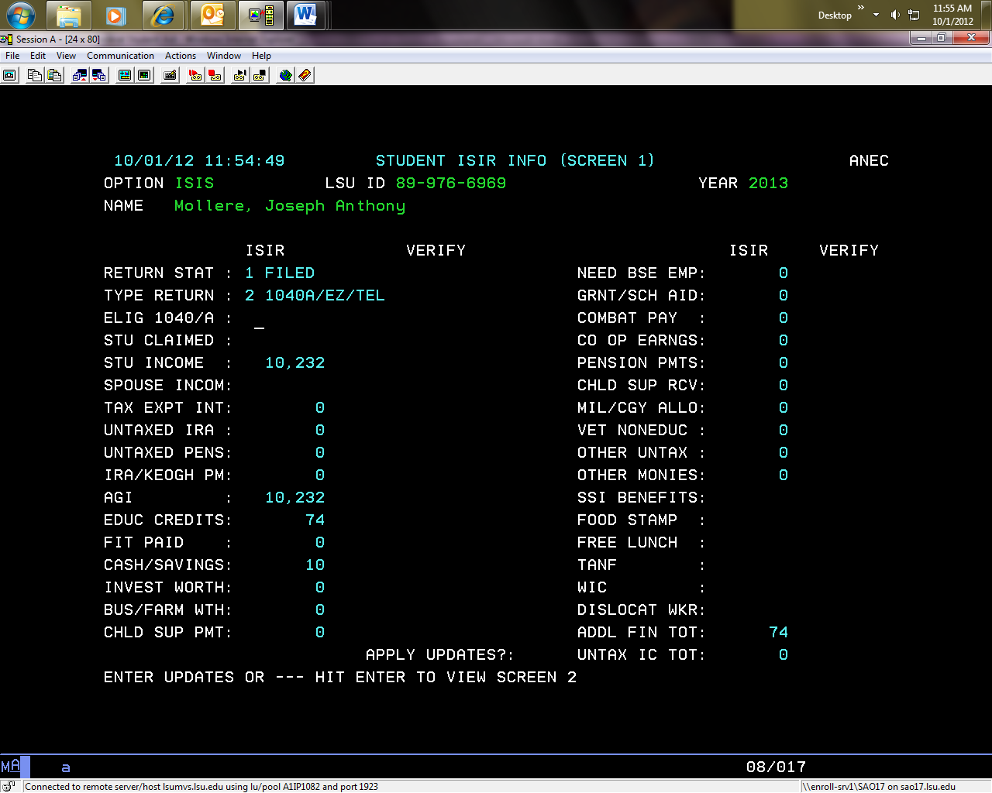

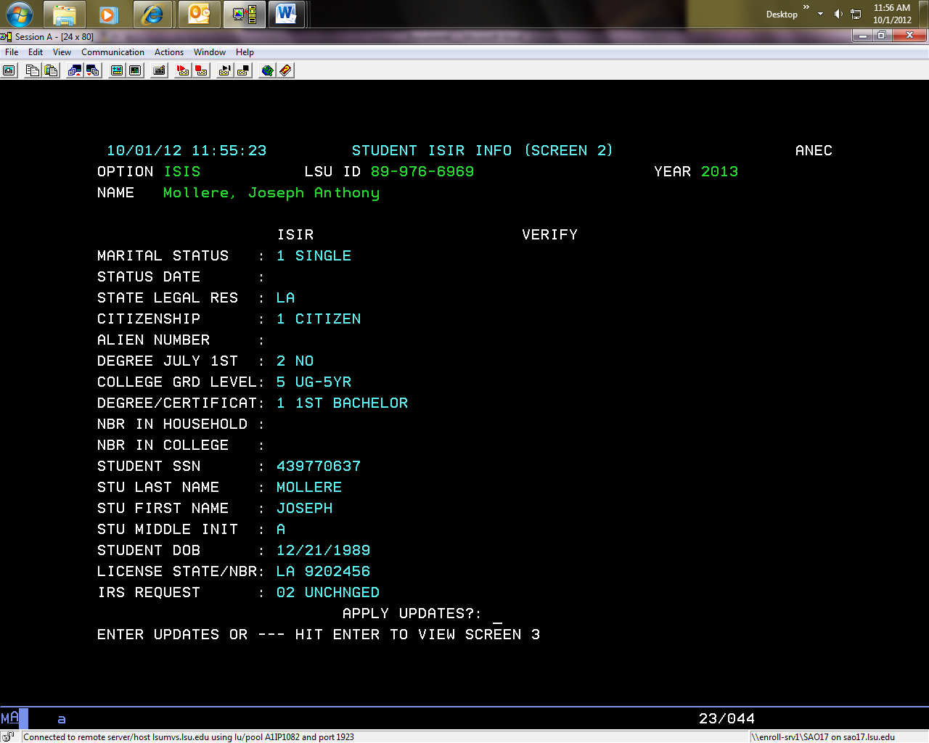

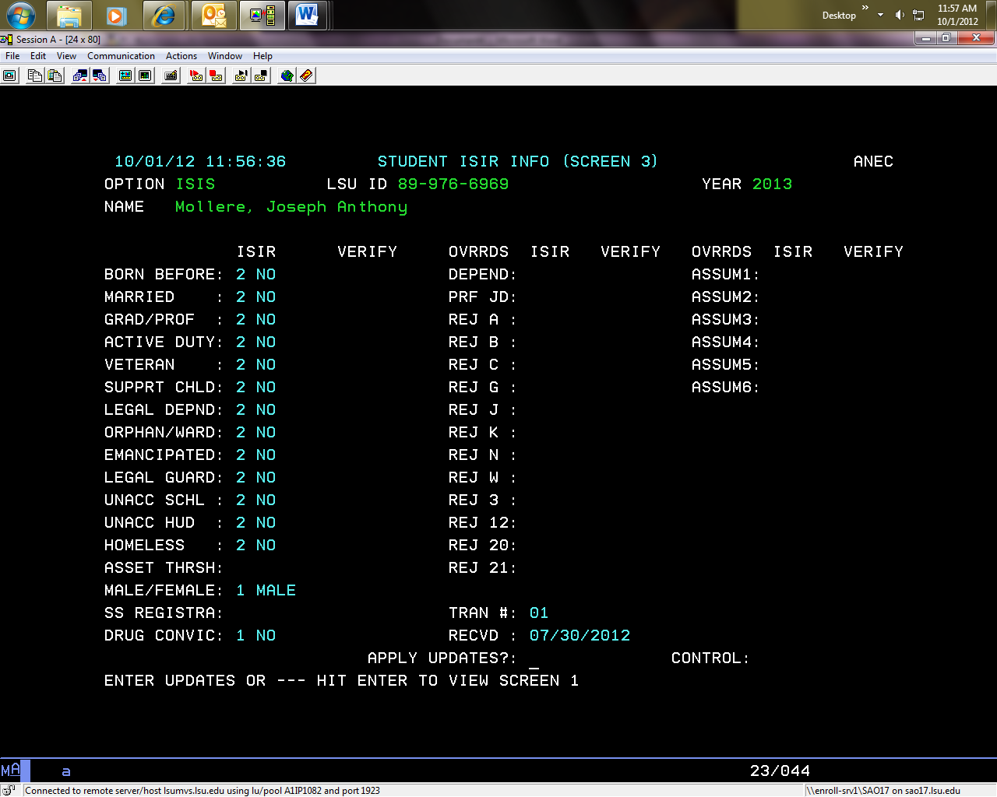

## Status of FAFSA

* To check the status of a FAFSA Application, check the VERY Screen

Very Screen

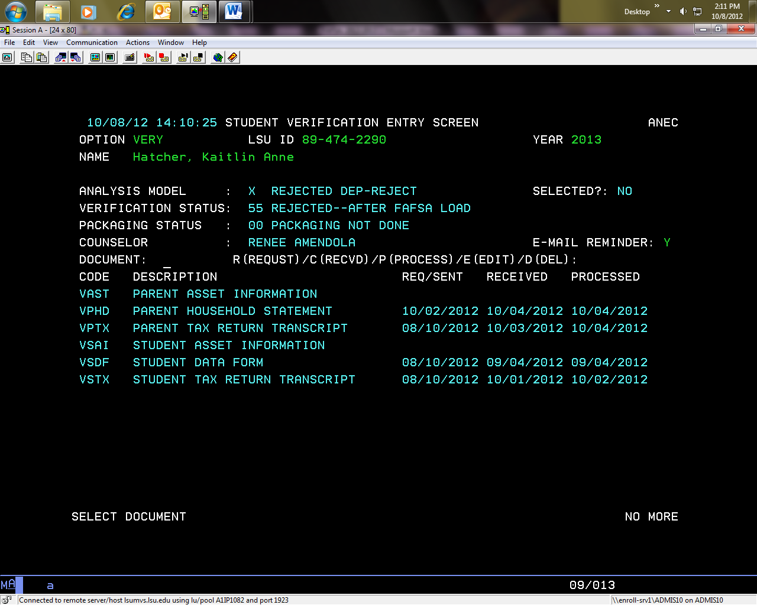

* This student’s FAFSA was rejected due to dep-reject, or dependent reject as seen in the square portion above.
* Due to the reject above, these two documents were requested for the student and parent to complete by the counselor.

COMM Screen:

* This screen will show the errors from the FAFSA.
* **Please reference FAFSA reject codes for reference.**

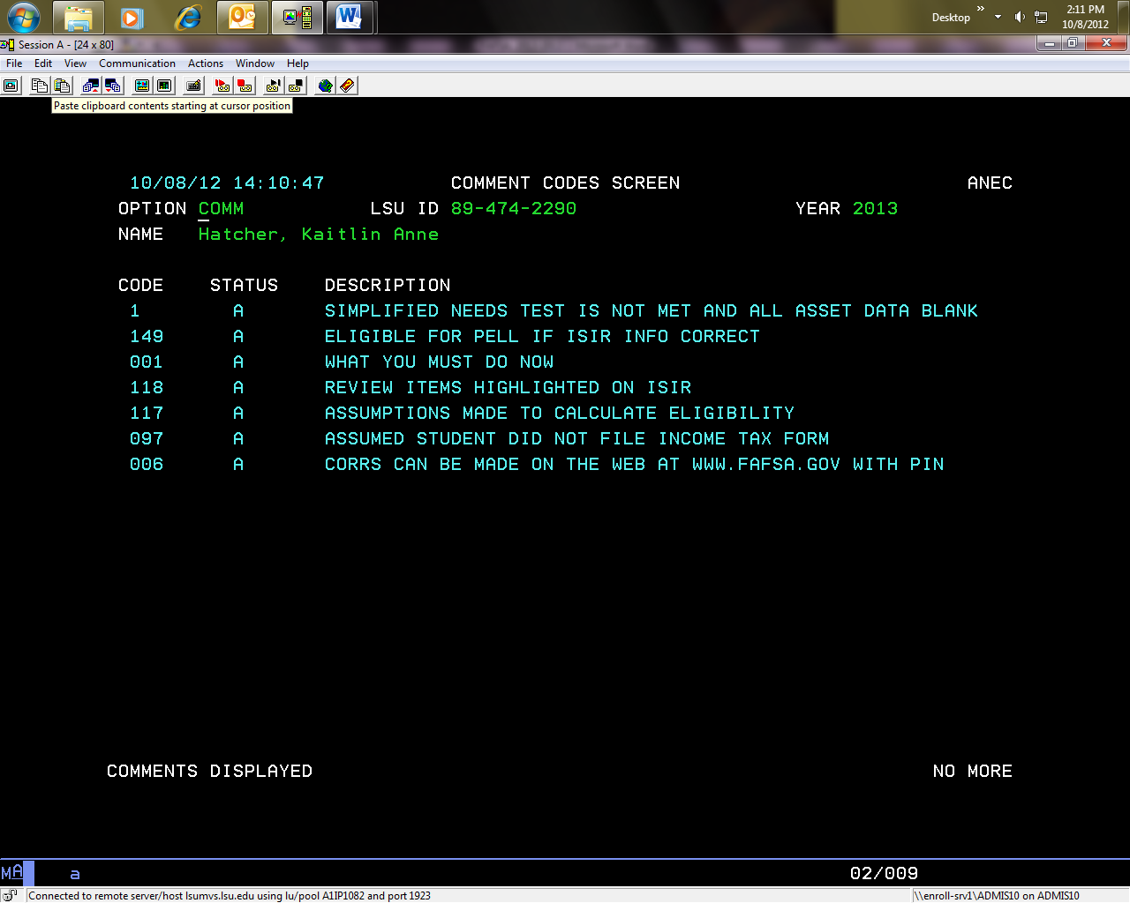

The Reject Code “1” References the FAFSA Reject Code Chart in this section.

**As you can see, it details why this student’s FAFSA is rejected and the questions that led to this reject status:**

|  |  |  |  |
| --- | --- | --- | --- |
| 1 | The simplified needs test is not met and all asset data is blank | You must provide asset information for you and your parent(s). Review Items 40 through 42 and Items 88 through 90 and make the necessary corrections. (Dependent Student)  You must provide your asset information. Review Items 40 through 42 and make the necessary corrections. (Independent Student).  If the parent or student has asset information already provided on ISIS or ISIP, their asset information will not be required again. Only the student or parent who did not originally submit asset info should submit the form. | #40-42 and 88-90 |

DEMI Screen:

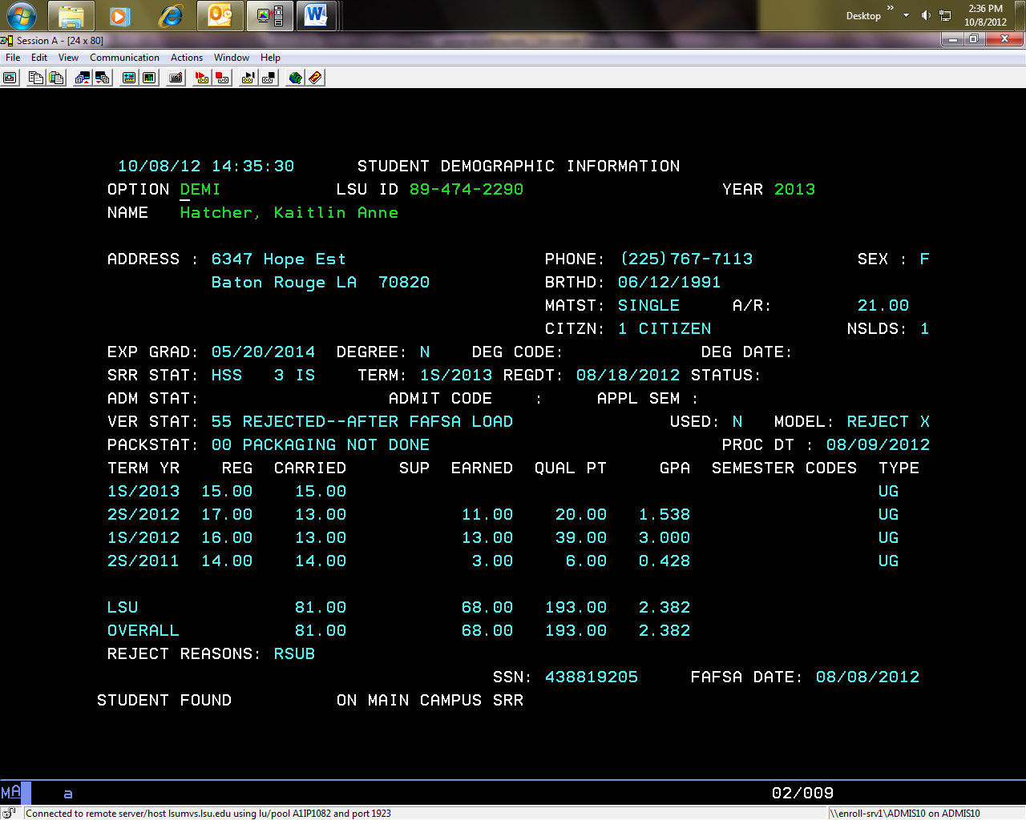

REJECT REASONS will always reference the Reject Code of the FAFSA.

RESUB- Subsequent Rejected by RECALC, which is also seen on CORR.

Model will also be an indicator that the FAFSA is in a reject status.

VERY Stat will show the status of the FAFSA. Here it shows that it is REJECTED, and VERIFICATION is NOT complete.

CORR Screen:

* This screen shows any correspondence sent by our computer system

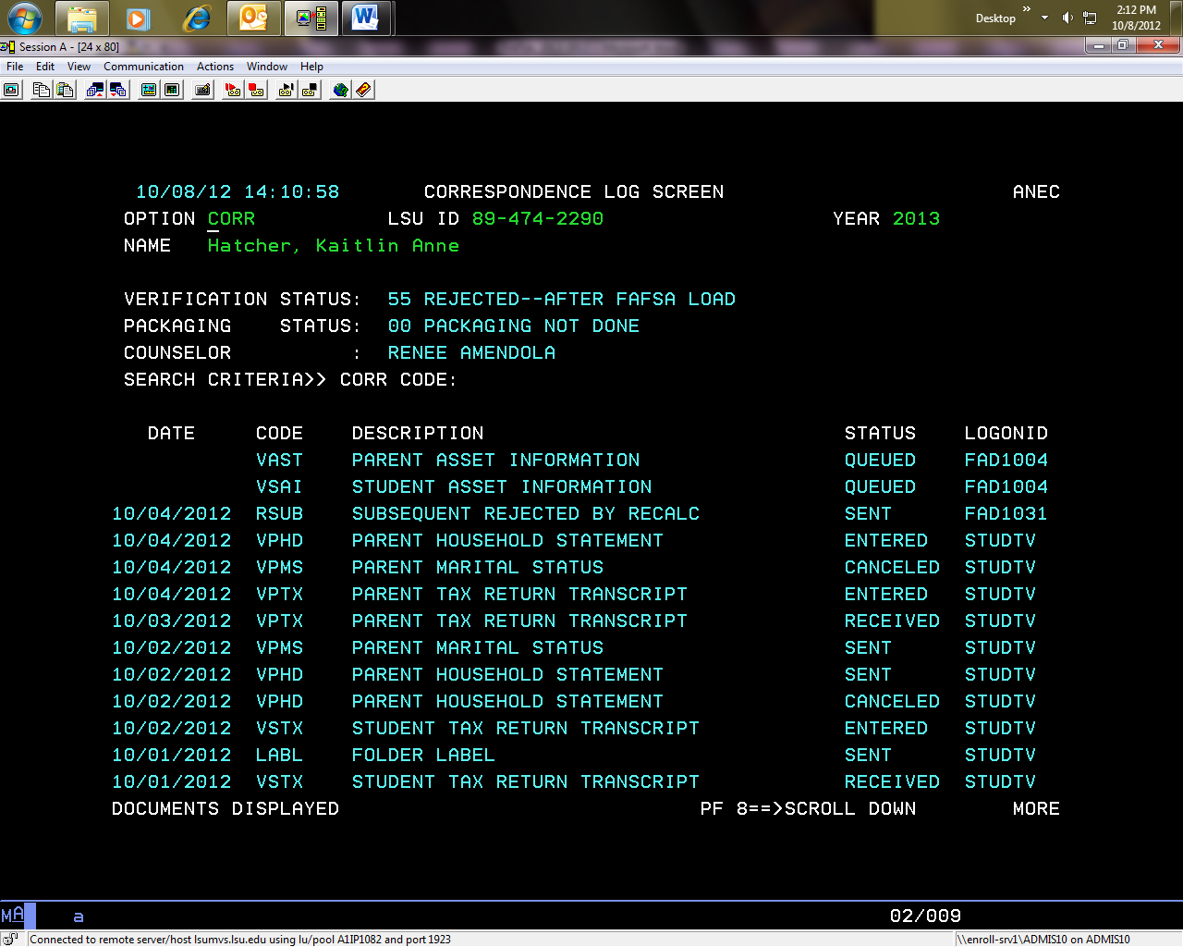

* The highlighted squares above show on 10/4/12 that the student was reject by RECALC. Per the chart, the RECALC reject is:

|  |  |
| --- | --- |
| **Reason for Reject** | **System Code** |
| Rejected by ED | RCAL |

* This FAFSA was rejected by The U.S. Department of Education. Based upon this the following documents were requested on the student’s behalf, which are highlighted above.

## FAFSA Reject Codes on Demi/Verbiage

### RAGG

We have received your application to participate in the federal financial aid programs for 20XX-20XX. Regretfully, we are unable to further consider your application for the following reason(s):

-Our records indicate that you have exceeded the aggregate maximum on your Federal Stafford Loan.

Please contact our office if you have any questions or if you need any additional information regarding your status.

### RAPP

No communication is sent as these students have not applied for admission to the University. This communication was stopped when e-mails began. These students do not have an e-mail on file therefore hundreds of paper letters would print.

### RCAL

We have received your application to participate in the federal financial aid programs for the 20XX-20XX academic year. We are currently unable to further consider your application. We have received information from the Federal Processing Center indicating that you must either provide additional information or make corrections to your 20XX-20XX financial aid application (FAFSA). Below you will find the reason(s) why your FAFSA was rejected:

Reject Code(s) - 12,15,16

Please refer to the chart at www.lsu.edu/rejectcodes to find out how to resolve these rejects.

### RCIT

We have received your application to participate in the federal financial aid programs for 20XX-20XX. Regretfully, we are unable to further consider your application for the following reason(s):

-Our records indicate that you are not a United States citizen.

Please contact our office if you have any questions or if you need any additional information regarding your status.

### RCOA

We have received your application to participate in the federal financial aid programs for 20XX-20XX. We are unable to make a financial aid award to you because your resources appear to be sufficient to cover your educational expenses. Examples of resources taken into consideration are scholarships, tuition waivers, fellowships, veteran’s benefits, etc.

Please contact our office if you have any questions or if you need any additional information regarding your status.

### RDDL

We have received your application to participate in the federal financial aid programs for 20XX-20XX. Regretfully, we are unable to further consider your application for the following reason(s):

-The deadline for processing student loans for the period you requested has passed.

Please contact our office if you have any questions or if you need any additional information regarding your status.

### RDEF

We have received your application to participate in the federal financial aid programs for 20XX-20XX. Regretfully, we are unable to further consider your application for the following reason(s):

- Information from the National Student Loan Data System indicates that you have defaulted on a student loan. If you need to contact the agency that has placed you in default, please go to [www.nslds.ed.gov](http://www.nslds.ed.gov) to view your loan history.

Please contact our office if you have any questions or if you need any additional information regarding your status.

### RDEN

We have received your application to participate in the federal financial aid programs for 20XX-20XX. Regretfully, we are unable to further consider your application for the following reason(s):

- Our records indicate that you have been denied admission to the university.

Please contact our office if you have any questions or if you need any additional information regarding your status.

### RDEP

We have received your application to participate in the federal financial aid programs for 20XX-20XX. Regretfully, we are unable to further consider your application for the following reason(s):

- You have provided conflicting information regarding your dependency status.

Please contact our office if you have any questions or if you need any additional information regarding your status.

### RDHS

We regret to inform you that the information we have received from the Department of Homeland Security indicates the documentation you submitted to our office does not verify that you are an “eligible non-citizen” or “permanent resident”. Therefore, you will be ineligible to participate in the federal financial aid programs for 20XX-20XX.

Please contact our office if you have any questions or if you need any additional information regarding your status.

### RDRC

We have received your application to participate in the federal financial aid programs for 20XX-20XX. Regretfully, we are unable to further consider your application for the following reason(s):

- Your response to the drug question on the FAFSA indicates that you are currently ineligible for federal student aid. If you have incorrectly answered this question, please contact our office for further instructions.

Please contact our office if you have any questions or if you need any additional information regarding your status.

### RDRP

We have received your application to participate in the federal financial aid programs for 20XX-20XX. Regretfully, we are unable to further consider your application for the following reason(s):

- Our records indicate that you have been scholastically dropped from the university.

Please contact our office if you have any questions or if you need any additional information regarding your status.

### RENR

We have received your application to participate in the federal financial aid programs for 20XX-20XX. Regretfully, we are unable to further consider your application for the following reason(s):

- Our records reflect that you are not enrolled on at least a half time basis.

Please contact our office if you have any questions or if you need any additional information regarding your status.

### REXT

We have received your application to participate in the federal financial aid programs for 20XX-20XX. Regretfully, we are unable to further consider your application for the following reason(s):

- Our records reflect indicate that you are registered as an Extension (EXTN) student and are therefore ineligible to participate in the federal financial aid programs.

Please contact our office if you have any questions or if you need any additional information regarding your status.

### RHSG

We have received your application to participate in the federal financial aid programs for 20XX-20XX. Regretfully, we are unable to further consider your application for the following reason(s):

-Our records indicate that you have not yet graduated from high school or earned a GED and are therefore ineligible to participate in the federal financial aid programs.

Please contact our office if you have any questions or if you need any additional information regarding your status.

### RMAP

We have received your FAFSA requesting to participate in the federal financial aid programs for 20XX-20XX.  We are unable to further consider your application for the following reason(s):

-Our records indicate that you have multiple active admission applications.  Please contact our office at 225-578-3103 or [financialaid@lsu.edu](mailto:financialaid@lsu.edu) to let you know which degree program you anticipate entering for the upcoming academic year.

### RNAR

We have received your application to participate in the federal financial aid programs for the 20XX-20XX academic year. We are unable to make an award offer as you indicated you were not interested in financial aid on your student data form. If you wish to be considered for financial aid programs such as grants or loans, please contact our office.

- Please note that if you completed the FAFSA for consideration for the Louisiana TOPS Program, you will be notified of your eligibility by the Louisiana Office of Student Financial Assistance.

Please contact our office at [financialaid@lsu.edu](mailto:financialaid@lsu.edu) or 225/578-3103 if you have any questions or need any additional information regarding your status.

### RNMT

We regret to inform you that your academic college did not certify that your current course work is necessary for enrollment into your desired degree/certificate program. Therefore, you will be ineligible to participate in the federal financial aid programs for the 20XX-20XX academic years.

### RNRA

We have received your application to participate in the federal financial aid programs for 20XX-20XX. Regretfully, we are unable to further consider your application for the following reason(s):

-Our records indicate that you are not a regularly admitted student at this time and are therefore ineligible to participate in the federal financial aid programs.

Please contact our office if you have any questions or if you need any additional information regarding your status.

### RNSL

We have received your application to participate in the federal financial aid programs for 20XX-20XX. Regretfully, we are unable to further consider your application for the following reason(s):

-Records from the National Student Loan Data System indicate a conflict with identifying your prior loan history. Once we have resolved this discrepancy we will notify you accordingly.

Please contact our office if you have any questions or if you need any additional information regarding your status

### ROLD

We have received your application to participate in the federal financial aid programs for 20XX-20XX. Regretfully, we are unable to further consider your application for the following reason(s):

-Our records indicate that you are not currently enrolled in the degree program indicated on your financial aid application, nor do you have an admissions application on file for that program.

Please contact our office if you have any questions or if you need any additional information regarding your status.

### ROTH

We have received your application to participate in the federal financial aid programs for the 20XX-20XX academic year. We are currently unable to further consider your application.

Please contact our office at financialaid@lsu or 225/578-3103 to determine the next step for processing your application.

*\*\*\*\*Internal comments…this code was established in the event that the system could not process a student but the specific reason is not yet established.*

### RPAC or RPEL

We have received your application to participate in the federal financial aid programs for 20XX-20XX. We are unable to make an award to you for the programs you requested. There may be other programs, such as student loans, for which you may qualify. If you wish to be considered for these loan programs, please let us know.

Please note that if you completed the FAFSA for consideration for the Louisiana TOPS Program, you will be notified of your eligibility by the Louisiana Office of Student Financial Assistance.

Please contact our office if you have any questions or if you need any additional information regarding your status.

### RPDH

We have received your application to participate in the federal financial aid programs for the 20XX-20XX academic year. We are currently awaiting confirmation of your eligible non-citizen status from the Department of Homeland Security. Once this information has been received, you will receive an email from our office concerning the status.

Please contact our office at [financialaid@lsu.edu](mailto:financialaid@lsu.edu) or 225/578-3103 if you have any questions or need any additional information regarding your status.

### RREF

We have received your application to participate in the federal financial aid programs for 20XX-20XX. Regretfully, we are unable to further consider your application for the following reason(s):

-Our records indicate that you owe a refund on a Federal Grant. Please visit <http://www.nslds.ed.gov/nslds_SA/> to inquire on the overpayment.

Please contact our office if you have any questions or if you need any additional information regarding your status.

### RRES

We regret to inform you that the information you submitted regarding your immigration status does not verify that you are an eligible non-citizen. Therefore, you will be ineligible to participate in the federal financial aid programs for 20XX-20XX.

Please contact our office if you have questions or if you need any additional information regarding your status.

### RSDH

We have received your application to participate in the federal financial aid programs for the 20XX-20XX academic year. The Department of Homeland Security could not initially confirm your eligible non-citizen status. Therefore, we are awaiting secondary confirmation of your eligible non-citizen status from the Department of Homeland Security. Once this information has been received, you will receive an email from our office concerning the status.

Please contact our office at [financialaid@lsu.edu](mailto:financialaid@lsu.edu) or 225/578-3103 if you have any questions or need any additional information regarding your status.

### RSEP

We have received your Identity and Statement of Educational Purpose, however you indicated that you would not use your federal financial aid funds for educational purposes only. Therefore, you will be ineligible to participate in federal financial aid programs for the 20XX-20XX academic year.

### RSPR

Our records indicate that you have been offered admission into the LSU Summer Provisional Program. We hope you will be successful in this program. While you will not be eligible for financial aid for the summer, you may indeed receive consideration for the fall and spring semesters once you successfully complete the summer academic requirements of the Summer Provisional Program. Your application for the federal financial aid programs has been placed in a "hold" status. Upon successful completion of the summer term, we will resume processing your application.

Please contact our office if you have any questions or if you need any additional information regarding your status.

### RSSR

We regret to inform you that the information we have received concerning your Selective Service registration indicates that you were required to register and did not. Therefore, you will be ineligible to participate in the federal financial aid programs for 20XX-20XX.

Please contact our office if you have questions or if you need any additional information regarding your status.

### RSU

We have received your application to participate in the federal financial aid programs for 20XX-20XX. Regretfully, we are unable to further consider your application for the following reason(s):

- Our records indicate that you are registered on a “Summer Only” basis and are therefore ineligible to participate in the federal financial aid programs.

Please contact our office if you have any questions or if you need any additional information regarding your status.

### RUEH

We regret to inform you that the Unusual Enrollment History statement and documentation that you submitted were denied. Therefore, you are ineligible to participate in the federal financial aid programs for the 20XX-20XX academic year.

Please contact our office at financialaid@lsu.edu or 225/578-3103 if you have any questions or need any additional information regarding your status.

### RWIT

We have received your application to participate in the federal financial aid programs for 20XX-20XX. Regretfully, we are unable to further consider your application for the following reason(s):

* Our records indicate that your application for admission to the university has been withdrawn.

Please contact our office if you have any questions or if you need any additional information regarding your status.

## 2019-2020 FAFSA Reject Codes on COMM

**2019-2020 FAFSA Rejects**

<http://sites01.lsu.edu/wp/financialaid/fafsa-reject-codes/>

|  |  |  |  |
| --- | --- | --- | --- |
| **Reject Code** | **Reject Reason** | **Student Action** | **Question Number on the FAFSA** |
| A | Date of birth questionable | Please review your date of birth in Item 9 and either confirm the date you have reported by reentering it in Item 9 or make the necessary corrections. | #9 |
| B | Date of birth questionable | Please review your date of birth in Item 9 and either confirm the date you have reported by re-entering it in Item 9 or make the necessary corrections. | #9 |
| C | Taxes Paid is greater than zero and greater than or equal to a fixed percentage of the AGI, but not equal to or greater than AGI. (Parent or Independent Student) | The amount you reported for taxes paid by your parent(s) appears to be incorrect based on the amount you reported for their adjusted gross income. Please review Items 83 and 84 and either confirm the amount of taxes paid by re-entering it or make the necessary corrections. (Parent of Dependent Student)  The amount you reported for your taxes paid appears to be incorrect based on the amount you reported for your adjusted gross income. Please review Items 35 and 36 and either confirm the amount of taxes paid by re-entering it or make the necessary corrections. (Independent Student) | 85, 86, 36, 37 |
| D | Student’s SSN match, but no name match. | The name you reported on the FAFSA does not match the name in the Social Security Administration’s (SSA) records for your Social Security Number (SSN). Therefore, you must correct your SSN (Item 8) or name (Items 1 and 2). If your name is correct, you must confirm it by reentering both your first and last names in Items 1 and 2. If you confirm your name, you should also contact the SSA to have them correct it in their records. The SSA can be contacted by calling 1-800-772-1213 or by visiting www.socialsecurity.gov. | #8, 1 and 2 |
| E | Parent 1 SSN match, but no name match | Your Parent 1’s name as reported on your FAFSA does not match the name in the Social Security Administration’s (SSA) records for their Social Security Number (SSN). Therefore, you must correct their SSN (Item 61) or their name (Items 62 and 63). If their name is correct, you must confirm it by reentering both their last name and first name initial in Items 62 and 63. If you confirm your Parent 1’s name, your Parent 1 should also contact the SSA to have them correct it in their records. The SSA can be contacted by calling 1-800-772-1213 or by visiting www.socialsecurity.gov. | #61, 62, and 63 |
| F | Parent 2 SSN match, but no name match | Your Parent 2’s name as reported on your FAFSA does not match the name in the Social Security Administration’s (SSA) records for their Social Security Number (SSN). Therefore, you must correct their SSN (Item 65) or her name (Items 66 and 67). If their name is correct, you must confirm it by reentering both their last name and first name initial in Items 66 and 67. If you confirm your Parent 2’s name, your Parent 4 should also contact the SSA to have them correct it in their records. The SSA can be contacted by calling 1-800-772-1213 or by visiting www.socialsecurity.gov. | 65, 66, 67 |
| G | Taxes Paid is greater than zero, and greater than or equal to a fixed percentage of the AGI, but not equal to or greater than AGI.  (Dependent Student) | The amount you reported for your taxes paid appears to be incorrect based on the amount you reported for your adjusted gross income. Please review Items 35 and 36 and make the necessary corrections**.** | #36, 37 |
| J | Parent 1 SSN contains all zeroes and reported as a tax filer | You reported that your Parent 1 did file or will file a 2015 income tax return (Item 80) but also reported that your Parent 1 does not have a social security number. Please review Item 61 and make the necessary corrections. | 61 |
| K | Parent 2 SSN contains all zeroes and reported as a tax filer. | You reported that your Parent 2 did file or will file a 2015 income tax return (Item 80) but also reported that your Parent 2 does not have a social security number. Please review Item 65 and make the necessary corrections. | 65 |
| N | Missing first or last name | Review the student’s first and last name in items 1 and 2. Correct the student’s name or confirm a blank first or last name field if the student actually has only one name. | #1, 2 |
| R | Student’s Social Security Match, but no date of birth match | The date of birth you reported on your FAFSA does not match the date of birth in the Social Security Administration’s (SSA) records for your Social Security Number (SSN). You should correct your SSN (Item 8) or your date of birth (Item 9). If your date of birth is correct, you must confirm it by reentering it in Item 9. If you confirm your date of birth, you should also contact the SSA to have them correct it in their records. The SSA can be contacted by calling 1-800-772-1213 or by visiting www.socialsecurity.gov. | #8, 9 |
| S | Parent 1 Social Security Match, but no date of birth match | Your Parent 1’s date of birth as reported on your FAFSA does not match their date of birth in the Social Security Administration’s (SSA) records for their Social Security Number (SSN). You should correct their SSN (Item 61) or their date of birth (Item 64). If their date of birth is correct, you must confirm it by re-entering it in Item 64. If you confirm your Parent 1’s date of birth, your Parent 1 should also contact the SSA to have them correct it in their records. The SSA can be contacted by calling 1-800-772-1213 or by visiting www.socialsecurity.gov. | 61, 64 |
| T | Parent 2 Social Security Match, but no date of birth match | Your Parent 2’s date of birth as reported on your FAFSA does not match their date of birth in the Social Security Administration’s (SSA) records for their Social Security Number (SSN). You should correct their SSN (Item 65) or their date of birth (Item 68). If their date of birth is correct, you must confirm it by re-entering it in Item 68. If you confirm your Parent 2’s date of birth, your Parent 2 should also contact the SSA to have them correct it in their records. The SSA can be contacted by calling 1-800-772-1213 or visiting www.socialsecurity.gov. | 65, 68 |
| W | Unusually high number of family members | Review the number of family members you have reported in Item 73 and either confirm your answer by reentering it or make the necessary correction. (Dependent Student)  Review the number of family members you have reported in Item 95 and either confirm your answer by reentering it or make the necessary correction. (Independent Student) | #73, 95 |
| 1 | The simplified needs test is not met, automatic zero EFC flag is not set, asset threshold exceeded is ‘Yes’ or blank on current transaction, and any asset data is blank | Dependent Student: Review Items 41 through 43 and Items 90 through 92 and make the necessary corrections. Independent Student: Review Items 41 through 43 and make the necessary corrections. | 41-43, 90-92 |
| 2 | Incomplete FAFSA or Renewal FAFSA | Dependent Student: You must provide your parent(s) income information in Items 85 through 94. Independent Student: You must provide you and your spouse’s (if married) income information in Items 36 through 45. | 85-94, 36-45 |
| 3 | Student’s Taxes Paid is greater than zero and equal to or greater than AGI | The amount you reported for your taxes paid is equal to or greater than the amount you reported for your adjusted gross income. Review Items 35 and 36 and make the necessary corrections. | #36, 37 |
| 4 | Student’s marital status date on the initial application is greater than the date the application was signed. OR Student’s marital status date on a correction transaction is greater than transaction receipt date. | You reported the date of your marital status in item 17 to be after the date you completed your application. You must report your marital status in item 16 as of the date the application was originally signed. | #16, 17 |
| 5 | Missing or invalid Date of Birth | You must provide your date of birth in Item 9. | #9 |
| 6 | Parent 1 Social Security Number was not matched with the Social Security Administration | The Social Security Administration (SSA) did not confirm that the Social Security Number (SSN) you reported for your Parent 1 on your FAFSA is valid. If you believe that the number you reported is correct, your Parent 1 should contact the SSA. If the SSN is incorrect, you need to make the necessary correction. Also, review and correct the name and/or date of birth for parent 2. The SSA can be contacted by calling 1-800-772-1213 or by visiting www.socialsecurity.gov. | 61, 66, 67, 68 |
| 7 | Parent 2 Social Security Number was not matched with the Social Security Administration | The Social Security Administration (SSA) did not confirm that the Social Security Number (SSN) you reported for your Parent 2 on your FAFSA is valid. If you believe that the number you reported is correct, your Parent 2 should contact the SSA. If the SSN is incorrect, you need to make the necessary correction. Also, review and correct the name and/or date of birth for parent 1. The SSA can be contacted by calling 1-800-772-1213 or by visiting www.socialsecurity.gov | 62, 63, 64, 65 |
| 8 | SSN match with Date of Death | Social Security Administration (SSA) records indicate that the Social Security Number (SSN) you provided in Item 8 belongs to a deceased person. If the SSN in Item 8 is correct, you must contact an SSA office to resolve this problem. The SSA can be contacted by calling 1-800-772-1213 or by visiting www.socialsecurity.gov. | #8 |
| 9 | Dependent student and one of SSN, last name, and Date of Birth are missing for both parents | You must report a valid social security number, name, and date of birth for Parent 1 and/or Parent 2. If your parent does not have a social security number, you should correct Item 61 and/or 65 to all zeroes. | 61-68 |
| 10 | Missing marital status and number of family members | Dependent Student: You must provide answers for your parents’ marital status and number of family members in Items 59 and 73. Independent Student: You must provide answers for your marital status and number of family members in Items 16 and 95. | 59, 73 or 16, 95 |
| 11 | Marital Status inconsistent with reported incomes | **Dependent Student**: Review your parents’ marital status in Item 59. If your parents are not married, provide only the income for the parent(s) who support(s) you. **Independent Student**: Review your marital status in Item 16. You should only report income for a spouse if you were married as of the date you submitted your application. | 59; 85 or 86; 16; 36 or 37 |
| 12 | Parents’ Taxes Paid is greater than zero and equal to or greater than AGI | The amount you reported for your parent(s) taxes paid is equal to or greater than the amount you reported for their adjusted gross income. Review Items 85 and 86 and make the necessary corrections. | #85, 86 |
| 13 | Missing Name | We recently received a FAFSA with no name from this address. The applicant must provide a full name in Items 1 and 2 on this SAR. | #1, 2 |
| 14 | Missing student signature on paper FAFSA or SAR | You did not sign your FAFSA or corrected FAFSA. You must sign and return this SAR to the Central Processing System before we can determine your eligibility for federal student aid. | #105 |
| 15 | Missing parent signature on FAFSA or SAR | Your parent did not sign your FAFSA or corrected FAFSA. At least one parent whose information was reported on the FAFSA must sign and return this SAR to the Central Processing System before we can determine your eligibility for federal student aid. | #105 |
| 16 | Missing student signature on Web application | We have not received the signature page from your FAFSA on the Web application. To sign the FAFSA online, you must first apply for a Personal Identification Number (PIN) at www.pin.ed.gov.Once retrieved, you can electronically sign the FAFSA at www.fafsa.ed.gov. If you experience difficulties receiving a PIN, you must sign and return your Student Aid Report to the Central Processing System before we can determine your eligibility for federal student aid. |  |
| 17 | Citizenship status left blank and SSA did not verify citizenship or applicant reported not a citizen or eligible noncitizen | You did not indicate on your FAFSA that you are a U.S. citizen or an eligible noncitizen (Item 14). To be eligible for federal student aid, a student must be a US citizen (or US National) or must be an eligible noncitizen, such as a US permanent resident or a resident of certain Pacific Islands, or as determined by the Department of Education. If you meet one of these requirements, you should complete Item(s) 14 and/or 15. | #14 |
| 18 | SSN not on Social Security Admin | The Social Security Administration (SSA) did not confirm that the Social Security Number (SSN) you reported on your FAFSA is correct, and also could not confirm your citizenship. If you believe that the SSN you reported in item 8 is correct, contact the SSA by calling 1-800-772-1213 or by visiting www.socialsecurity.gov. If the SSN is incorrect, you must correct the SSN on a paper SAR or submit a new FAFSA online with the correct SSN. | #8 |
| 19 | An EFC cannot be calculated because the Department of Justice has placed a “hold” on the student. | We cannot process your FAFSA further because of issues related to the Anti-Drug Abuse Act of 1988. To resolve, call 1-202-377-3889. | #23 |
| 20 | Income reported exceeds minimum amount required to file a tax return | You reported that your parents will not file an income tax return, but the amount you reported for your parents’ income appears to be over the minimum amount required to file a tax return. Please review items 80, 88, and 89 and make the necessary corrections. You reported that you will not file an income tax return, but the amount you reported for your (and your spouse’s) income appears to be over the minimum amount required to file a tax return. Please review items 32, 39, and 40 and make the necessary corrections. | 80, 88, 89; 32, 39, 40 |
| 21 | Student’s corrected marital status date is greater than or equal to the application receipt date and less than or equal to the transaction receipt date. | You corrected the date of your marital status to be after the date you submitted your application. Your marital status (Item 16) and date (Item 17) should only be changed if they were reported incorrectly on the date the FAFSA was originally submitted, or if a Financial Aid Administrator has instructed you to update this information. Review Items 16 and 17 and make the necessary corrections or contact your Financial Aid Administrator for assistance. | 16, 17 |

|  |  |  |  |
| --- | --- | --- | --- |
| 23 | An EFC cannot be calculated because the Department of Education has placed an eligibility ‘hold’ on you. | To resolve, call 1-202-377-3889. |  |
| 24 | NSLDS Fraud Loan Flag is set indicating loan was obtained fraudulently |  |  |

# Verification

## Basic Information

* 30% of students are selected for verification. We are requesting these documents to verify the information that was provided to us on the FAFSA application.
* All of the information we receive is kept in secure rooms that only the financial aid counselors have access to.
* All information must be completed and signed before we will process the information.
* All information can be emailed to [financialaid@lsu.edu](mailto:financialaid@lsu.edu) using filestogeaux, faxed to (225)578-6300, mailed to 1146 Pleasant Hall, or hand delivered.
* All items will be logged as received within 1-2 business days and processed within 7-10 business days during our peak processing time.
* To view the requested documents of the students account they must log into their MyLSU account> select financial services> financial aid> verification> 20xx-20xx> process request.
* To view the verification document next to OPTION enter VERY and press enter.
* 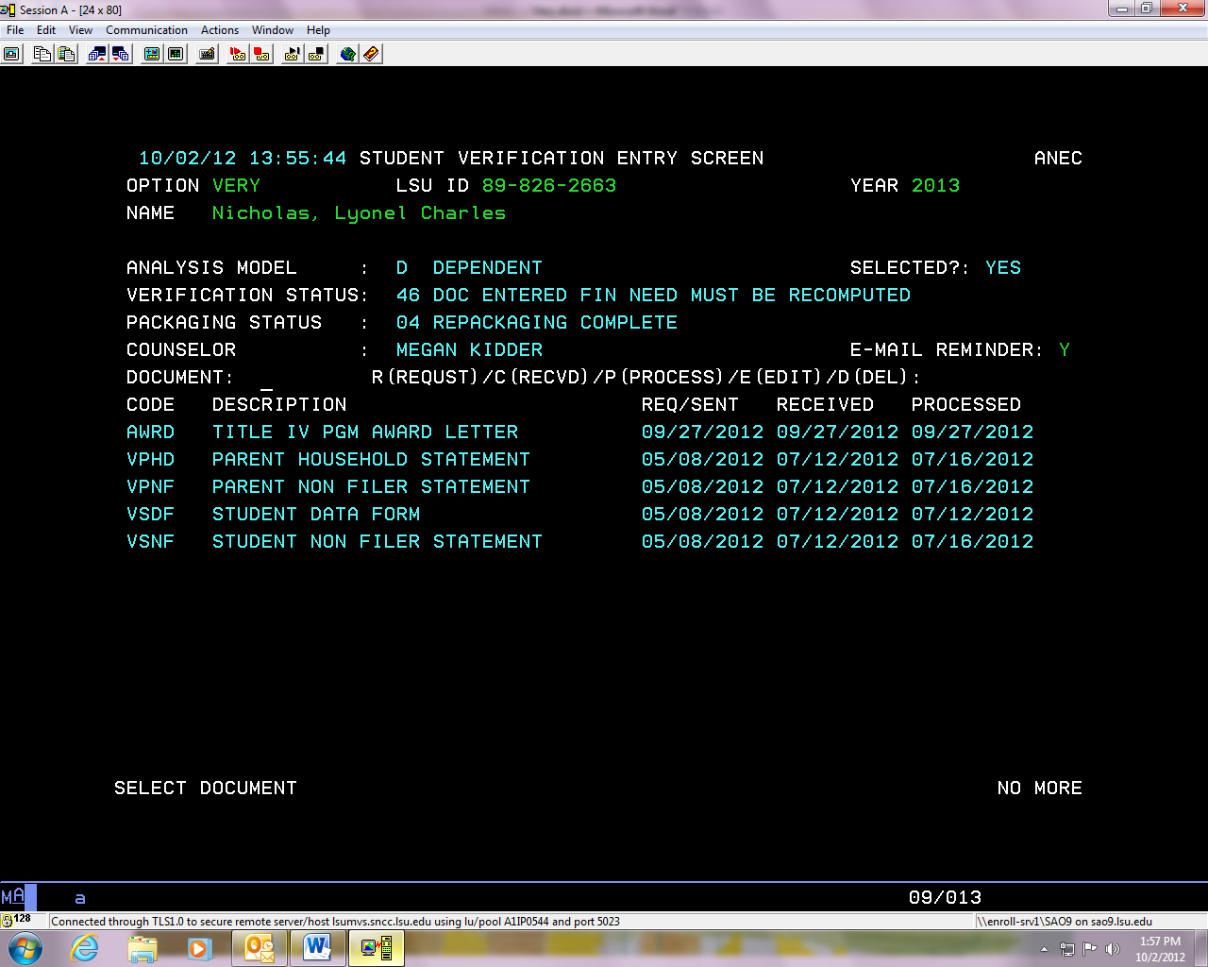
  + All of the above student’s documents have been received and processed and the student has been awarded financial aid.
* 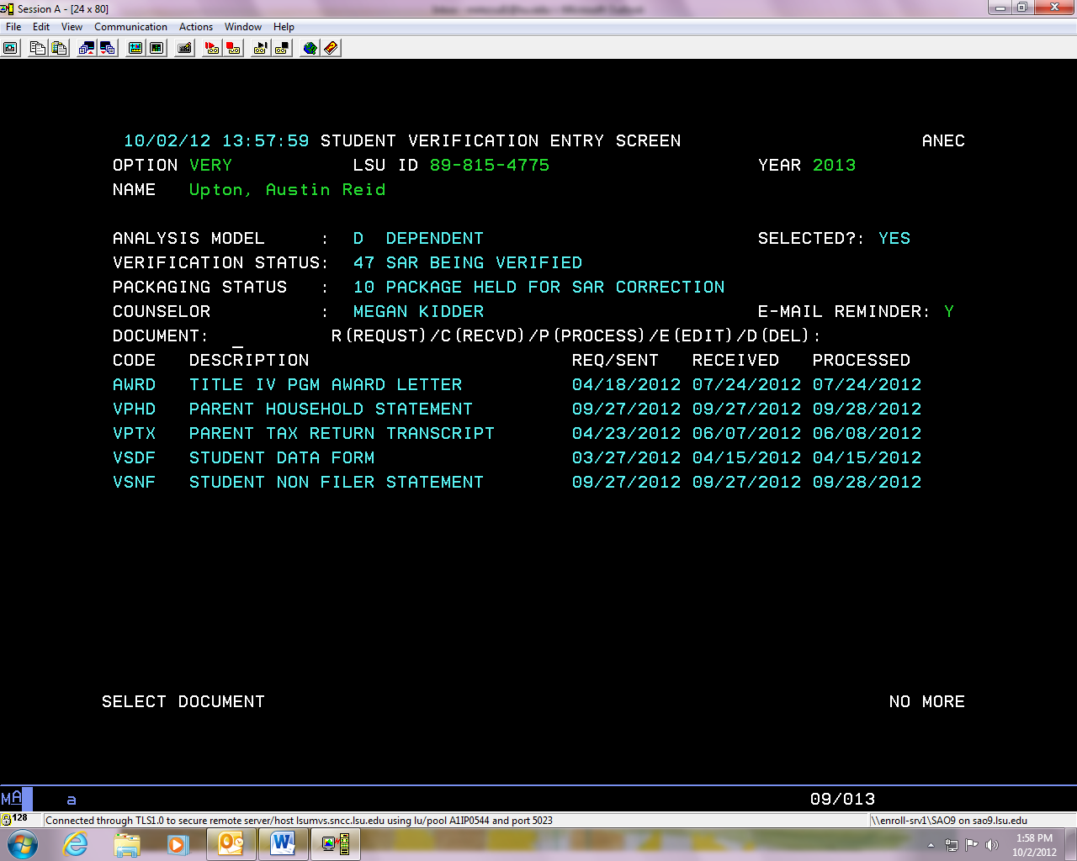
  + All items have been received for the above student but his verification status says that his SAR is being verified. We are making corrections to the students FAFSA based off of the updated information we received for the verification process. The student will receive his award generally about 3-5 business days from the date the last document was processed.
* **Be sure to view ANEC if you see the following on VERY**:
  + If an item has been logged as received more than 7-10 business days and has not been processed.
  + If the REQ/SENT date is different on a specific document from the other REQ/SENT dates.

## Descriptions for MyLSU for 2019-2020

Submission of the following documents is required for processing eligibility for Pelican Promise, Federal Grants, Work Study, Loans and any state need-based aid (i.e., LA Go Grant). These documents are NOT required if you completed the FAFSA for TOPS purposes only. Documents will be logged as received within 1-2 business days and processed within 7-10 business days.

**VCIT**

Please submit proof of your U.S. citizenship. A copy of your birth certificate, U.S. passport, or Certificate of Naturalization is acceptable.

If you have any questions, you can e-mail the Office of Enrollment Management at [financialaid@lsu.edu](mailto:financialaid@lsu.edu) or you may contact the office at (225) 578-3103.

**VDFR**

A Duplicate FAFSA Verification Form has been emailed to you. Please complete and return the form to the Office of Enrollment Management as soon as possible. No further processing of your application will occur until the information is received.

If you have any questions, you can e-mail the Office of Enrollment Management at [financialaid@lsu.edu](mailto:financialaid@lsu.edu) or you may contact the office at (225) 578-3103.

**VDRL**

Please submit a photocopy of your driver's license or a copy of your birth certificate.

If you have any questions, you can e-mail the Office of Enrollment Management at [financialaid@lsu.edu](mailto:financialaid@lsu.edu) or you may contact the office at (225) 578-3103.

**VDHS**

Our office is currently verifying your eligible non-citizen status with the Department of Homeland Security. Once a response has been received from DHS, your account will be updated.

If you have any questions, you can e-mail the Office of Enrollment Management at [financialaid@lsu.edu](mailto:financialaid@lsu.edu) or you may contact the office at (225) 578-3103.

**VEMI**

Please submit a photocopy of the court’s decision indicating you are an emancipated minor, are in a legal guardianship, or received a decision of either before you reached the age of being an adult in your state. The court must be located in your state of legal residence at the time the court’s decision was issued.

If you have any questions, you can e-mail the Office of Enrollment Management at [financialaid@lsu.edu](mailto:financialaid@lsu.edu) or you may contact the office at (225) 578-3103.

**VFAE**

Please submit a copy of your Father’s 20XX IRS Form 4868 “Application for Automatic Extension of Time to File U.S. Individual Income Tax Return”.

If you have any questions, you can e-mail the Office of Enrollment Management at [financialaid@lsu.edu](mailto:financialaid@lsu.edu) or you may contact the office at (225) 578-3103.

**VHLY**

Please provide documentation from the individual who declared you an unaccompanied youth who was homeless or at risk of being homeless.

If you have any questions, you can e-mail the Office of Enrollment Management at [financialaid@lsu.edu](mailto:financialaid@lsu.edu) or you may contact the office at (225) 578-3103.

**VISS**

A Verification of Student Status form has been emailed to you. Please complete and return the form to the Office of Enrollment Management soon as possible. No further processing of your application will occur until the information is received.

If you have any questions, you can e-mail the Office of Enrollment Management at [financialaid@lsu.edu](mailto:financialaid@lsu.edu) or you may contact the office at (225) 578-3103.

**VMAE**

Please submit a copy of your Mother’s 20XX IRS Form 4868 “Application for Automatic Extension of Time to File U.S. Individual Income Tax Return”.

If you have any questions, you can e-mail the Office of Enrollment Management at [financialaid@lsu.edu](mailto:financialaid@lsu.edu) or you may contact the office at (225) 578-3103.

**VMRL**

Please submit documentation of your marital status. Acceptable documentation includes a marriage license or divorce decree.

If you have any questions, you can e-mail the Office of Enrollment Management at [financialaid@lsu.edu](mailto:financialaid@lsu.edu) or you may contact the office at (225) 578-3103.

**VORP**

Please submit court documentation to verify your placement in foster care or status as a ward of the court, as well as a copy of your birth certificate. If you are an orphan, you should submit a copy of both parents’ death certificates, as well as a copy of your birth certificate.

If you have any questions, you can e-mail the Office of Enrollment Management at [financialaid@lsu.edu](mailto:financialaid@lsu.edu) or you may contact the office at (225) 578-3103.

**VPAE**

Please submit a copy of your Parent’s 20XX IRS Form 4868 “Application for Automatic Extension of Time to File U.S. Individual Income Tax Return”.

If you have any questions, you can e-mail the Office of Enrollment Management at [financialaid@lsu.edu](mailto:financialaid@lsu.edu) or you may contact the office at (225) 578-3103.

**VPCI**

Please submit proof of your parent’s U.S. citizenship. A copy of a birth certificate, U.S. passport, or Certificate of Naturalization is acceptable.

If you have any questions, you can e-mail the Office of Enrollment Management at [financialaid@lsu.edu](mailto:financialaid@lsu.edu) or you may contact the office at (225) 578-3103.

**VPDL**

Please submit a photocopy of your mother and/or father’s driver's license.

If you have any questions, you can e-mail the Office of Enrollment Management at [financialaid@lsu.edu](mailto:financialaid@lsu.edu) or you may contact the office at (225) 578-3103.

**VPMS**

Please submit documentation of your parent’s marital status. Acceptable documentation includes a marriage license or divorce decree.

If you have any questions, you can e-mail the Office of Enrollment Management at [financialaid@lsu.edu](mailto:financialaid@lsu.edu) or you may contact the office at (225) 578-3103.

**VPSC**

Please submit a photocopy of your mother and/or father’s social security card.

If you have any questions, you can e-mail the Office of Enrollment Management at [financialaid@lsu.edu](mailto:financialaid@lsu.edu) or you may contact the office at (225) 578-3103.

**VRES**

Please submit a photocopy (both front and back) of your immigration card. Examples of acceptable immigration cards include I-551, I94A, or I-94. Your eligibility for federal financial aid will not be determined until you have submitted proper immigration status documents.

If you have any questions, you can e-mail the Office of Enrollment Management at [financialaid@lsu.edu](mailto:financialaid@lsu.edu) or you may contact the office at (225) 578-3103.

**VSAE**

Please submit a copy of your 20XX IRS Form 4868 “Application for Automatic Extension of Time to File U.S. Individual Income Tax Return”.

If you have any questions, you can e-mail the Office of Enrollment Management at [financialaid@lsu.edu](mailto:financialaid@lsu.edu) or you may contact the office at (225) 578-3103.

**VSPA**

Please submit a copy of your Spouse’s 20XX IRS Form 4868 “Application for Automatic Extension of Time to File U.S. Individual Income Tax Return”.

If you have any questions, you can e-mail the Office of Enrollment Management at [financialaid@lsu.edu](mailto:financialaid@lsu.edu) or you may contact the office at (225) 578-3103.

**VSSN**

Please submit a photocopy of your social security card.

If you have any questions, you can e-mail the Office of Enrollment Management at [financialaid@lsu.edu](mailto:financialaid@lsu.edu) or you may contact the office at (225) 578-3103.

**VSSR**

Please submit a copy of your selective service registration. A copy of your registration card will be acceptable or you may go to [www.sss.gov](http://www.sss.gov)to obtain verification of your registration. If you have not have not registered with selective service, and are not exempt from registering, please go to [www.sss.gov](http://www.sss.gov) to request a status information letter to submit in place of your registration card.

If you have any questions, you can e-mail the Office of Enrollment Management at [financialaid@lsu.edu](mailto:financialaid@lsu.edu) or you may contact the office at (225) 578-3103.

**VVET**

Please submit a photocopy of your DD-214 (Veterans' discharge papers) indicating a discharge status other than dishonorable.

If you have any questions, you can e-mail the Office of Enrollment Management at [financialaid@lsu.edu](mailto:financialaid@lsu.edu) or you may contact the office at (225) 578-3103.

**VW2P**

Please submit copies of all 20XX W-2 and 1099 forms received by your father and/or mother.

If you have any questions, you can e-mail the Office of Enrollment Management at [financialaid@lsu.edu](mailto:financialaid@lsu.edu) or you may contact the office at (225) 578-3103.

**VW2F**

Please submit copies of all 20XX W-2 and 1099 forms received by your father.

If you have any questions, you can e-mail the Office of Enrollment Management at [financialaid@lsu.edu](mailto:financialaid@lsu.edu) or you may contact the office at (225) 578-3103.

**VW2M**

Please submit copies of all 20XX W-2 and 1099 forms received by your mother.

If you have any questions, you can e-mail the Office of Enrollment Management at [financialaid@lsu.edu](mailto:financialaid@lsu.edu) or you may contact the office at (225) 578-3103.

**VW2S**

Please submit copies of all 20XX W-2 and 1099 forms received by you.

If you have any questions, you can e-mail the Office of Enrollment Management at [financialaid@lsu.edu](mailto:financialaid@lsu.edu) or you may contact the office at (225) 578-3103.

**VWSP**

Please submit copies of all 20XX W-2 and 1099 forms received by your spouse.

If you have any questions, you can e-mail the Office of Enrollment Management at [financialaid@lsu.edu](mailto:financialaid@lsu.edu) or you may contact the office at (225) 578-3103.

**VSDF**

Can be completed online.

**VAST, VMAD, VNMS, VPHD, VPNF, VPTE, VPTX, VSAI, VSDP, VSHD, VSNF, VSTE, VSTX, VWRK, VPCS, VSCS, VPFS, VSFS, VPFI, VMFI, VFFI, VSFI, VSPI, VMTX, VFTX, VMNF, VFNF, VSPX, VSPF, VMTE, VFTE, VSPE, VSCP, VSSC, VSCF, VSCM, VSPC,**

Can be printed from MyLSU.

**VMIS**

Will not be available to students. Internal form only. Should not be viewing on PAWS.

## Descriptions for MyLSU 2019-2020

Submission of the following documents is required for processing eligibility for Pelican Promise, Federal Grants, Work Study, Loans and any state need-based aid (i.e., LA tops

). These documents are NOT required if you completed the FAFSA for TOPS purposes only. Documents will be logged as received within 1-2 business days. Documents will be processed within 7-10 business days once all documents are received.

**VASP**

Please submit a signed copy of your Spouse’s IRS Form 1040X “Amended U.S. Individual Income Tax Return”.

If you have any questions, you can e-mail the Office of Enrollment Management at [financialaid@lsu.edu](mailto:financialaid@lsu.edu) or you may contact the office at (225) 578-3103.

**VCIT**

Please submit proof of your U.S. citizenship. A copy of your birth certificate, U.S. passport, or Certificate of Naturalization is acceptable.

If you have any questions, you can e-mail the Office of Enrollment Management at [financialaid@lsu.edu](mailto:financialaid@lsu.edu) or you may contact the office at (225) 578-3103.

**VDFR**

A Duplicate FAFSA Verification Form has been emailed to you. Please complete and return the form to the Office of Enrollment Management as soon as possible. No further processing of your application will occur until the information is received.

If you have any questions, you can e-mail the Office of Undergraduate Admissions and Student Aid at [financialaid@lsu.edu](mailto:financialaid@lsu.edu) or you may contact the office at (225) 578-3103.

**VDRL**

Please submit a photocopy of your driver's license or a copy of your birth certificate.

If you have any questions, you can e-mail the Office of Enrollment Management at [financialaid@lsu.edu](mailto:financialaid@lsu.edu) or you may contact the office at (225) 578-3103.

**VDHS**

Our office is currently verifying your eligible non-citizen status with the Department of Homeland Security. Once a response has been received from DHS, your account will be updated.

If you have any questions, you can e-mail the Office of Enrollment Management at [financialaid@lsu.edu](mailto:financialaid@lsu.edu) or you may contact the office at (225) 578-3103.

**VEMI**

Please submit a photocopy of the court’s decision indicating you are an emancipated minor, are in a legal guardianship, or received a decision of either before you reached the age of being an adult in your state. The court must be located in your state of legal residence at the time the court’s decision was issued.

If you have any questions, you can e-mail the Office of Enrollment Management at [financialaid@lsu.edu](mailto:financialaid@lsu.edu) or you may contact the office at (225) 578-3103.

**VFAE**

Please submit a copy of your Father’s IRS Form 4868 “Application for Automatic Extension of Time to File U.S. Individual Income Tax Return”.

If you have any questions, you can e-mail the Office of Enrollment Management at [financialaid@lsu.edu](mailto:financialaid@lsu.edu) or you may contact the office at (225) 578-3103.

**VFAX**

Please submit a signed copy of your Father’s IRS Form 1040X “Amended U.S. Individual Income Tax Return”.

If you have any questions, you can e-mail the Office of Enrollment Management at [financialaid@lsu.edu](mailto:financialaid@lsu.edu) or you may contact the office at (225) 578-3103.

**VHLY**

Please provide documentation from the individual who declared you an unaccompanied youth who was homeless or at risk of being homeless.

If you have any questions, you can e-mail the Office of Enrollment Management at [financialaid@lsu.edu](mailto:financialaid@lsu.edu) or you may contact the office at (225) 578-3103.

**VISS**

A Verification of Student Status form has been emailed to you. Please complete and return the form to the Office of Enrollment Management soon as possible. No further processing of your application will occur until the information is received.

If you have any questions, you can e-mail the Office of Enrollment Management at [financialaid@lsu.edu](mailto:financialaid@lsu.edu) or you may contact the office at (225) 578-3103.

**VMAE**

Please submit a copy of your Mother’s IRS Form 4868 “Application for Automatic Extension of Time to File U.S. Individual Income Tax Return”.

If you have any questions, you can e-mail the Office of Enrollment Management at [financialaid@lsu.edu](mailto:financialaid@lsu.edu) or you may contact the office at (225) 578-3103.

**VMAX**

Please submit a signed copy of your Mother’s IRS Form 1040X “Amended U.S. Individual Income Tax Return”.

If you have any questions, you can e-mail the Office of Enrollment Management at [financialaid@lsu.edu](mailto:financialaid@lsu.edu) or you may contact the office at (225) 578-3103.

**VMRL**

Please submit documentation of your marital status. Acceptable documentation includes a marriage license or divorce decree.

If you have any questions, you can e-mail the Office of Enrollment Management at [financialaid@lsu.edu](mailto:financialaid@lsu.edu) or you may contact the office at (225) 578-3103.

**VORP**

Please submit court documentation to verify your placement in foster care or status as a ward of the court, as well as a copy of your birth certificate. If you are an orphan, you should submit a copy of both parents’ death certificates, as well as a copy of your birth certificate.

If you have any questions, you can e-mail the Office of Enrollment Management at [financialaid@lsu.edu](mailto:financialaid@lsu.edu) or you may contact the office at (225) 578-3103.

**VPAE**

Please submit a copy of your Parent’s IRS Form 4868 “Application for Automatic Extension of Time to File U.S. Individual Income Tax Return”.

If you have any questions, you can e-mail the Office of Enrollment Management at [financialaid@lsu.edu](mailto:financialaid@lsu.edu) or you may contact the office at (225) 578-3103.

**VPAX**

Please submit a signed copy of your Parent’s IRS Form 1040X “Amended U.S. Individual Income Tax Return”.

If you have any questions, you can e-mail the Office of Enrollment Management at [financialaid@lsu.edu](mailto:financialaid@lsu.edu) or you may contact the office at (225) 578-3103.

**VPCI**

Please submit proof of your parent’s U.S. citizenship. A copy of a birth certificate, U.S. passport, or Certificate of Naturalization is acceptable.

If you have any questions, you can e-mail the Office of Enrollment Management at [financialaid@lsu.edu](mailto:financialaid@lsu.edu) or you may contact the office at (225) 578-3103.

**VPDL**

Please submit a photocopy of your mother and/or father’s driver's license.

If you have any questions, you can e-mail the Office of Enrollment Management at [financialaid@lsu.edu](mailto:financialaid@lsu.edu) or you may contact the office at (225) 578-3103.

**VPMS**

Please submit documentation of your parent’s marital status. Acceptable documentation includes a marriage license or divorce decree.

If you have any questions, you can e-mail the Office of Enrollment Management at [financialaid@lsu.edu](mailto:financialaid@lsu.edu) or you may contact the office at (225) 578-3103.

**VPSC**

Please submit a photocopy of your mother and/or father’s social security card.

If you have any questions, you can e-mail the Office of Enrollment Management at [financialaid@lsu.edu](mailto:financialaid@lsu.edu) or you may contact the office at (225) 578-3103.

**VRES**

Please submit a photocopy (both front and back) of your immigration card. Examples of acceptable immigration cards include I-551, I94A, or I-94. Your eligibility for federal financial aid will not be determined until you have submitted proper immigration status documents.

If you have any questions, you can e-mail the Office of Enrollment Management at [financialaid@lsu.edu](mailto:financialaid@lsu.edu) or you may contact the office at (225) 578-3103.

**VSAE**

Please submit a copy of your IRS Form 4868 “Application for Automatic Extension of Time to File U.S. Individual Income Tax Return”.

If you have any questions, you can e-mail the Office of Enrollment Management at [financialaid@lsu.edu](mailto:financialaid@lsu.edu) or you may contact the office at (225) 578-3103.

**VSAX**

Please submit a signed copy of your IRS Form 1040X “Amended U.S. Individual Income Tax Return”.

If you have any questions, you can e-mail the Office of Enrollment Management at [financialaid@lsu.edu](mailto:financialaid@lsu.edu) or you may contact the office at (225) 578-3103.

**VSEP**

Our office is required to obtain proof of identity and statement of educational purposes for students selected for verification by the Department of Education.

If you are able to appear in person, please bring form provided in the link to 1146 Pleasant Hall. Identity and Statement of Educational Purposes in Person (link to form)

If you are unable to appear in person, please complete the form provided in the link with a Notary. Identity and Statement of Educational Purposes Signed with Notary (link to form) Once complete, please mail the **original** to :

Office of Enrollment Management

1146 Pleasant Hall

Baton Rouge, LA 70803

**VSPA**

Please submit a copy of your Spouse’s IRS Form 4868 “Application for Automatic Extension of Time to File U.S. Individual Income Tax Return”.

If you have any questions, you can e-mail the Office of Enrollment Management at [financialaid@lsu.edu](mailto:financialaid@lsu.edu) or you may contact the office at (225) 578-3103.

**VSSN**

Please submit a photocopy of your social security card.

If you have any questions, you can e-mail the Office of Enrollment Management at [financialaid@lsu.edu](mailto:financialaid@lsu.edu) or you may contact the office at (225) 578-3103.

**VSSR**

Please submit a copy of your selective service registration. A copy of your registration card will be acceptable or you may go to [www.sss.gov](http://www.sss.gov)to obtain verification of your registration. If you have not have not registered with selective service, and are not exempt from registering, please go to [www.sss.gov](http://www.sss.gov) to request a status information letter to submit in place of your registration card.

If you have any questions, you can e-mail the Office of Enrollment Management at [financialaid@lsu.edu](mailto:financialaid@lsu.edu) or you may contact the office at (225) 578-3103.

**VVET**

Please submit a photocopy of your DD-214 (Veterans' discharge papers) indicating a discharge status other than dishonorable.

If you have any questions, you can e-mail the Office of Enrollment Management at [financialaid@lsu.edu](mailto:financialaid@lsu.edu) or you may contact the office at (225) 578-3103.

**VW2P**

Please submit copies of all 20XX W-2 and 1099 forms received by your father and/or mother.

If you have any questions, you can e-mail the Office of Enrollment Management at [financialaid@lsu.edu](mailto:financialaid@lsu.edu) or you may contact the office at (225) 578-3103.

**VW2F**

Please submit copies of all 20XX W-2 and 1099 forms received by your father.

If you have any questions, you can e-mail the Office of Enrollment Management at [financialaid@lsu.edu](mailto:financialaid@lsu.edu) or you may contact the office at (225) 578-3103.

**VW2M**

Please submit copies of all 20XX W-2 and 1099 forms received by your mother.

If you have any questions, you can e-mail the Office of Enrollment Management at [financialaid@lsu.edu](mailto:financialaid@lsu.edu) or you may contact the office at (225) 578-3103.

**VW2S**

Please submit copies of all 20XX W-2 and 1099 forms received by you and/or your spouse.

If you have any questions, you can e-mail the Office of Enrollment Management at [financialaid@lsu.edu](mailto:financialaid@lsu.edu) or you may contact the office at (225) 578-3103.

**VWSP**

Please submit copies of all 20XX W-2 and 1099 forms received by your spouse.

If you have any questions, you can e-mail the Office of Enrollment Management at [financialaid@lsu.edu](mailto:financialaid@lsu.edu) or you may contact the office at (225) 578-3103.

**VSDF**

Can be completed online.

**VSDM**

Can be completed online.

## Sample Verification Documents

* All verification documents can be found on the financial aid website:
* <https://www.lsu.edu/financialaid/apply_for_aid/verification/2019-20_verification_forms.php>

# Screens

## ANEC

* + Any notes about the students account will be located on this screen. For example, any issues with the students verification documents.

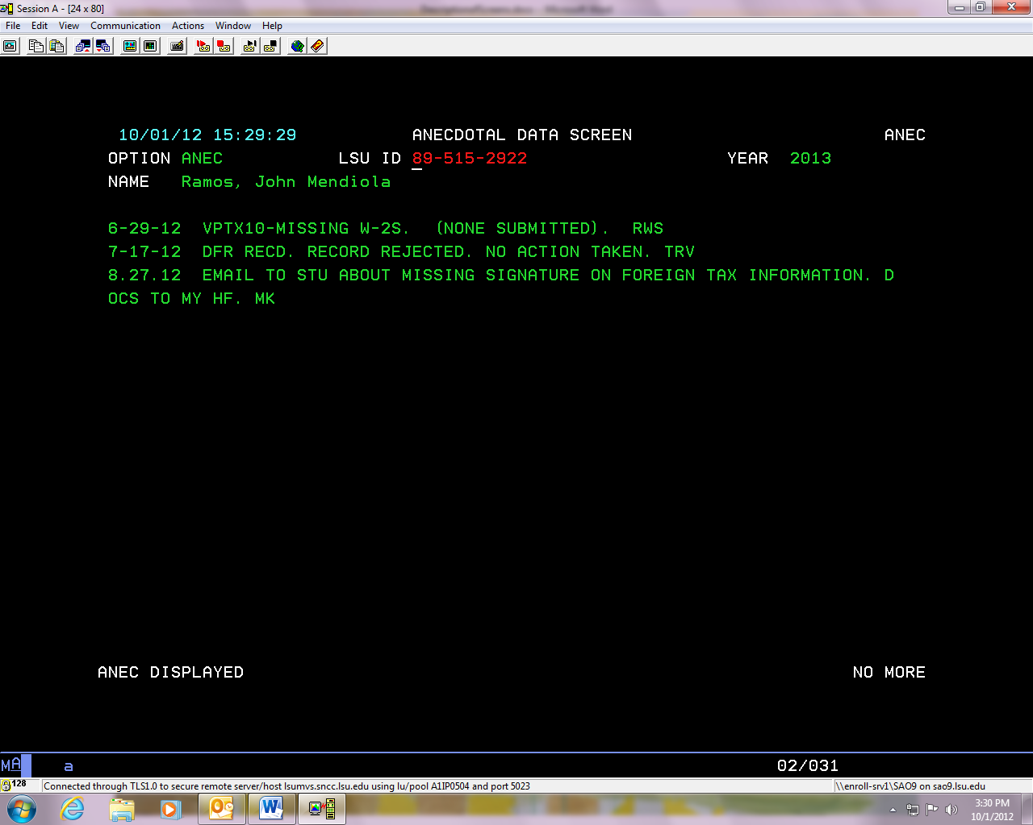

## AWRD

* + On this screen you can view every award the student has received so far this year.

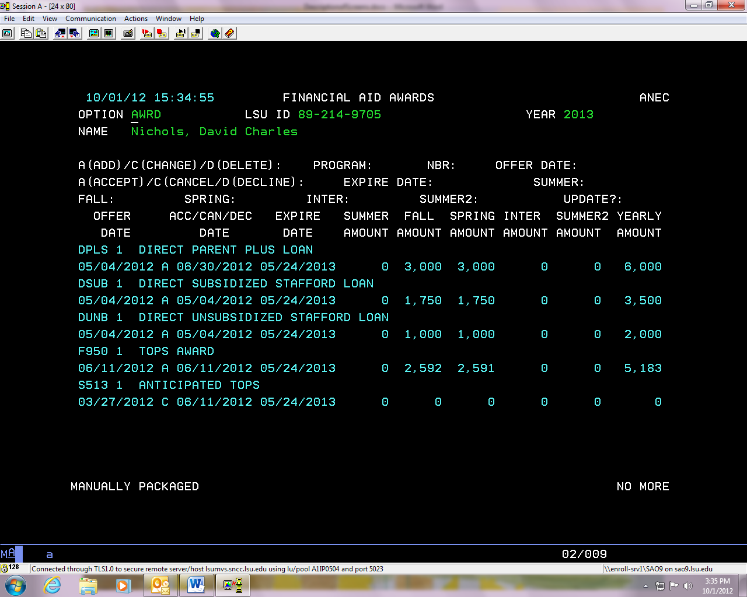

Be sure check the expiration date on scholarships, to see that they are still current.

You can view if the student has accepted or declined an award. A= Accepted, D= Declined

## BDGT

* 1. This is the budget we use to calculate the amount of aid a student can receive.
  2. The COA or cost of attendance is listed on this page: the estimated total amount it will cost to attend Louisiana State University. It is determined by Financial Aid using rules established by the U.S. Congress. It is based on average costs incurred by students. Amounts are included for tuition, room/board, books, travel, and personal miscellaneous expenses. (Under TOTAL)
  + The EFC or expected family contribution- The amount you and/or your parents are expected to contribute toward your educational expenses as determined by a federally-mandated formula, which uses the information you provide on your FAFSA or Renewal FAFSA. Your EFC is used to determine your financial need. **You are not required to contribute this amount, this is a number used to determine the students financial need.**

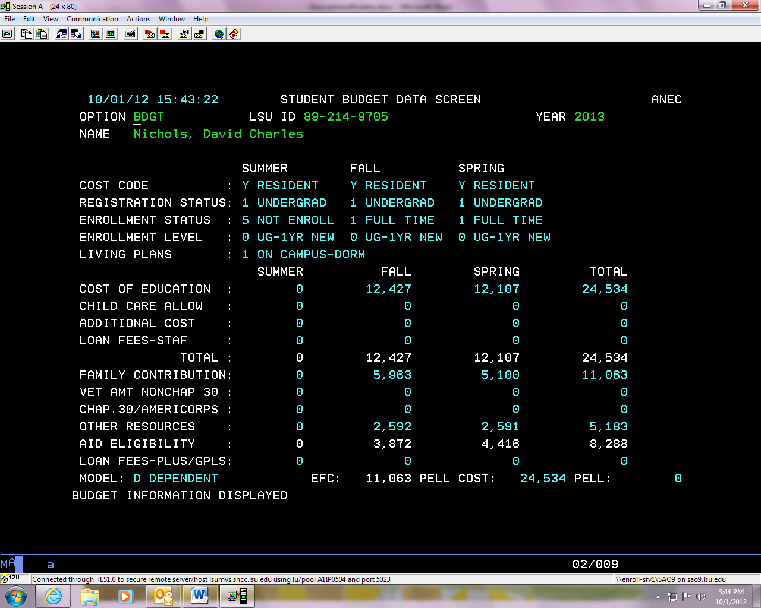

The total cost of attendance for the year. This is the same for every student depending on how they answered their student data form. (This student is UG, full-time, live on campus, and a resident.)

Number we use to calculate the Pell grant. This may differ from the listed year total EFC.

The EFC (estimated family contribution)

## CHCK

* + You can view what money has or has not been disbursed to the student.
  + STAT FLAG for E (electronic) fund types: TR= not crediting, DS= funds have credited, CN= canceled, MS= miscellaneous hold on funds, CR= funds canceled today, RF= returned, OV= funds overed, will credit next business day, IN= student must complete entrance counseling, PR= funds have been added to FAD manually, DY= funds were added the previous day, will credit next business days unless there is a crediting problem.

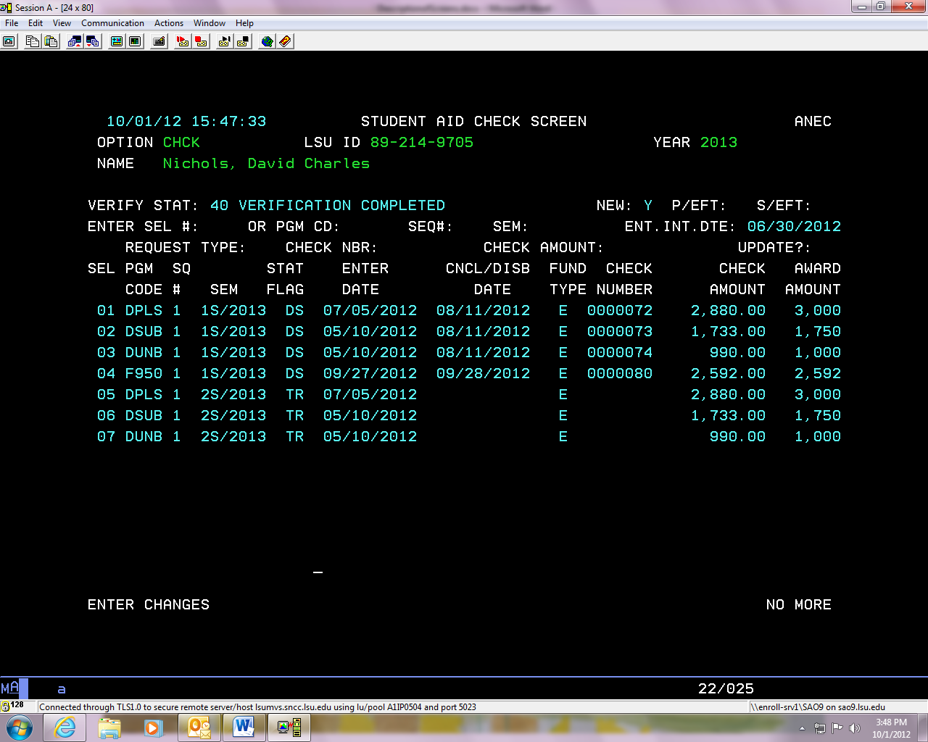

E means these funds will be sent to the university electronically

DS means the funds have credited the students account in the Bursar’s Office.

TR means the funds have not yet credited

* + STAT FLAG for fund type C (paper check): PR: check enter that day, DY: check was entered the previous day, TR: the check is at Office of Bursar Operations to be endorsed and picked up, CN: check is canceled, MS: miscellaneous hold, DS: student has picked checkup, IN: student must complete entrance counseling (may differ).

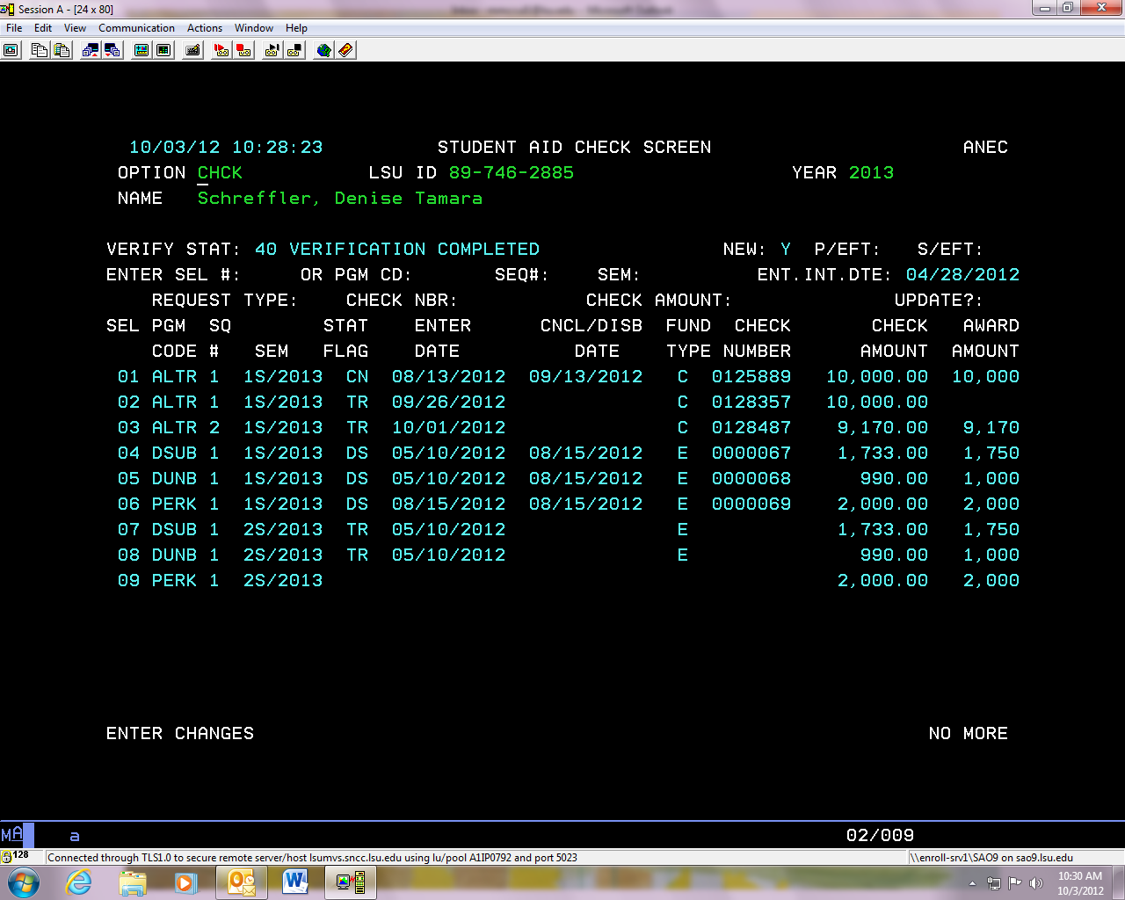

TR when the student is receiving a paper check means that the funds are at the Bursar’s office ready for the student to pick up.

CN means the loan was canceled. DY in this position with a C under fund type means the check will be available for pick up tomorrow.

Since there is no date listed the student has not claimed their funds at the Bursar’s office.

C means these funds are sent to us in a paper check.

## COMM

* + Any errors with the FAFSA will be listed here.
  + Please see the FAFSA section for a code chart of the errors listed.

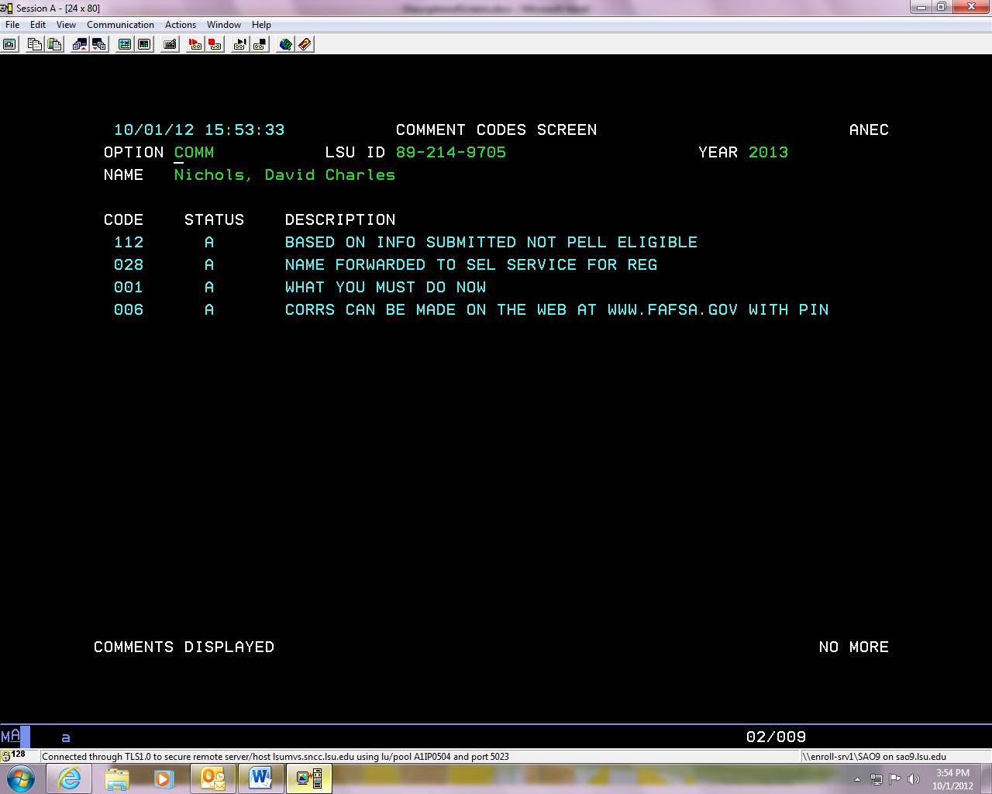

## CORR

* + Any correspondence sent by our computer system will be listed here.

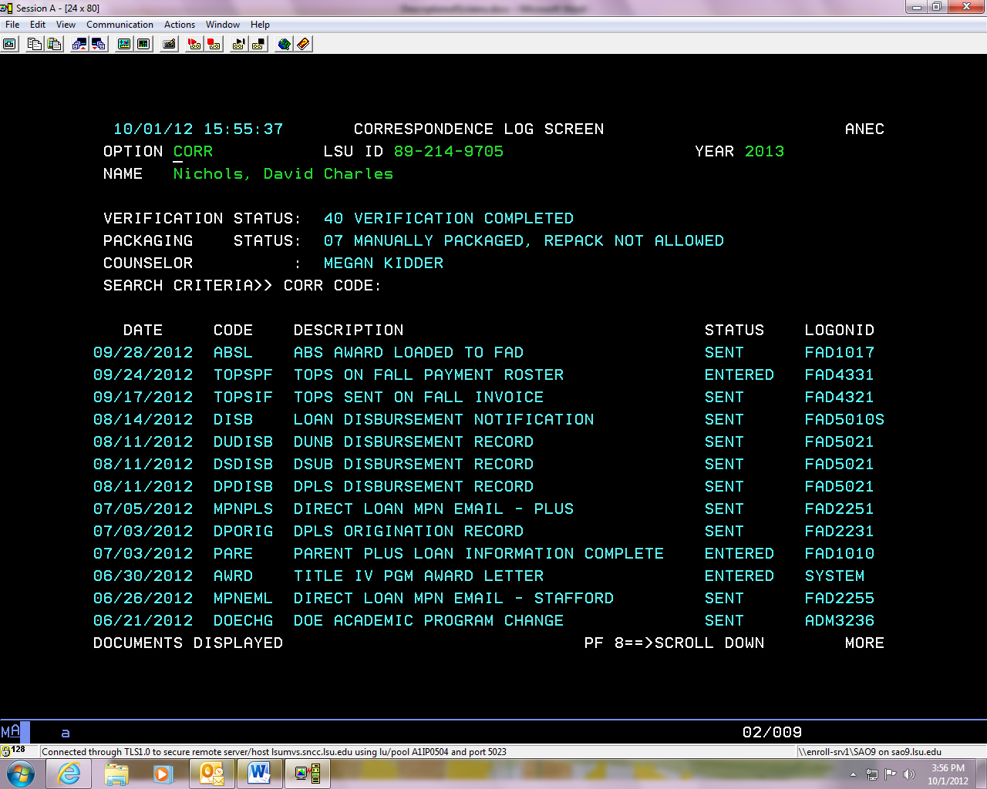

## DEMI

* + This screen can provide you with a lot of information. You can view hours carried for how many hours the student is currently enrolled under carried.
  + You can view if the student has a FAFSA on file by looking in the bottom right hand corner.
  + Classification: 1= freshman, 2= sophomore, 3= Junior, 4= senior.

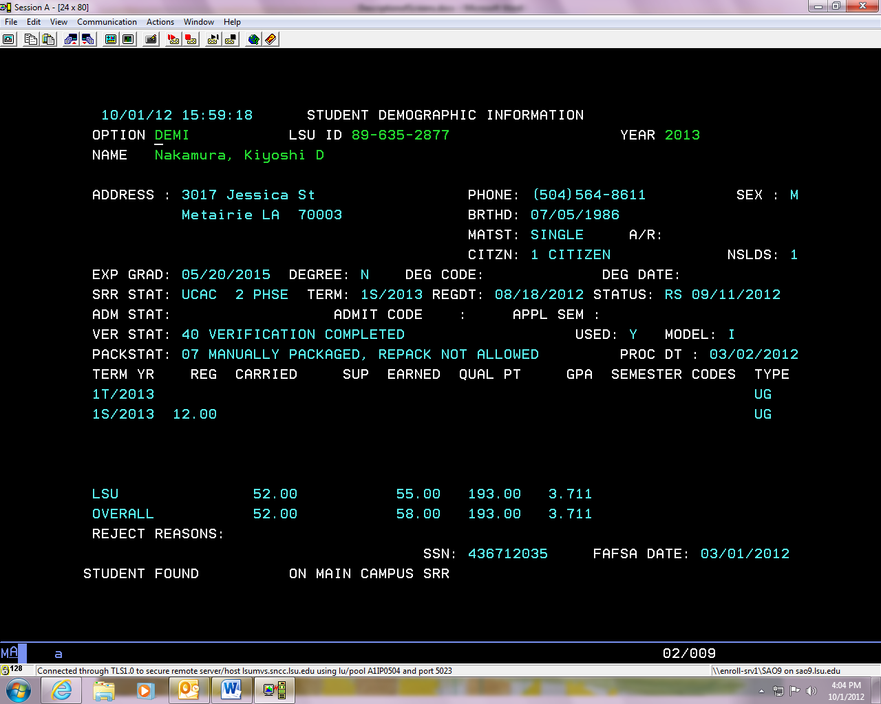

You can view the student’s college and grade classification. *see below

Tells you that student is an Undergraduate. This will say GRAD if student is in graduate school.

This will also let you know if the student needs to complete verification.

## DFLD

* Duplicate FAFSA Load screen…..allows us to view the ISIRS that were loaded.

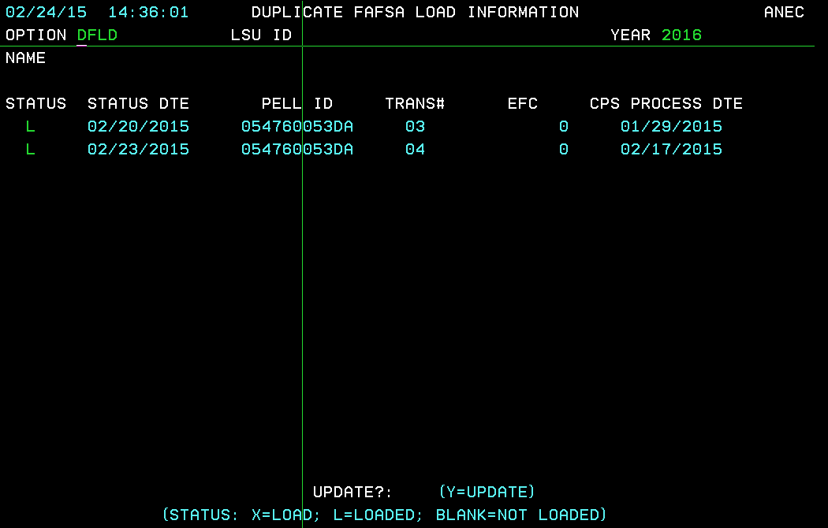

## DLPL

* + The Direct Loans Plus entry screen, if the student has submitted a DGPL or DPLS and the application has been processed this screen will be filled out.
  + For additional information please see the loans section.

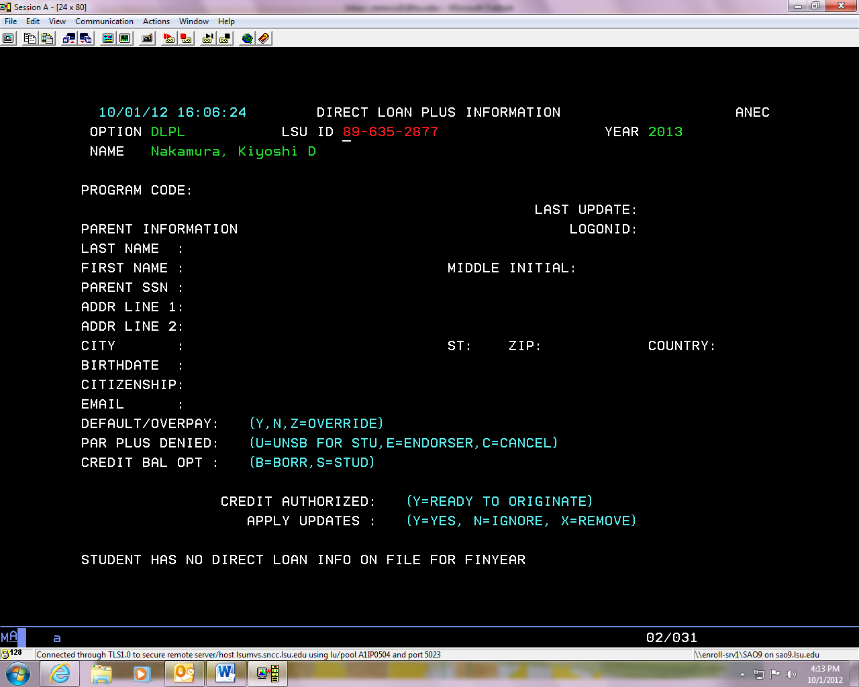

## DRLN

* + This is the direct loan origination and disbursement screen.
  + You can check to see if we have received a loan’s Master Promissory Note and if the loan has been originated with COD. **To view info about a specific loan, be sure it is green next to program code**.

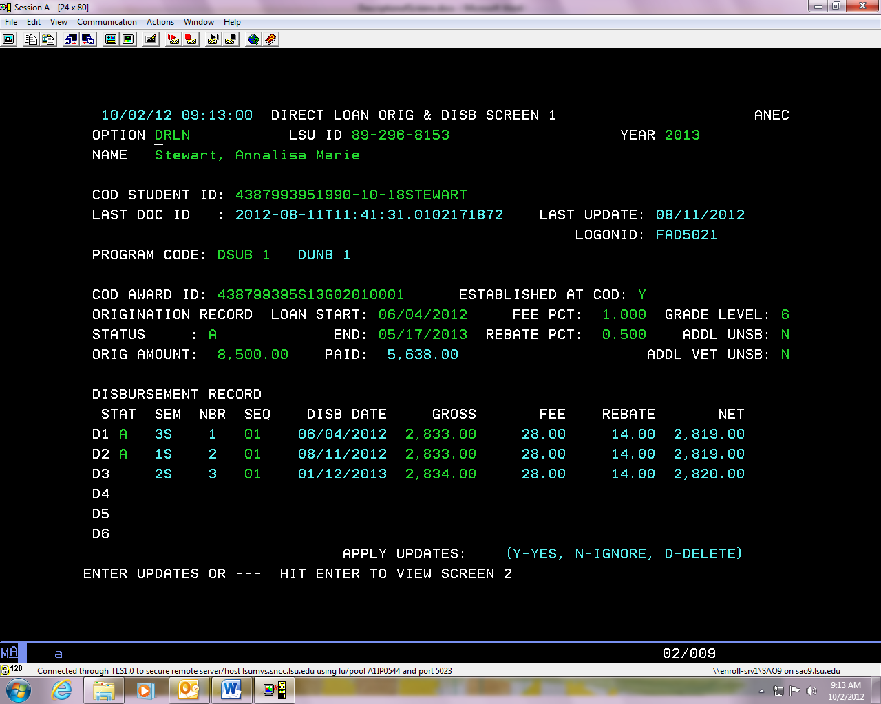

This is the origination status code:

A: accepted, R: Rejected, T: transmitted, X: Will transmit that night

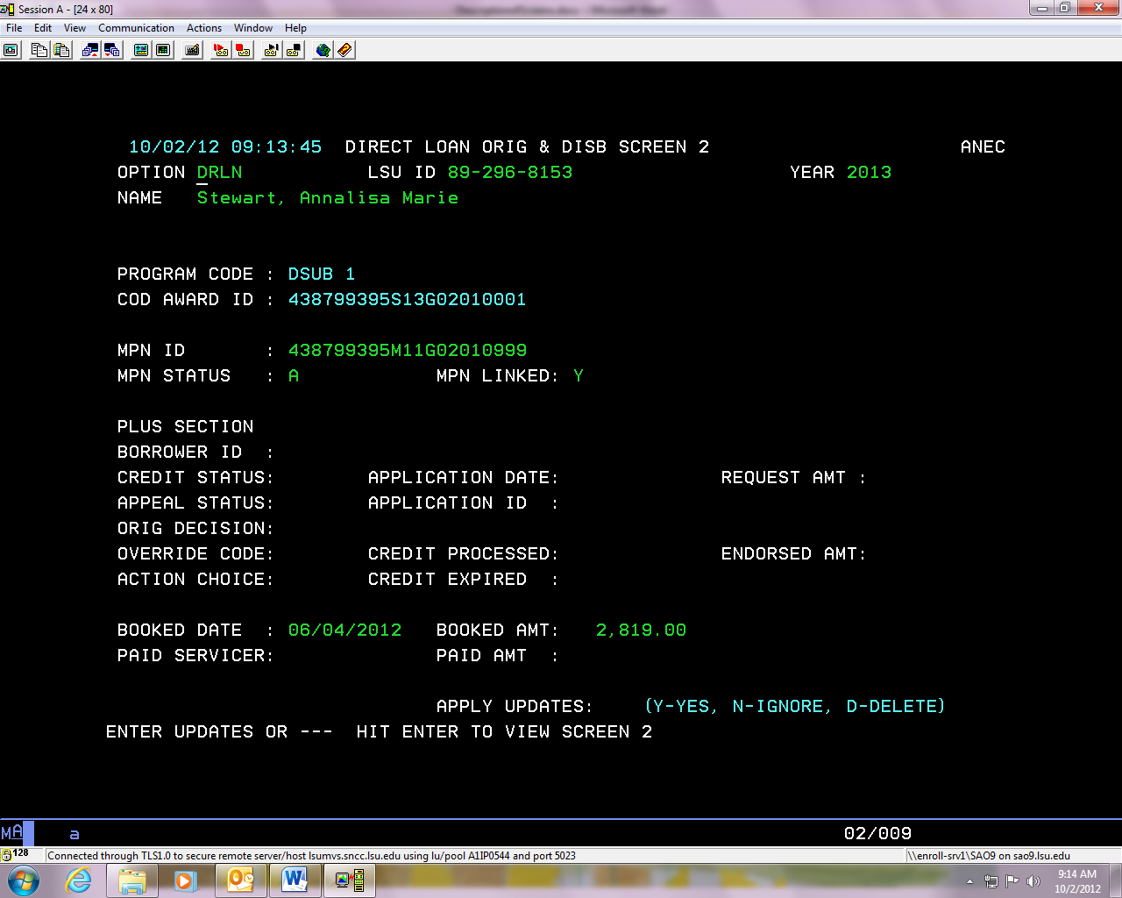

This student’s MPN has been linked with the account; the status is A for accepted. Make sure the loan status on above page is A.

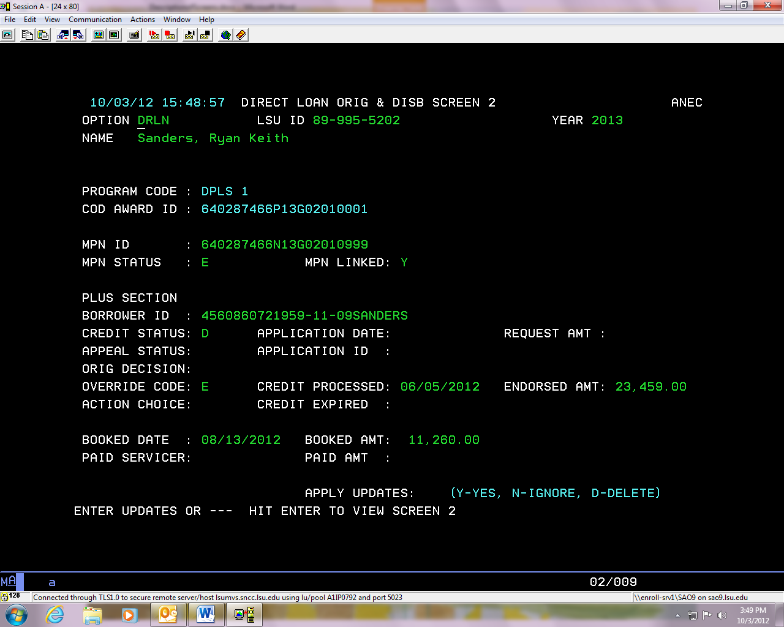

Override Codes for Plus loans:

A: accepted, C: credit overridden as a result of new info, D: credit denied as a result of endorser’s denial, E: credit overridden as a result of endorser’s approval, N: credit denied after pending.

Credit Status Code: A= accepted, D= denied, P= Pending (only for PLUS loans)

This student’s DPLS was denied but the parent added an endorser and the endorser completed the MPN.

## EFCC

* Estimated Family Contribution Calculation screen...allows us to view the elements that went into the calculation of the student’s EFC.

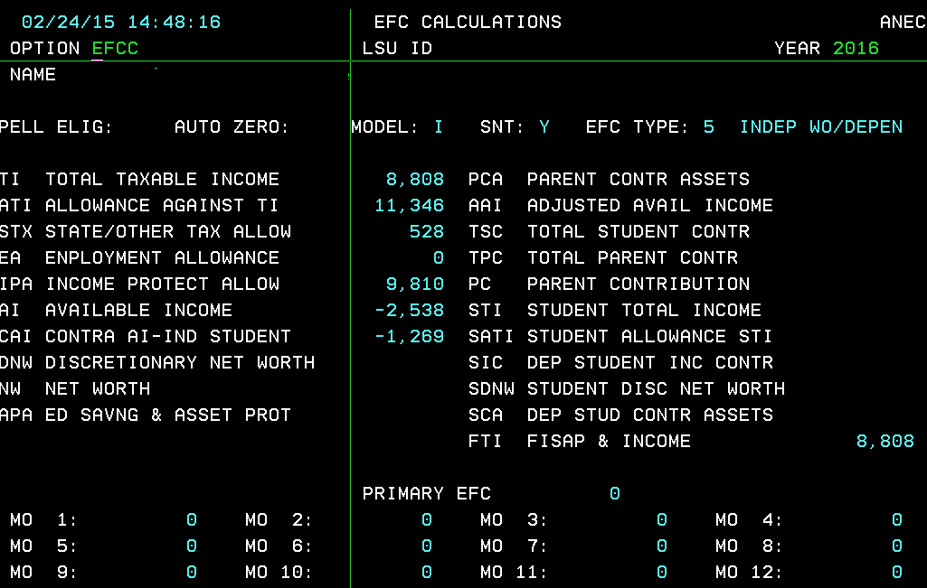

## ISIP

* + This is the parents FAFSA information.
  + For more information see the FAFSA section.



**\*\*\*IMPORTANT REMINDERS!**

* **Only speak to those parents listed on ISIP, Screen 2**
* **DO NOT provide Tax Information/Figures to Student and/or Parent from these screens** 

## ISIS

* + This is the students FAFSA information.
  + For more information see the FAFSA section.







## NSLD

* + This is the National Student Loan Database screen.
  + You can view a student’s total borrowing of subsidized, and unsubsidized loans.
  + You can verify that a student is in default and if they are at their aggregate borrowing limit.

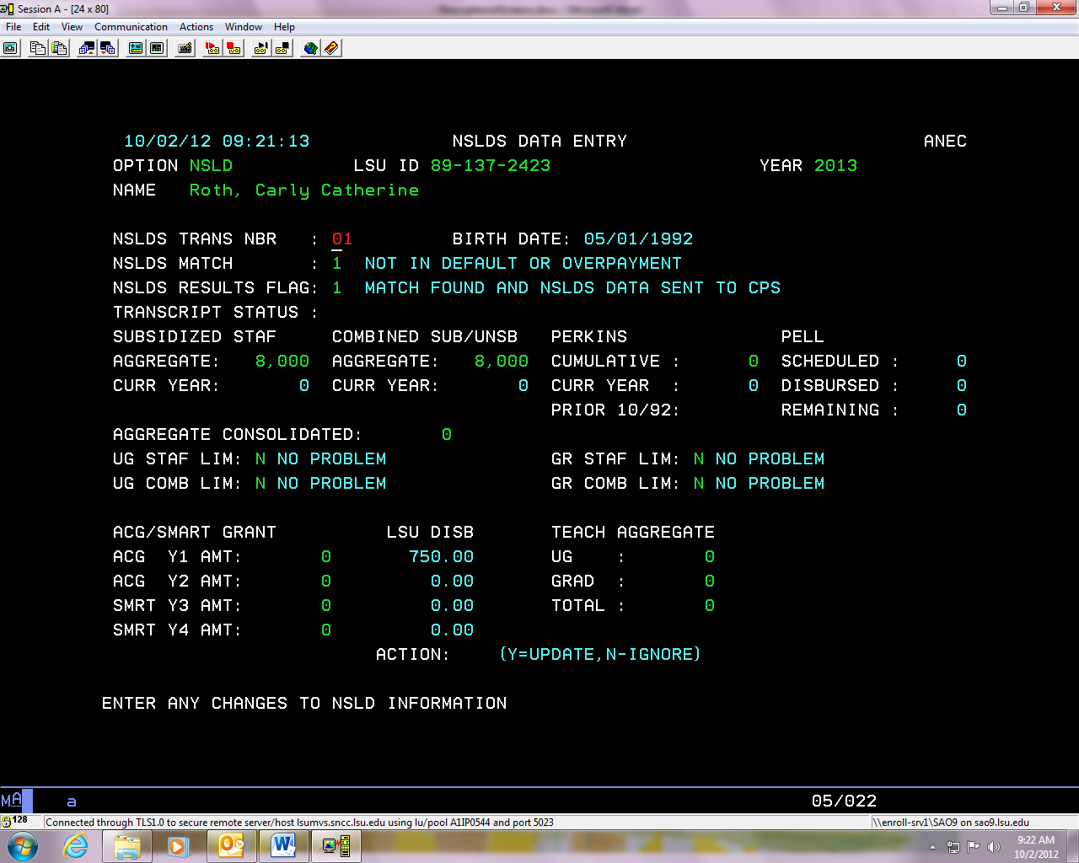

## PACK

* + This is the packaging results. You can view any federal student loans and the Pell grant offered.
  + We will only package a student for summer if they are enrolled in classes at the time they package. Otherwise, assumed enrollment is full time for fall and spring semesters.

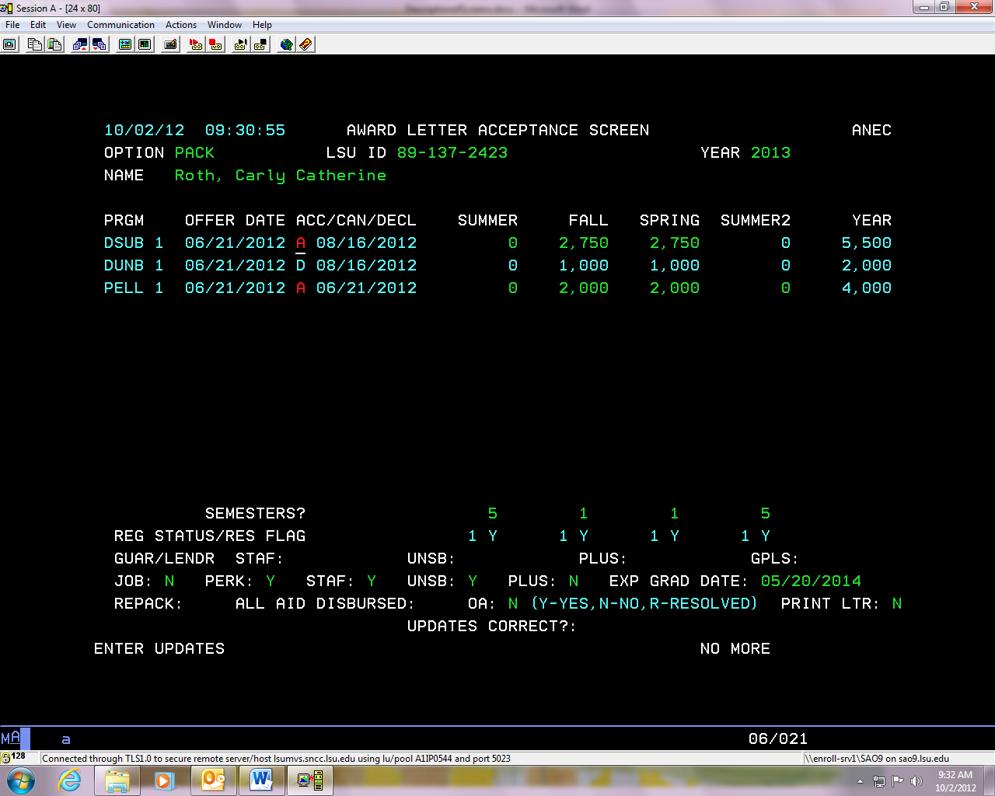

1= full time, 2= ¾ time, 3= ½ time, 4= less than part time, 5= not enrolled, 6= no aid.

## PELL

* + All Pell grant information can be found on this screen.

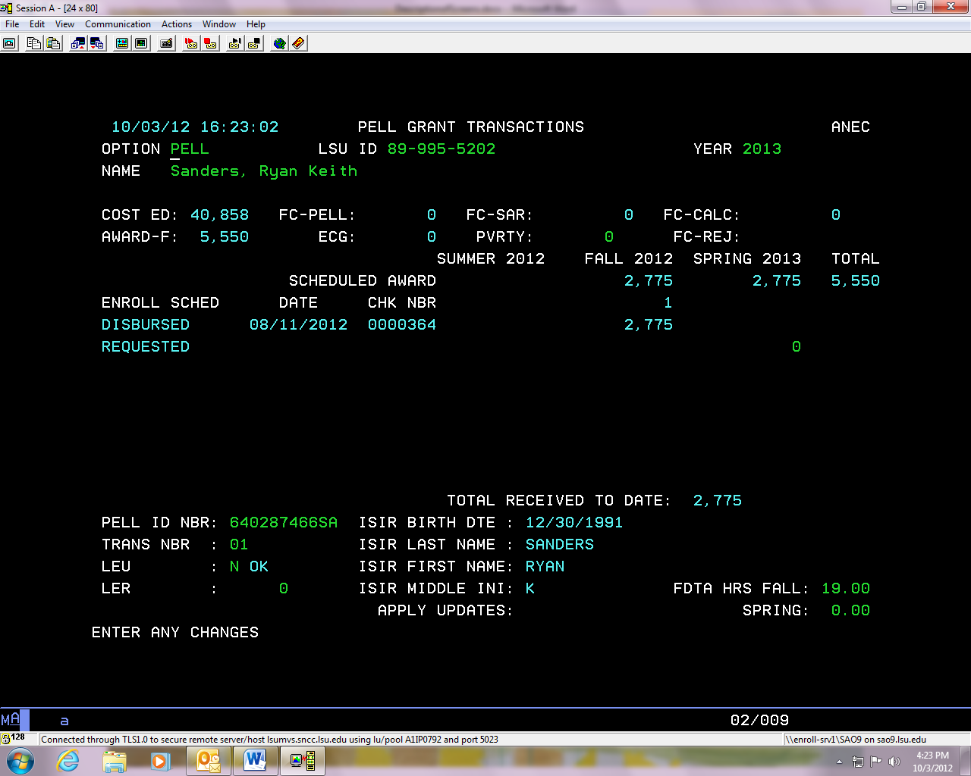

This will have amount of Pell Grant a student can receive if close to LEU limit.

LEU codes: Y= over or at the limit of Pell Grant, C= close to limit, N= OK

Number used to determine Pell eligibility

This number must match FC-CALC. If they do not match changes are being made to the students FAFSA.

Amount of Pell Grant the student will receive.

* + For more information about the LEU and LER flags please see the Grant section.
  + Never speak to how much Pell Grant a student will receive until they have completed the verification process and we have received all FAFSA corrections back.

## PSCH

* Pell Schedule screen….allows us to input a student’s EFC and immediately pull up their Pell eligibility.

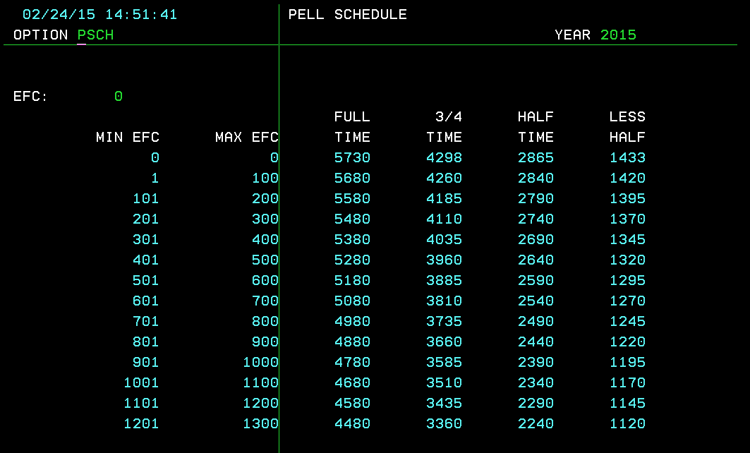

## SAPS

* + You can view a student’s Satisfactory Academic progress information on this screen.
  + You can also view if a student’s appeal has been submitted and if we have an academic plan of file for them.

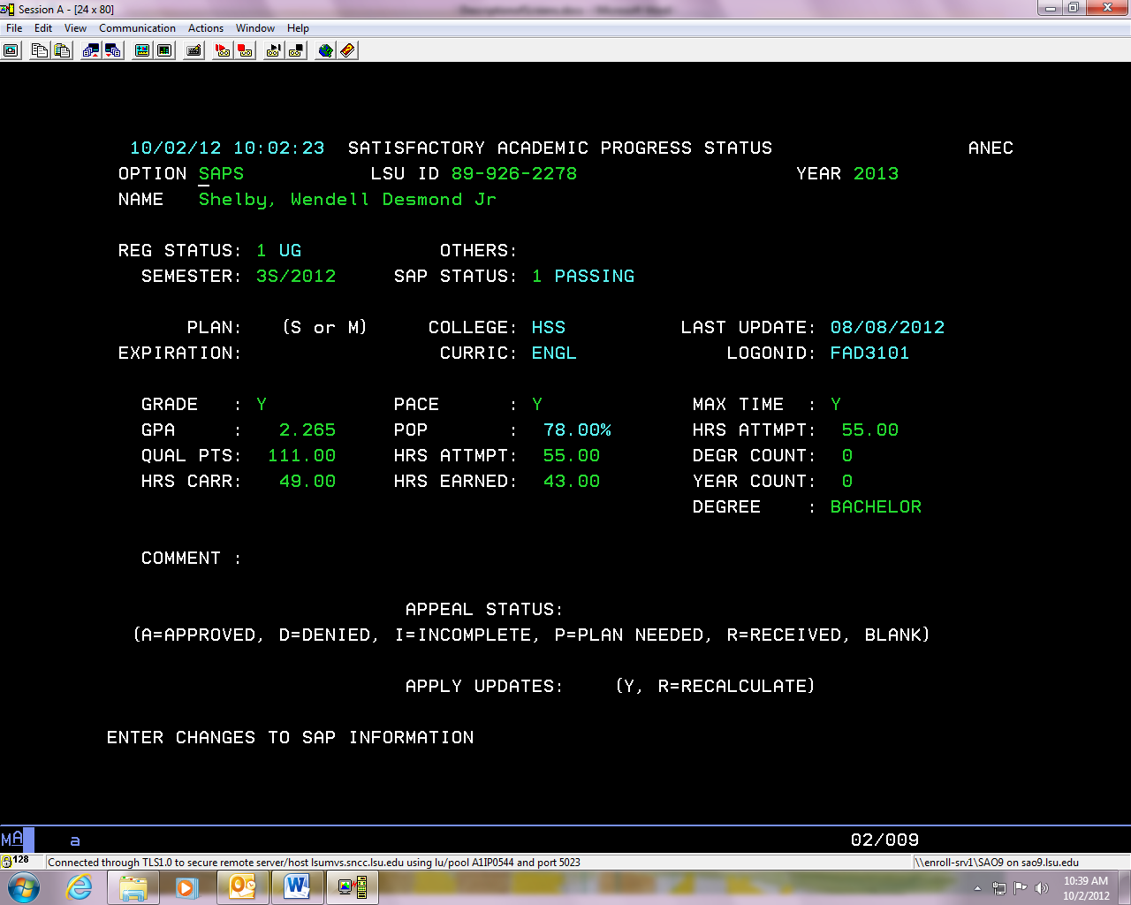

By viewing this row of information you will be able to see which requirement the student is not meeting.

* + If the plan has been received PLAN will have an S or and M next to it and an expiration semester listed. If the appeal form has been received APPEAL STATUS will have a P or R next to it if the appeal has not yet been reviewed. I is for incomplete if we need additional information, also check anec.

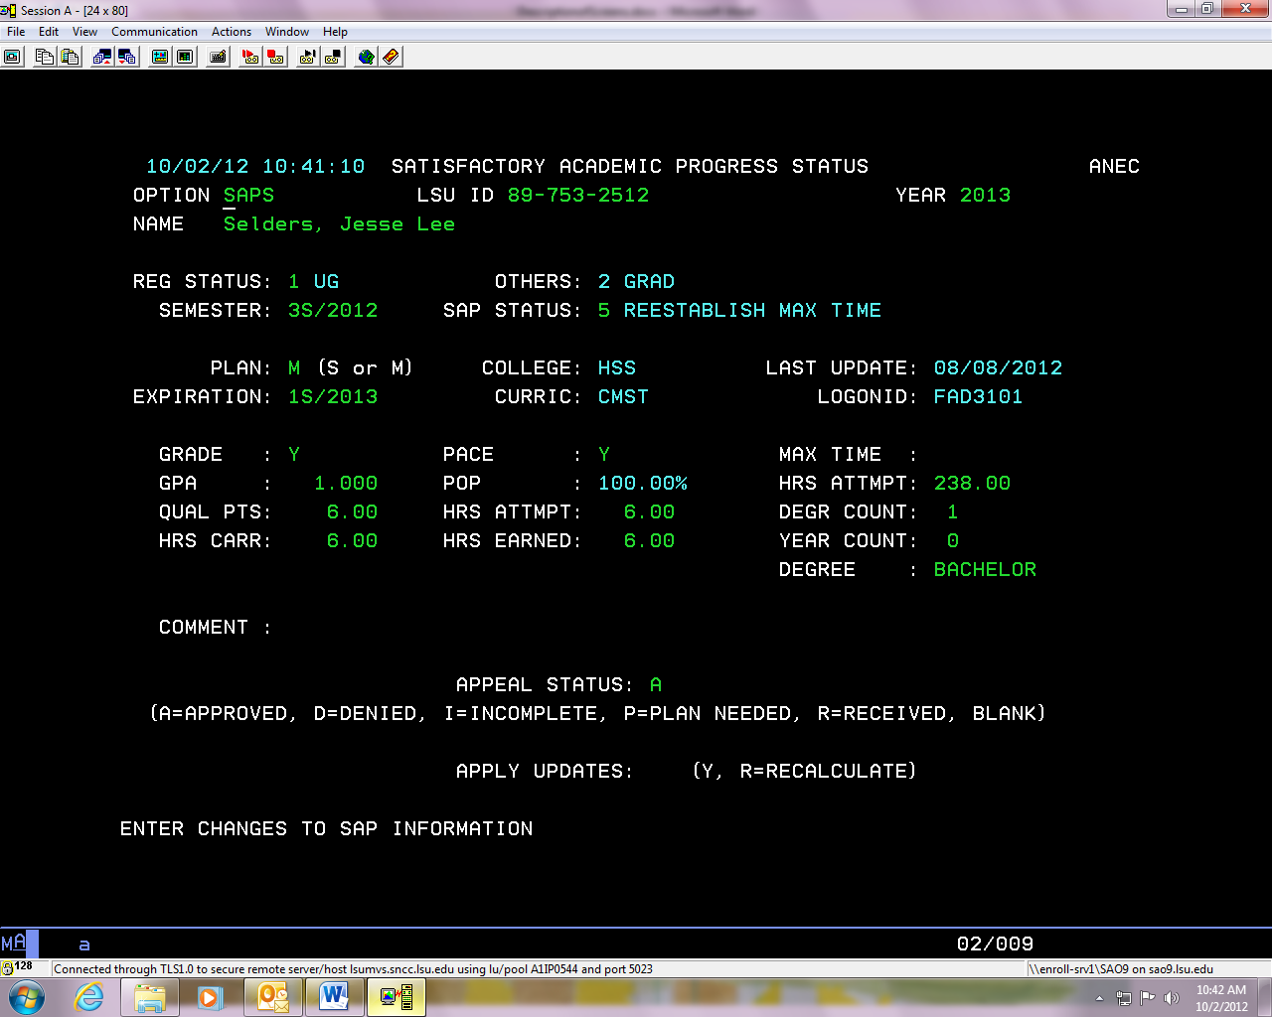

* + To view past semester SAP records you must manually type in the semester code next to semester.

## SCHL

* + You can view an incoming freshman ACT/SAP and computed GPA on this screen. This is all the information we use when award scholarships. Only used for incoming freshman.

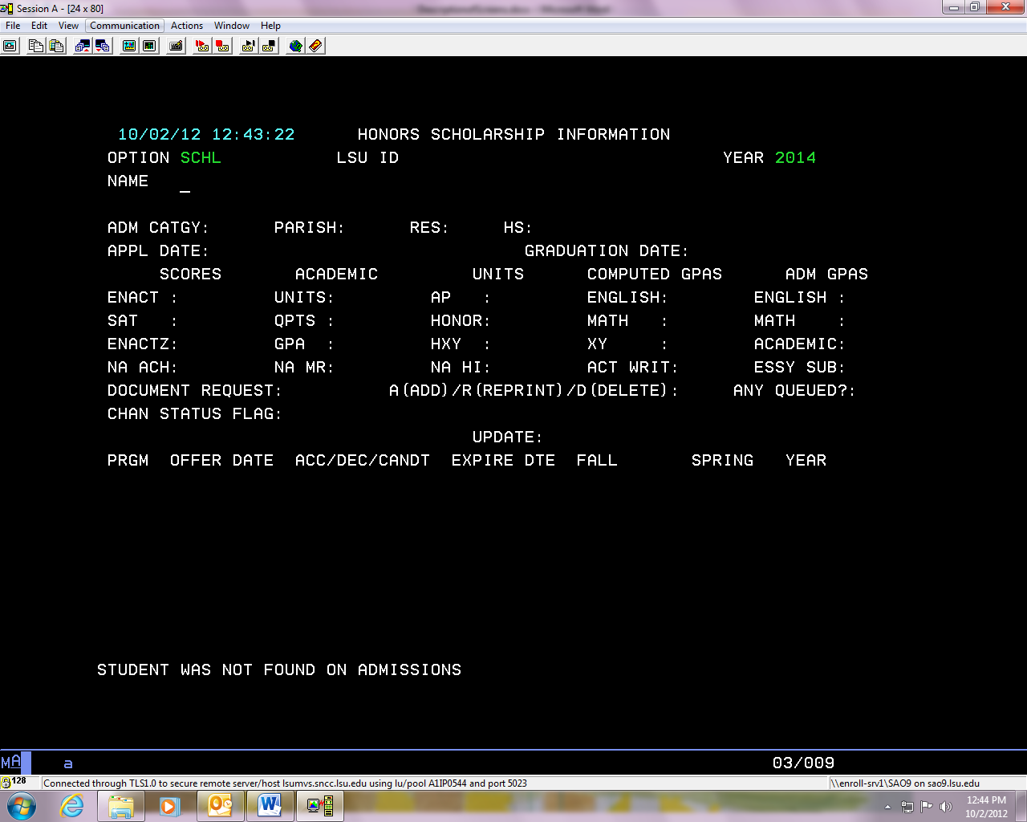

* + The student’s scholarship GPA will be located under COMPUTED GPAS and next to XY(must be a 3.0). Please keep in mind that both the math and English GPAs must be above a 2.0.
  + The test scores are located under SCORES and next to SAT and ENACT.
  + If a scholarship has been awarded it will also be listed on this screen under UPDATE.
  + To view all of the scholarship requirements view the scholarships section.

## STUU

* + Student Data Update
  + You can view if a student has completed their loan entrance counseling. Look next to LOAN ENTR INTRVW and a date should be listed.
  + If they are a graduate student, who has completed a graduate plus loan application they must also complete an entrance counseling session. To see if the student has completed the graduate entrance counseling session there should be a date listed next to GPLS.

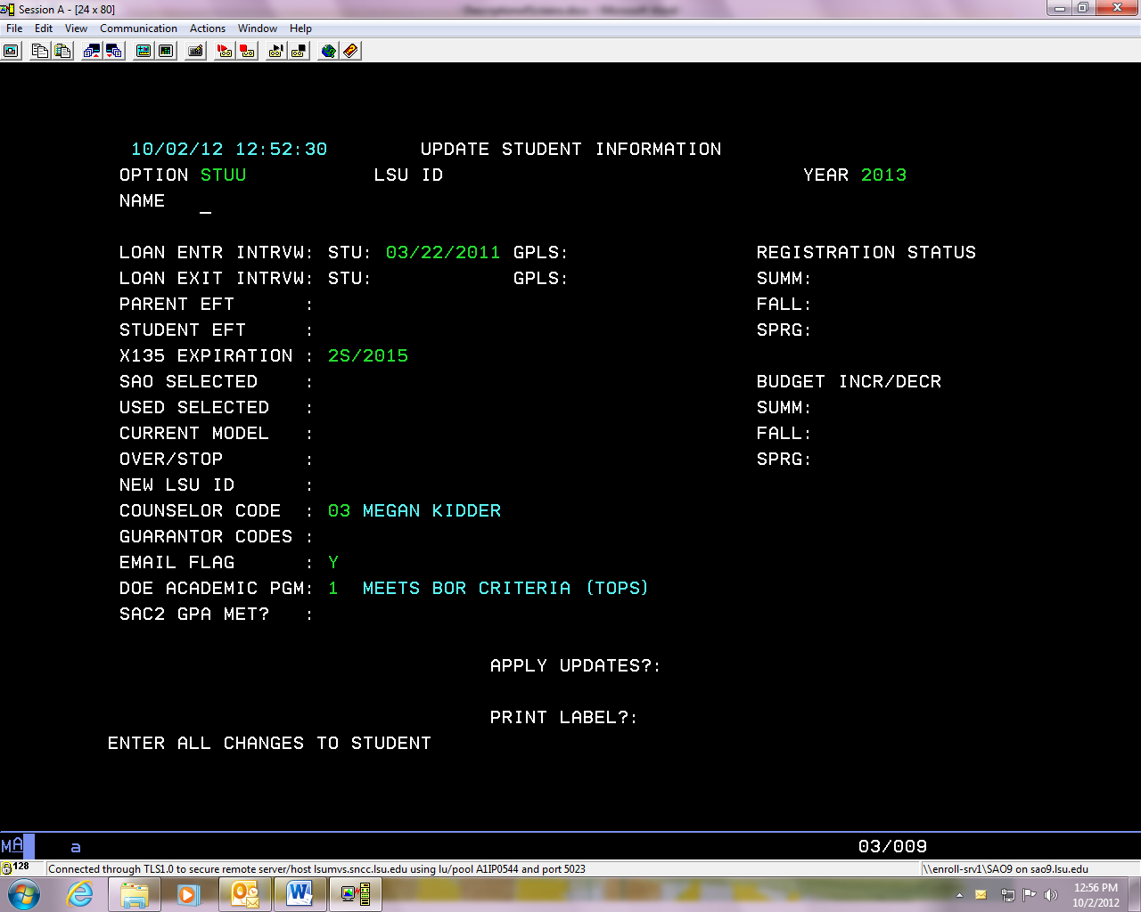

## TOPS

* + TOPS information
  + If we have received information from LOSFA this screen will be filled out.

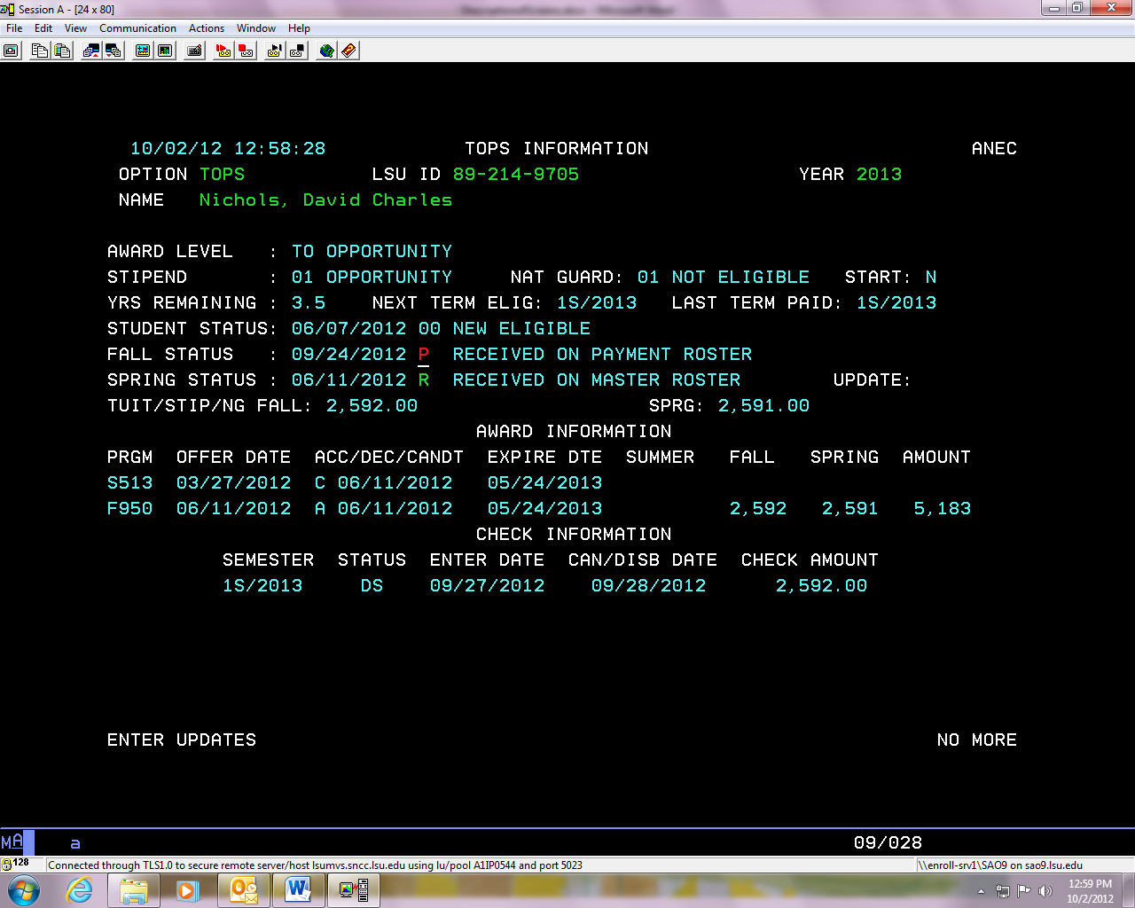

* + To view is a student is eligible look next to STUDENT STATUS
    1. If under student status it says eligible make sure that NEXT TERM ELIG has the current semester listed.

## VERY

* + Verification entry- all request for verification documents will be listed here
  + Documents will be logged as received within 1-2 business days and processed within 7-10 during peak processing times.

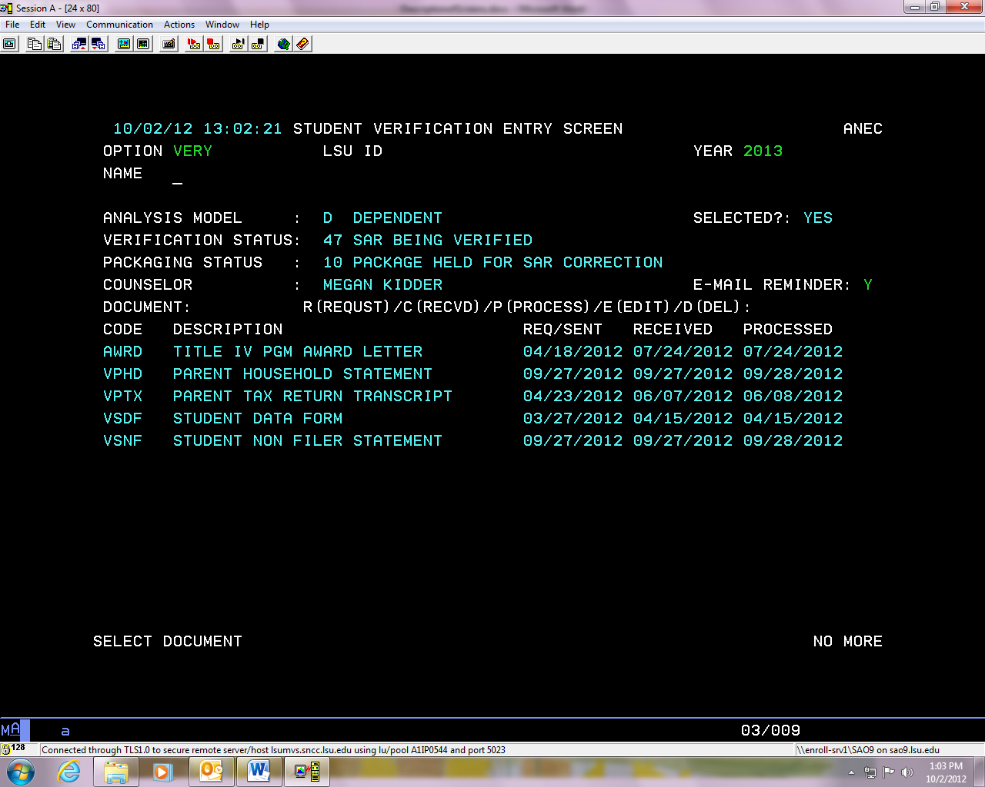

## xabs> info

* + To view if a student has completed registration
    1. Next to **OPTION** enter **xabs** and then press enter
    2. This will bring you to a new system. Next to **Function** enter **info** and then press enter.

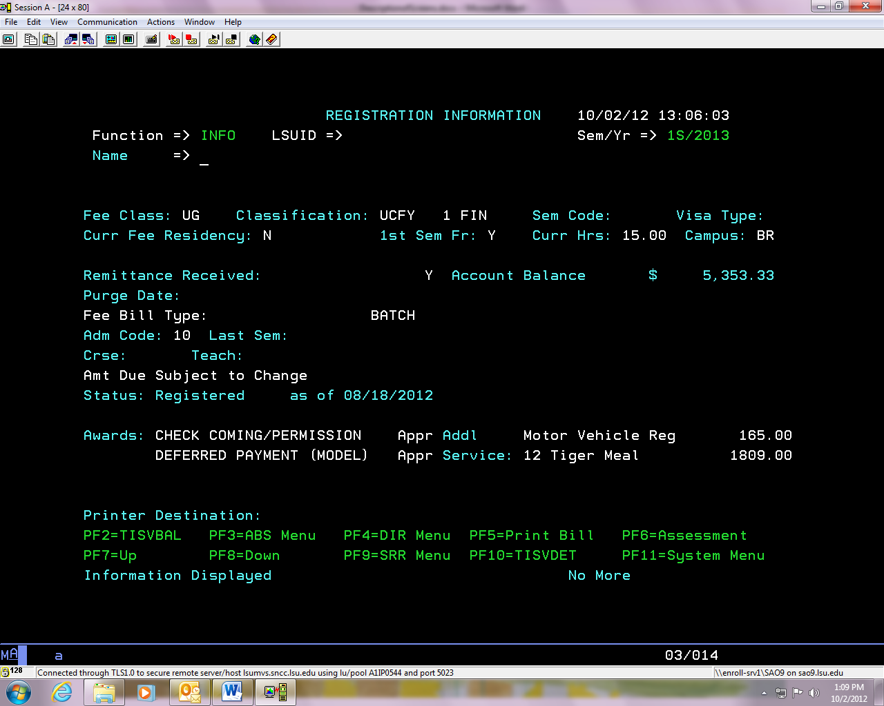

* + If the student is registered next to Status, it will list registered and give the date registration was completed.

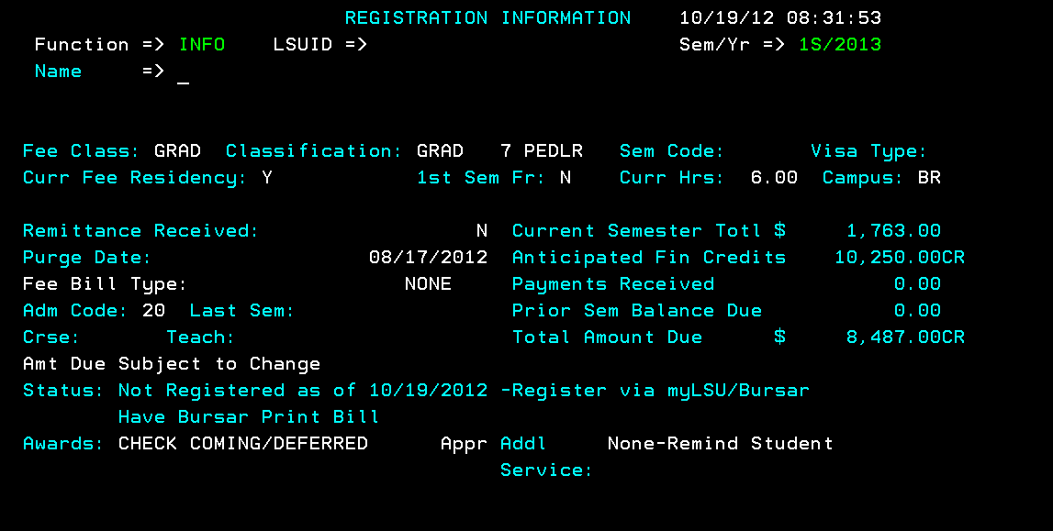

Amount owed for current semester

Amount owed from a prior semester that was not paid during that semester

Anticipated credit from financial aid the student has accepted

Total amount due to complete registration for the current semester

* + If the student has not completed registration, you can view their current semester total and any prior balance giving you the total amount due to complete registration.
  + Anticipated credits will total the amount of financial aid accepted for the semester with good expiration date
    1. Exemptions will already be taken out of the semester total so will not be listed as an anticipated credit
    2. Any loans applied will be the amount of the loan accepted minus the origination fee
  + No financial aid will disburse until the student has completed registration on the fee bill
  + To get back to the financial aid system:
    1. Next to **Function** enter **xfad** and then press enter

## Xabs>sawd

* + To view aid applied to the student’s fee bill
    1. Next to **Option** enter **xabs** and then press enter
    2. Next to **Function** enter **sawd** and press enter

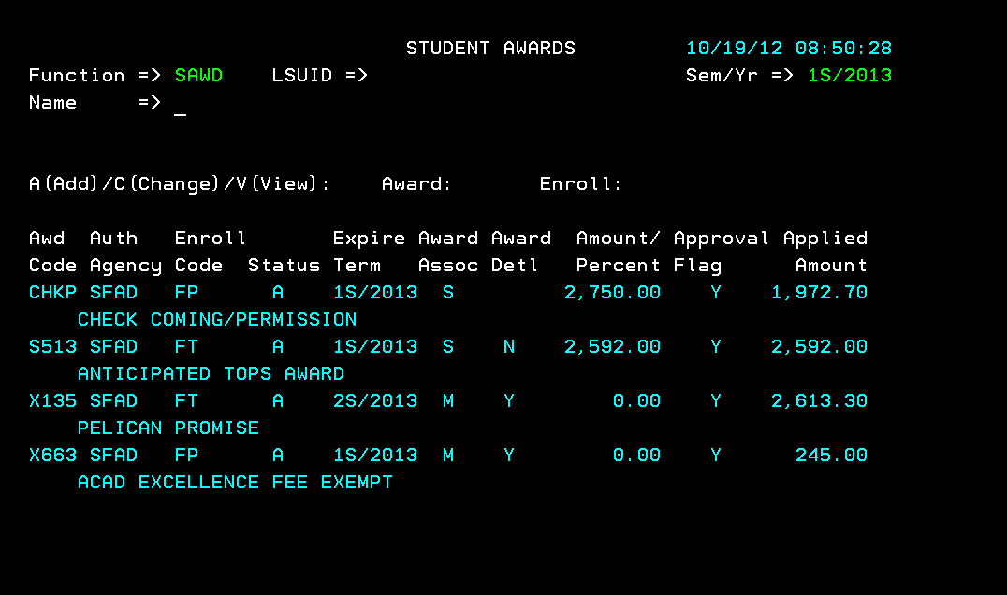

Exemption amount crediting on fee bill. Exemptions should credit for the same amount of that fee the student is being charged.

Amount needed to pay remaining balance on fee bill

Amount of financial aid applied to fee bill

## xtis>vdet

* + You can view if a refund was issued to a student and what date the refund was received.
  + To view the students account transactions:
    1. Next to OPTION enter xtis and press enter
    2. Next to **Action** enter **v**.
    3. Next to **Code** enter **det**.

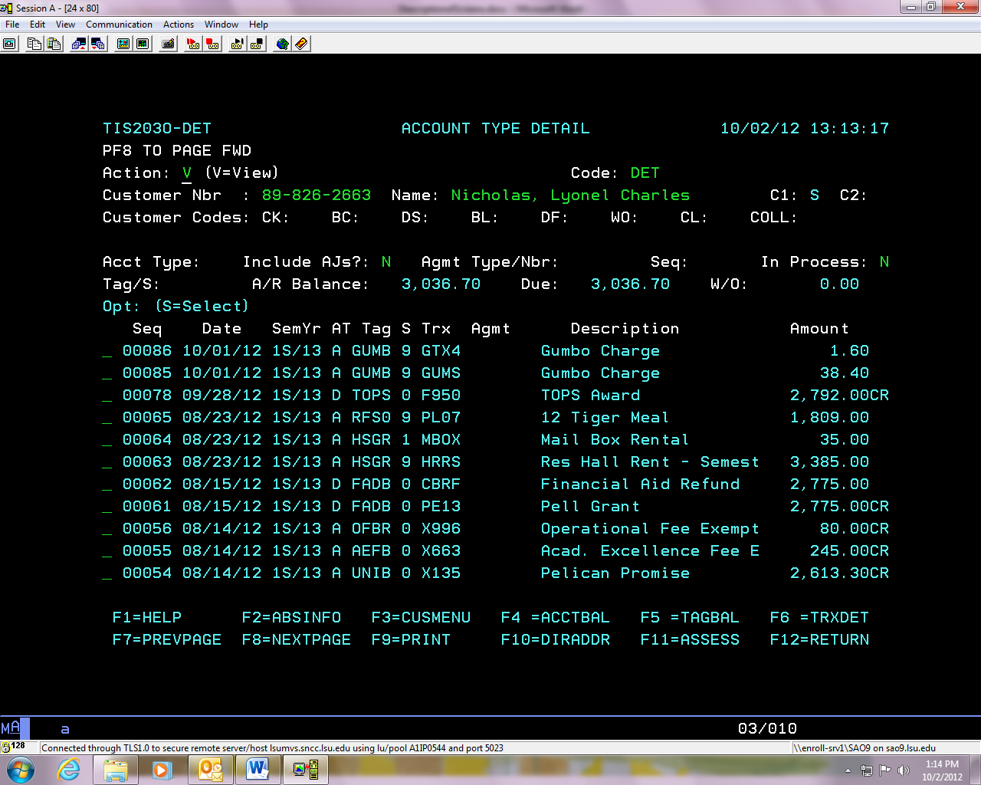

* + Be sure to check that the refund you are speaking to was issued for the current semester.
    1. If the refund was issued by paper check the code under the Trx column will end in a CBRF.
    2. If the refund was issued by direct deposit the code under the Trx column will end in CBDD.

## Xtis>vbil

* + To view the student’s fee bill for the semester
    1. Next to **Option** enter **xtis** and press enter
    2. Next to **Action** enter **v**
    3. Next to **Code** enter **bil**

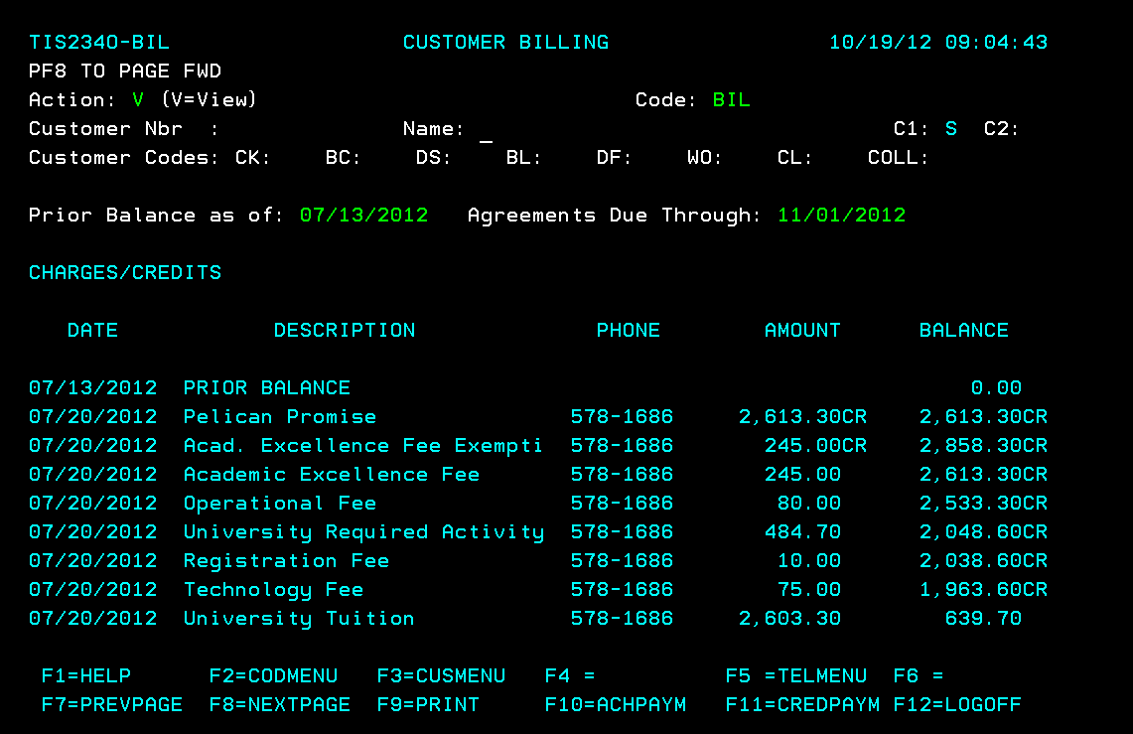

Exemptions crediting on fee bill

Tuition and fees charged

Press F8 to view next page of bill

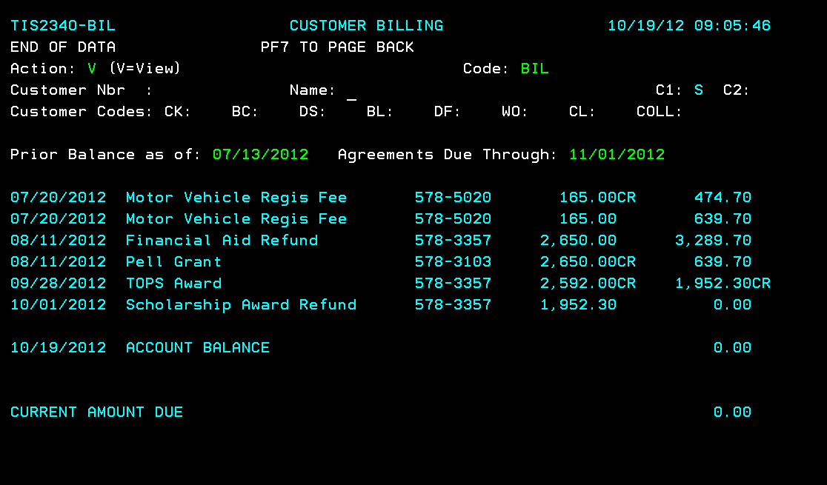

Any amount still owed on fee bill

Shows refunds issued

# Grants

## Types of Grants

**Grants**

Grants are need based awards that do not require repayment. Eligibility for grants is determined by the Estimated Family Contribution (EFC) that is calculated using a federal formula from the information submitted on the FAFSA. The EFC takes into account the family taxed and untaxed income, assets, benefits (such as unemployment or Social Security), the number in the household and the number in college.

Pell Grant

* Award ranges from $636 - $6,195 for the year
* Award amount is prorated based on the number of hours the student is enrolled
* Award amount is updated after the last day to add (if necessary) based on the student’s enrollment status
* Must have an EFC of $5,576 or less for the 2019-2020 academic year
* LEU – Lifetime Eligibility Used
  + Students can only receive Pell for a maximum of 12 full time semesters

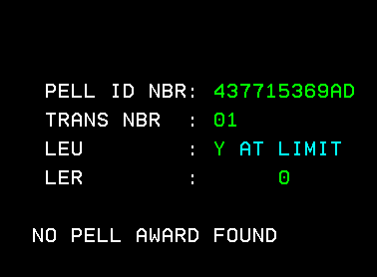

On the Pell screen, there will be a Y, C or N next to LEU.

Y means the student has reached the limit for Pell

C means the student is close to the limit

N means the student has not reached the limit

Supplemental Educational Opportunity Grant (SEOG)

* Award is $1,000 for the year
* EFC must be zero
* Must receive Pell Grant
* Limitedly funded

Go Grant

* Award ranges from $300 - $1500 for the year
* Administered by the Louisiana Office of Student Financial Assistance (LOSFA). We bill for students’ Go Grant after the 14th class day and the funds typically come in around the middle of the semester. We do not have a specific date as it depends when LOSFA sends the funds.
* Must be a LA resident
* Must receive Pell Grant
* Limitedly funded
* The student must have remaining financial need after deducting EFC and all other aid from COA
* Gift aid including Go Grant cannot exceed 60% of the student’s need based eligibility
* Student must enroll at least half time

TEACH Grant

* Non need based award
* Must be enrolled in a program that certifies you to teach in a high need field
  + We will ask the student to complete a Certification of Eligible Major form which Lisa Newman with the College of Education will sign confirming they are enrolled in a high need field
* Must score above the 75th percentile on the SAT/ACT/GRE or have a 3.25 cumulative GPA
* Upon graduating, the student must teach in a high need field at a low income school for at least 4 years within an 8 year period.
  + **IMPORTANT:** If the student does not meet this requirement, the grant is automatically converted to an Unsubsidized Loan that begins accruing interest from the date the student received the funds. Once the grant is converted into a loan, it cannot be converted back. Data from the Department of Education indicates that 80% of students do not complete the program.
* Students interested in receiving the grant should email [financialaid@lsu.edu](mailto:financialaid@lsu.edu) or their counselor

Additional information:

* Grant eligibility is determined by the information submitted on the FAFSA.
* You can **only** receive grants as an undergraduate completing your first degree.
* Generally, there are no grants awarded during the summer semester.
* The Pell Grant and SEOG are federal so can be offered to any student but Go Grant is only offered by the state so students must be a LA resident.

## Pelican Promise

* Louisiana resident
* Tuition exemption
* Administered by LSU
* Must be full time through the university refund period
* Must receive Pell Grant
* Family income is equal or less than 150% of the poverty level
* Freshmen can only receive their first four years of college work
  + The expiration can be found on STUU under x135 expiration
* Transfer can only receive Pelican Promise for up to 120 hours

# Budgets

## Budget Chart

You can access the Budget Charts by clicking [here](../../../Counselor%20Procedures/Budgets/2018-19%20Budget%20Chart.xls).

# Loans

## Types of Loans

* **Interest rates can change as of July 1 for each academic year.**
* Students can view their loan history at nslds.ed.gov
* Students must be **enrolled half time** for any semester in order to receive loans (see enrollment chart below)

Federal Stafford Loans-

* Direct Subsidized Stafford Loans (DSUB)-
  + 4.529% fixed interest rate for **undergraduate students** **only** and does not gain any interest until graduation.
  + No longer available to graduate/professional students.
  + There is a 1.062% origination fee applied to the loan before the funds are applied to the students account.
  + Repayment begins 6 months after graduation or when the student is no longer enrolled at least half-time.
  + This loan is based on financial need.
* Direct Unsubsidized Stafford loans (DUNB)-(must be half-time, see enrollment chart below)
  + 4.529% fixed interest rate for undergraduates and 6.079% for graduate students. This loan begins to gain interest once the loan is disbursed to the student.
  + There is a 1.062% origination fee applied to the loan before the funds are applied to the students account.
  + Repayment begins 6 months after graduation or when the student is no longer enrolled at least half-time.
* First time borrowers of the above loans must complete a Master Promissory note and an Entrance Counseling session at [www.studentloans.gov](http://www.studentloans.gov) before receiving the loan.

Direct Plus Loans-

* Direct topa- (must complete a new application every year)
  + 7.079% fixed interest rate that starts to gain interest once the funds are disbursed to the student.
  + Available to creditworthy parents regardless of financial need. The credit check will be performed by the department of education.
    - If the parent’s credit is denied the student does have the option to seek additional Unsubsidized Stafford loans or the Parents can add a cosigner to the loan.
  + The student can receive up to the cost of education minus any other financial resources.
  + A 4.248% origination is fee is applied to the loan before the student receives the funds.
  + Repayment begins 60 days after the last disbursement of the loan or the parent has the right to defer the loan until the student is no longer attending at least half-time.
  + You can access the application by clicking <http://lsu.edu/financialaid/types_of_aid/types_of_federal_loans.php>.

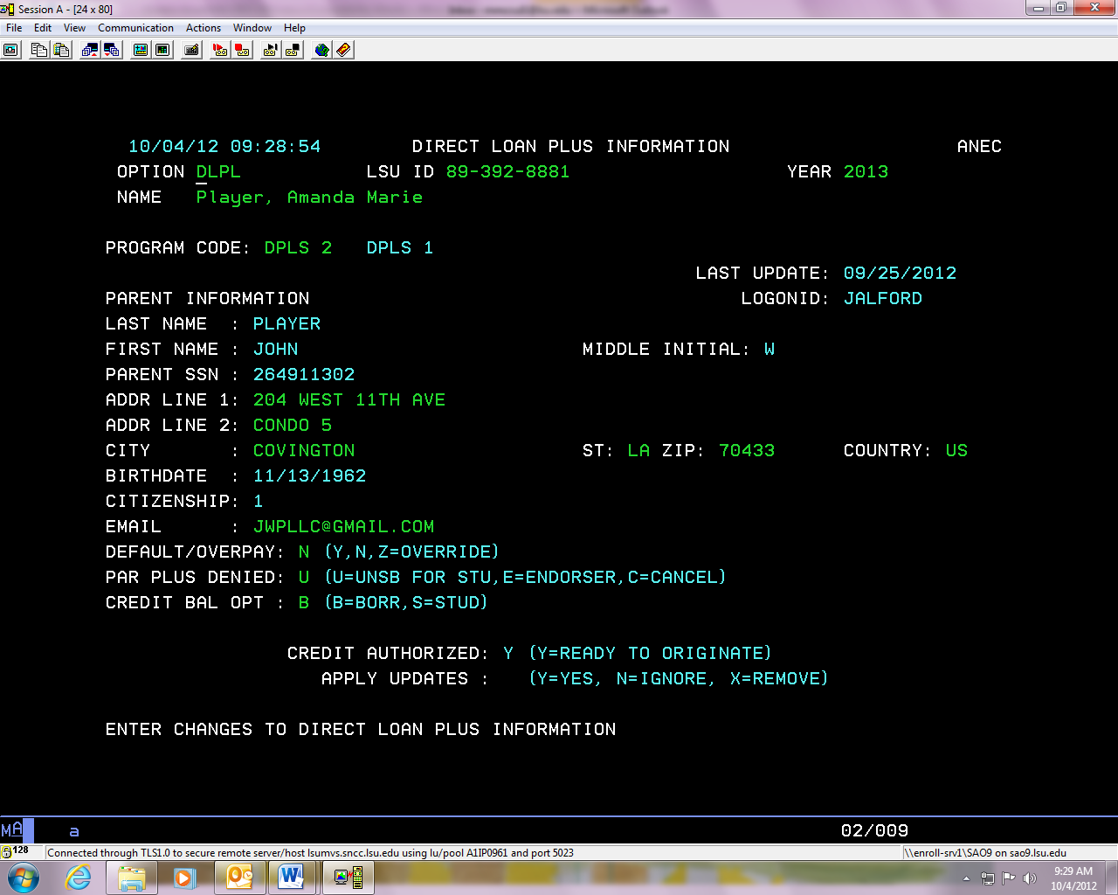

This parent has asked that any overages of DPLS be sent to the Parents. These funds will be mailed to the address on the application.

IF the DPLS is denied this student has selected to receive additional DUNB. This will have an E if the parent plans to add an endorser.

* + To change the CREDIT BAL OPT from a B to and S, we must have a signed written statement from the parent who applied for the loan.
* Direct Graduate Plus loan- (must complete a new application every year)
  + 7.079% fixed interest rate that starts to gain interest once the funds are disbursed to the student.
  + Available to creditworthy students regardless of financial need. The credit check will be performed by the department of education.
    - If the students credit is denied the student does have the option to seek a credit worthy cosigner.
  + The student can receive up to the cost of education minus any other financial resources.
  + A 4.248% origination is fee is applied to the loan before the student receives the funds.
  + Repayment begins 6 months after the student is no longer attending at least half-time.
  + You can access the Graduate Plus Loan application by clicking <http://lsu.edu/financialaid/types_of_aid/types_of_federal_loans.php>.

|  |  |  |  |
| --- | --- | --- | --- |
| **Classification/Semester** | **Full Time** | **¾ Time** | **½ Time** |
| UG Students (Summer/Fall/Spring) | 12+ hours | 9-11 hours | 6-8 hours |
| Grad Students (Fall/Spring) | 9+ hours | 7 hours | 5-6 hours |
| Grad Students (Summer) | 6+ hours | 5 hours | 3-4 hours |
| Law Students (Fall/Spring) | 12+ hours | 9-11 hours | 6-8 hours |
| Law Students (Summer) | 5+ hours | 4 hours | 3 hours |

Private Student Loans-

* Last resort for students needing funds in addition to federal aid to meet educational expenses.
* Loans are credit based and the terms vary based in the lender.
* Amount borrowed may be up to the cost of attendance as determined by the school, minus any other financial aid and resources.
* Loans require school certification.
* It takes about 7-10 days for our office to certify an alternative loan, once the loan is certified it will be listed on the AWRD screen.
* It takes 10 business days from the date we certify an alternative loan for the university to receive the funds.

Emergency Loans-

* Small loan available to students who meet certain requirements and are awaiting federal aid funds.
* Typically used for books and supplies.
* Available the first two weeks of each summer, fall, and spring semester.
* Repayment in full plus a 2% fee is due 60 days after disbursement of funds.
* Max loan is $300 for undergraduates and $500 for graduate/professional.

## Annual Loan Limit Chart

|  |  |  |  |
| --- | --- | --- | --- |
| **Dependent Undergraduates** | | | |
| **Academic Level** | **Subsidized (DSUB)** | **Total Subsidized (DSUB) & Unsubsidized (DUNB)** | **Perkins (PERK)** |
| **Freshman** | **$3,500** | **$5,500** | **$5,500** |
| **Sophomore** | **$4,500** | **$6,500** | **$5,500** |
| **Junior and Up** | **$5,500** | **$7,500** | **$5,500** |

|  |  |  |  |  |  |
| --- | --- | --- | --- | --- | --- |
| **Dependent Undergraduates whose parents are denied for PLUS & Independent Students** | | | | | |
| **Academic Level** | **Subsidized (DSUB) or (DUNB if stu not need based)** | **Unsubsidized (DUNB)** | **Unsubsidized (DUNB) due to Plus Denial & Independent Students** | **Total Subsidized (DSUB) & Unsubsidized (DUNB)** | **Perkins (PERK)** |
| Freshman | $3,500 | $2,000 | $4,000 | $9,500 | $5,500 |
| Sophomore | $4,500 | $2,000 | $4,000 | $10,500 | $5,500 |
| Junior and Up | $5,500 | $2,000 | $5,000 | $12,500 | $5,500 |

|  |  |  |  |
| --- | --- | --- | --- |
| **Graduate Professional Students** | | | |
| **Academic Level** | **Subsidized (DSUB)** | **Total Subsidized (DSUB) & Unsubsidized (DUNB)** | **Perkins (PERK)** |
| Graduate or Law | $0 | $20,500 | $8,000 |
| Vet Med | $0 | $40,500 | $8,000 |
| PhD Clinical Psychology | $0 | $33,000 | $8,000 |

|  |  |  |  |
| --- | --- | --- | --- |
| **Non-Degree Seeking (NMAT)** | | | |
| **Academic Level** | **Subsidized (DSUB)** | **Total Subsidized (DSUB) & Unsubsidized (DUNB)** | **Perkins (PERK)** |
| NMAT UG Dependent | $2,625 | $2,625 | $5,500 |
| NMAT UG Independent & Dependent with PLUS Denial | $2,625 | $8,625 | $5,500 |
| NMAT Grad Dependent | $5,500 | $5,500 | $8,000 |
| NMAT Grad Independent & Dependent with PLUS Denial | $5,500 | $12,500 | $8,000 |
| Teacher Certification NMAT Dependent | $5,500 | $5,500 | N/A |
| Teacher Certification NMAT Independent & Dependent with PLUS Denial | $5,500 | $12,500 | N/A |

***Subsidized (DSUB) is not a guarantee. The eligibility for DSUB is determined if the student has financial need. Financial Need is defined as Cost of Attendance (COA) minus Expected Family Contribution (EFC) minus Resources (Scholarships) equals financial need.

## Aggregate Loan Limits

|  |  |  |  |
| --- | --- | --- | --- |
| **Aggregate Loan Limits** | | | |
| **Academic Level** | **Subsidized (DSUB)** | **Total Subsidized (DSUB) & Unsubsidized (DUNB)** | **Perkins (PERK)** |
| Dependent Undergraduate | $23,000 | $31,000 | Fr/So: $11,000  Total: $27,500 |
| Independent or Dependent with PLUS Denial | $23,000 | $57,500 | Fr/So: $11,000  Total: $27,500 |
| GRAD/Professional | $65,500 | $138,500 | $60,000 |
| Doctorate Clinical Psychology | $65,500 | $224,000 | $60,000 |
| Vet Med | $65,500 | $224,000 | $60,000 |

Screen Shots

To view if a students loan has been disbursed to them:

1. Enter their LSU I.D. number
2. Option: chck
3. 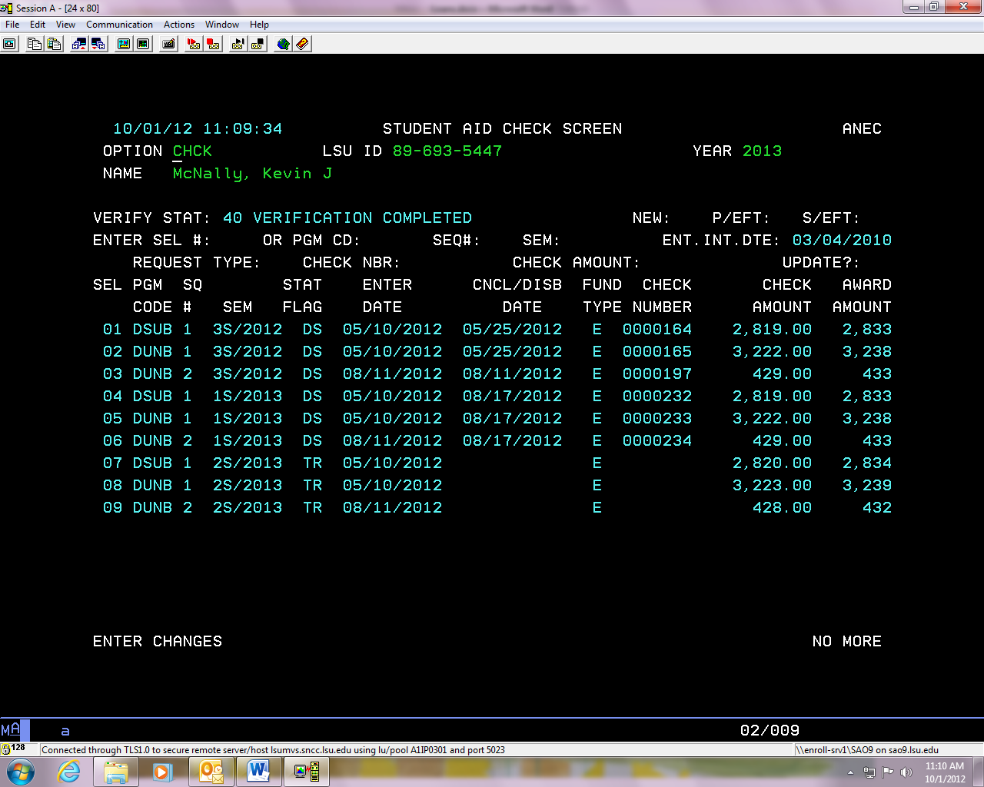Check under stat flag: if status is DS that means the loan has disbursed.

To view if a student has submitted a Master Promissory Note:

1. Enter the students LSU I.D. number.
2. Option: DRLN
3. Make sure the program code is green for the loan the loan the student is inquiring about.
4. Hit enter.
5. There will be a MPN ID, and the MPN status should say A.

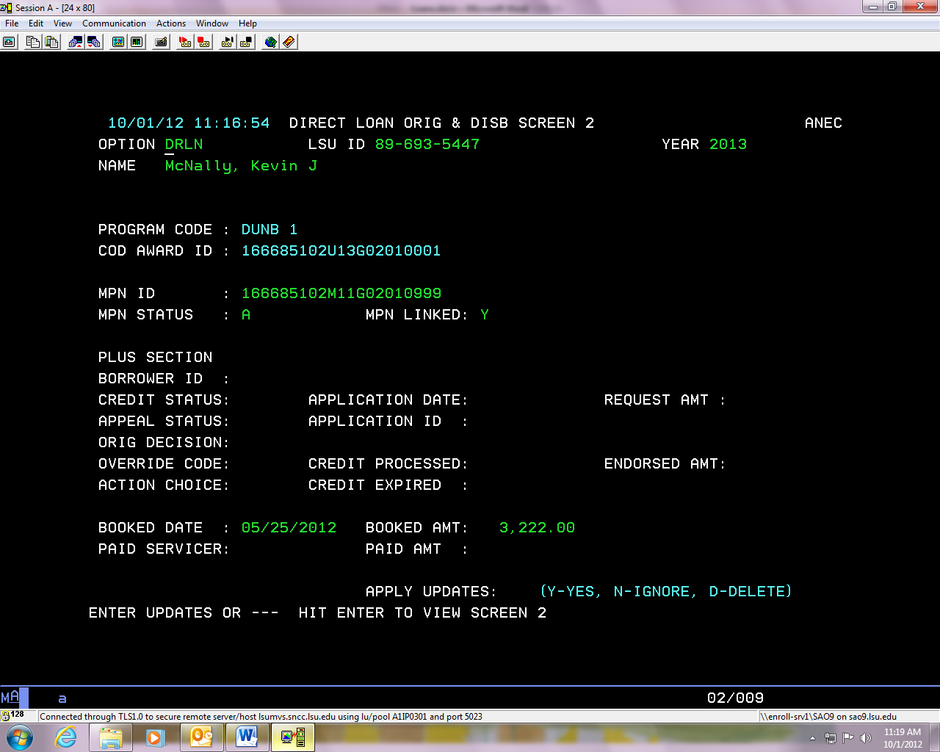

To view if a student has completed the Entrance Counseling:

1. Enter the students LSU I.D. number.
2. Option: STUU
3. There will be a date next to Loan Entr Intrvw if the student has completed counseling.

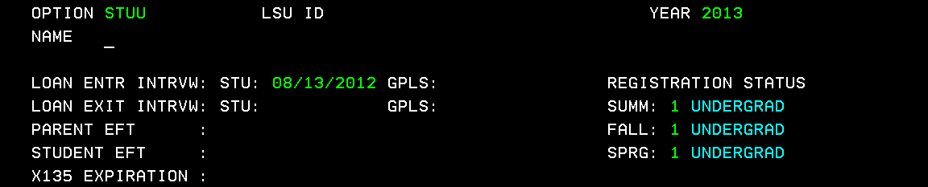

# Campus Jobs

## Federal Work Study

What: Work-Study is a limitedly-funded program that allows students to work for the University and get paid through federal funding. This is a need-based award, and students must show that they are within this Financial Need.

Who: UG and Graduate students who are within Financial Need, as determined by the FAFSA.

How Much: UG’s and Graduate can receive $2,000 a year maximum, if they are attending Fall and Spring. If either the UG or Graduate Student is Summer, Fall, & Spring, they would qualify for $2,400 a year.

Retention: Must be full-time throughout the entire semester for Fall & Spring:

* UG- 12 hours for Fall and Spring
* Grad- 9 hours for Fall and Spring

Students must be half-time throughout the Summer Semester:

* UG- 6 hours for the Summer
* Grad- 3 hours for the Summer

Also:

* Must maintain a cumulative 2.0 GPA

**AND**

* Must not be on Academic Probation with The University

Job Types: Jobs may be on campus or off campus. The off-campus jobs must be in the public interest if the work is for a federal, state, or local public agency or for a private nonprofit organization.

Pay: Pay rates vary according to the type of job you obtain. The least you will be paid is the current minimum wage rate. Off-campus positions may pay a slightly higher wage rate due to travel expense, which is incurred by the student. The student is paid an hourly wage and paychecks are sent bi-monthly.

The award amount will be made to allow you to work 12 to 15 hours per week. This is an average workweek and may vary depending on other obligations a student may have related to academic requirements. The maximum a student can work on-campus is 20 hours per week.

Change Job: If a student would like to switch a job, please let Ms. Laurie Herrin know, or provide them with her email if unable to meet with her.

## Chancellor’s Student Aide

**About:**

Chancellor’s Student Aide Program provides an opportunity for students to work in one of our many departments. Students participating in this program can work up to 20 hours per week to earn up to $1550 per year. The student is paid an hourly wage and paychecks are sent bi-monthly.

**Who:**

Offered only to those incoming Freshman (resident and non-residents) who received scholarships such as:

* Flagship Scholars Award
* Global Leaders
* Chancellor’s Alumni
* STAMPS
* LSU Academic Scholars Award
* Only UG Students

**Key Points:**

* Not based on Financial Need
* Students must retain a cumulative 3.0 for the scholarships these jobs are offered with, however if they were to lose their scholarship due to suspension or cancellation; they can still retain this award. However, they are still held to the requirement of meeting a minimum cumulative 2.0 GPA.
* Do not need to have a FAFSA on file for this award

## Retention

**Chancellor’s Student Aide Program and Chancellor’s Future Leaders in Research**  
The student must remain full-time (12 hours) throughout the semester to participate in this program.  If a student fails to meet the GPA requirement at the end of the spring semester, he or she will be unable to participate in the program until a 2.0 cumulative GPA has been regained.  It is the student’s responsibility to request reinstatement/reassignment through the Office of Undergraduate Admissions and Student Aid after the requirement has been met.

 Student cannot be on Academic Probation.

## Job Types

Jobs may be on campus.

## Change of Jobs

If a student would like to change jobs, please refer them to Mrs. Laurie Herrin. If she is unable to speak with the student, please provide them with her email address.

## Denying the Award

The student will be offered this award as a scholarship recipient their freshman year. If they originally deny this award, and request that it be offered, the student will be reviewed on an individual basis. There is a limited chance that the student will have this award reinstated if they had originally denied the offer as an incoming freshman.

If they would like to be considered for reinstatement, please take their information, LSU ID, and provide this information to Mrs. Laurie Herrin for review.

**If a student was not awarded Work Study or Chancellor’s Student Aide and would like to work on campus, the student can contact Olinde Career Center at 578-2162 located at 158 Student Union.

# Special Considerations

**What are they?**

The U.S. Department of Education allows institutions, like LSU to take into consideration changes in a student and/or family’s financial situation, from what was originally reported on that year’s FAFSA. Within that consideration, it may adjust the student’s financial aid eligibility, opening up additional eligibility. These Special Considerations are a request, and are not a guarantee that they will be granted, or a change in the financial aid will occur. The Special Considerations can also be lengthy and are subject to processing and review by our department.

**Examples:**

* Loss of Job
* Reduction in wages
* One-time income received
* Private School Tuition Costs (not to include LSU’s tuition)
* High Medical Expenses
* Loss of some benefits
* Petition of Independent Status- if a student mentions they are at risk of being homeless, or contact with their parents would result in risk their well-being.
* Separation of Income- parents were married on FAFSA now separated or divorced.
* Review of independent Status- students who had answered “No” on all dependency questions on FAFSA, and:
  + The student has children who receive more than half of their support from the student
  + The student has other dependents who live with the student and who receive more than half of the support from the student, and will continue to do so through June 30, 20XX

**Things we will not consider:**

* Normal Living Costs, expenses (housing, food, utilities, etc.)
* Standard Maintenance Costs/Expenses
* Vacation Expenses

**What to do if someone mentions one of the acceptable examples above:**

1. Let the student and/or parent know that this would be something that would need to be discussed directly with their counselor.
2. Provide them with the counselor’s email information, and instruct them to email the counselor a specific timeline of the change in events, and the type of change they are experiencing.
3. The counselor will respond with specific questions, and request additional documentation if necessary.

**Important Reminders:**

* Do not speak for the Special Considerations, simply instruct the student and/or parent that they will need to contact the counselor for any further review of this change in their financial situation.
* The Special Considerations are a request, and subject to approval by the department
* The Special Considerations may not make a change to the awards a student was originally offered

# Satisfactory Academic Progress (SAP)

## What is Satisfactory Academic Progress (SAP)?

* We are required to have this policy by the US Department of Education
* Students must be meeting the policy requirements in order to be eligible for financial aid, including federal loans

GPA requirement

* Undergraduate, Law and Vet students must maintain a cumulative 2.0 GPA
* Graduate students must maintain a cumulative 3.0 GPA

Pace of Progression/Completion Rate

* Students must complete 67% of the hours they attempt
* Calculated by dividing number of hours attempted by number of hours earned
* The percentage is never rounded up
* Resigning for the semester, withdrawing from or failing courses, academic bankruptcy, and receiving an incomplete adversely affects pace of progression because they are hours attempted but not earned

** Students not meeting the GPA and pace of progression requirement are placed on warning for a semester and if after that semester, the student is not meeting the requirement, they are placed on suspension. Students can still receive aid while on warning.

Maximum Timeframe

* Students have a timeframe in which they should graduate. This is 150% of the published length of their program.

|  |  |
| --- | --- |
| **Maximum Timeframe** | |
| Bachelor’s Degree | 180 Attempted Hours |
| Architecture Degree | 243 Attempted Hours |
| Post baccalaureate certificate | 27 Hours |
| Master’s Degree | 45 Attempted Hours |
| PHD | 7 years from start of program |
| DVM Degree | 267 Attempted Hours |
| J.D./C.L. | 141 Attempted Hours |

**Students who have exceeded their timeframe are automatically placed on suspension and cannot receive aid without appealing.

SAP E-mail Communication

For all students in which SAP has been checked after grades post, when ISIR is loaded, before packaging:

* CORR Codes:
  + SAPC1S                 SAP CHECKED AT END OF FALL SEMESTER
  + SAPC2S                 SAP CHECKED AT END OF SPRING SEMESTER
  + SAPC3S                 SAP CHECKED AT END OF SUMMER SEMESTER
  + SAPCI                    SAP CHECKED WHEN ISIR LOADED
  + SAPCP                   SAP CHECKED BEFORE PACKAGING

Students with the above CORR codes, will receive the following e-mail:

Eligibility for Federal Financial Aid is based on maintaining Satisfactory Academic Progress (SAP). Our office has reviewed your academic history since your latest period of enrollment. To determine if you are in compliance with the minimum standards, please log onto your MyLSU account, click Financial Services, Financial Aid, and SAP Status to view your financial aid eligibility.

To view LSU’s Satisfactory Academic Progress policy, please see below. [www.lsu.edu/financialaid/sap](http://www.lsu.edu/financialaid/sap).

*Also, see the ”SAP Policy Overview” document below which shows examples of what the student sees in MYLSU.

## Policy

To view the SAP Policy click [here.](http://sites01.lsu.edu/wp/financialaid/satisfactory-academic-progress/)

## Appeal Process

* Complete appeal form and academic plan
* The appeal form can be found on students’ MyLSU account under Financial Services 🡪 Financial Aid 🡪 Satisfactory Academic Progress and it is also on our website under lsu.edu/financialaid 🡪 Forms 🡪 Appeal Form. The appeal form is submitted to our office with documentation.
  + If the appeal is denied due to the student not submitting documentation, the student can submit documentation and their appeal will be reviewed again.
* The appeal should explain why the student did not meet the policy requirement and what they will do so that it is not an issue in the future.
* Students must meet with their academic advisor in their college to complete an academic plan. The advisor has access to the plan form on their MyLSU account and will submit the plan online to our office.
  + All Deans and Associate Deans have access to the academic plan. Not all academic advisors do. The student will need to meet with the person handling academic plans in their college or their advisor can contact our office to request access.
* The appeal can take up to two weeks to be reviewed and the student will receive an email once a decision is made. Please refer to the official appeal committee schedule to give students a date in which they will be notified.
* Appeals must be submitted at least 2 weeks before the semester ends. Appeals will not be reviewed for a semester that has already ended.
* We can never guarantee an appeal will be approved as each situation is student specific and the committee will review the information submitted for approval.

**If the appeal is denied, the student can apply for a private loan. However, some lenders require that students meet the school’s SAP policy so the student should ask about this requirement with the lender.

## Screen Shots

If an academic plan has been submitted, there will be an S or M next to plan. It can take 24 hours for the plan to load.

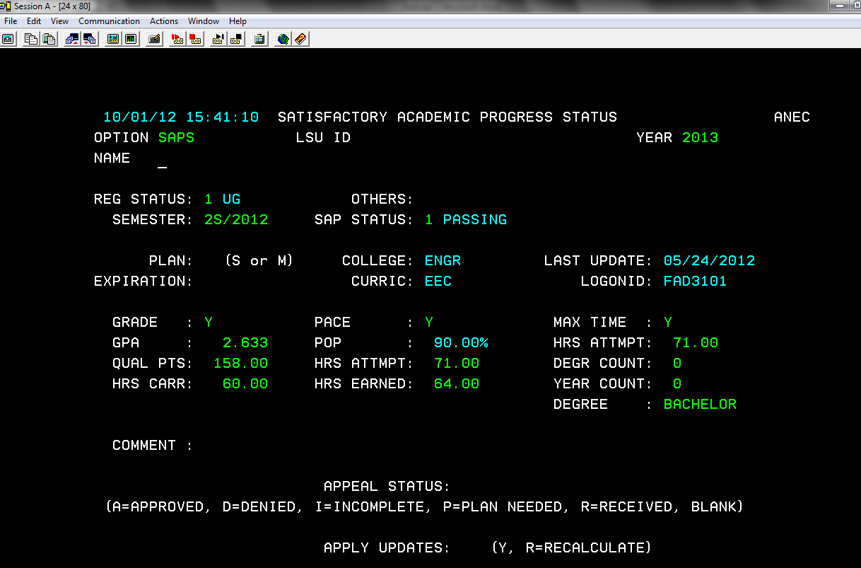

Appeals are logged in at the end of each week. If we have received the student’s appeal and plan, appeal status will have an “R”. If we have received a student’s appeal but not their plan, appeal status will have a “P.” If we have received a student’s plan, but not appeal, appeal status will have a ‘N’. The appeal status will be “I” if the appeal is incomplete and our office has requested additional documentation before a final decision can be made on the appeal.

Reg Status shows if the student is 1 UG, 2 Grad, 4 Law or 5 Vet

Degr count shows if the student has already earned a degree

There will be a Y in each column if the student is meeting that requirement or an N if they are not

|  |  |
| --- | --- |
| **SAP Status** | |
| **Students can receive aid** | **Students cannot receive aid** |
| 1 Passing | 3 Suspension |
| 2 Warning | 6 Ineligible |
| 4 Probation | 7 Exceeded Max Timeframe |
| 0 Reestablish Grade/Pace | 8 Plan Not Med Exceed Time |
| 5 Reestablish Max Time | 9 Plan Not Met Grade/Pace |

Additional Information

* Transfer or re-entry students cannot receive a financial aid package unless their admit code is less than 20. Admit code 20 means they are provisionally admitted and they must be fully admitted before they can receive financial aid. Typically, an admit code of 20 means admissions is still waiting on a transcript. We must receive this information in order to be able to calculate their SAP.

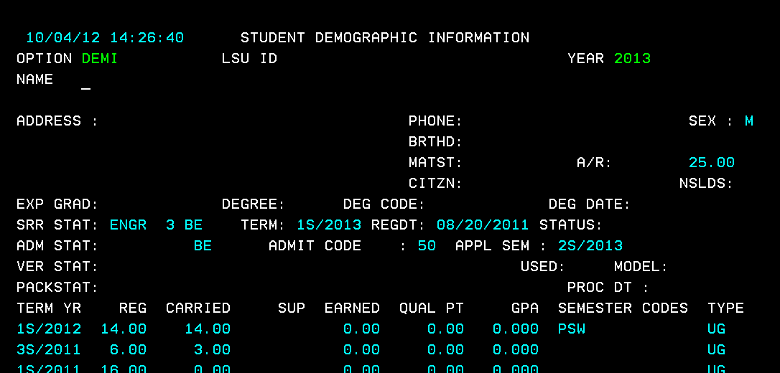

## Appeal Review Dates

|  |  |
| --- | --- |
| APPEALS RECEIVED | DECISION BY |
| 4/29/19-5/3/19 | 5/13/19 |
| 5/6/19-5/10/19 | 5/20/19 |
| 5/1319-5/17/19 | 5/27/19 |
| 5/20/19-5/24/19 | 6/3/19 |
| 5/27/19-5/31/19 | 6/10/19 |
| 6/3/19-6/7/19 | 6/17/19 |
| 6/10/19-6/14/19 | 6/24/19 |
| 6/17/19-6/21/19 | 7/1/19 |
| 6/24/19-6/28/19 | 7/8/19 |
| 7/1/19-7/5/19 | 7/15/19 |
| 7/8/19-7/12/19 | 7/22/19 |
| 7/15/19-7/19/19 | 7/29/19 |
| 7/22/19-7/26/19 | 8/5/19 |
| 7/29/19-8/2/19 | 8/12/19 |
| 8/5/19-8/9/19 | 8/19/19 |
| 8/12/19-8/16/19 | 8/26/19 |
| 8/19/19-8/23/19 | 9/3/19 |
| 8/26/19-8/30/19 | 9/9/19 |
| 9/2/19-9/6/19 | 9/16/19 |
| 9/9/19-9/13/19 | 9/23/19 |
| 9/16/19-9/20/19 | 9/30/19 |
| 9/23/19-9/27/19 | 10/7/19 |
| 9/30/19-10/4/19 | 10/14/19 |
| 10/7/19-10/11/19 | 10/21/19 |
| 10/14/19-10/18/19 | 10/28/19 |
| 10/21/19-10/25/19 | 11/4/19 |
| 10/28/19-11/1/19 | 11/11/19 |
| 11/4/19-11/8/19 | 11/18/19 |
| 11/11/19-11/15/19 | 11/25/19 |
| 11/18/19-11/22/19 | 12/2/19 |
| 11/25/19-11/29/19 | 12/9/19 |
| 12/2/19-12/6/19 | 12/16/19 |
| 12/9/19-12/13/19 | 12/23/19 |
| 12/16/19-12/20/19 | 1/7/2020 |
| 12/23/19-1/3/2020 | 1/13/2020 |
| 1/6/2020-1/10/2020 | 1/21/2020 |
| 1/13/2020-1/17/2020 | 1/27/2020 |
| 1/20/2020-1/24/2020 | 2/3/2020 |
| 1/27/2020-1/31/2020 | 2/10/2020 |
| 2/3/2020-2/7/2020 | 2/17/2020 |
| 2/10/2020-2/14/2020 | 2/24/2020 |
| 2/17/2020-2/21/2020 | 3/2/2020 |
| 2/24/2020-2/28/2020 | 3/9/2020 |
| 3/2/2020-3/6/2020 | 3/16/2020 |
| 3/9/2020-3/13/2020 | 3/23/2020 |
| 3/16/2020-3/20/2020 | 3/30/2020 |
| 3/23/2020-3/27/2020 | 4/6/2020 |

## SAP Appeal Form

Found on lsu.edu/sap and the students MyLSU account under Financial Services, Financial Aid, SAP if the student is in a bad status.

## SAP Policy Overview with MyLSU Screen Shots

**SAP Policy Overview**

Satisfactory Academic Progress will be checked at the end of a regular semester which includes summer, fall, and spring or once a student has been clearly admitted. There will also be a SAP check in place prior to packaging and disbursement to ensure all students have been verified. SAP Status will not be updated in these additional checks if the student has already been assigned a SAP Status for the semester.

**When is SAP checked?**

Continuing Students

All enrolled students will have SAP checked at the end of the regular semesters: summer, fall, and spring. A SAP Status will be populated on the SAPS screen along with information verified in the check.

First Semester Students

All students beginning a program will have SAP checked after their first semester of enrollment. A SAP Status will not be populated on SAPS screen. This includes UGF (Undergraduate Entering Freshmen), GSN (Graduate Student-New to LSU), GSL (Graduate Student-UG from LSU), LWN (Law Student-New to LSU), LWL (Law Student-UG from LSU), VMN (VetMed Student-New to LSU), VML (VetMed Student-UG from LSU).

Transfer Students

All transfer students will have SAP checked once clearly admitted. SAP cannot be checked on a transfer student until all necessary paperwork (transcripts, etc.) have been received. A SAP Status will be populated on the SAPS screen along with information verified in the check. This includes UGT (Undergraduate Transfer Student). LSU does not accept transfer students into Graduate, Law, or VetMed programs.

Re-Entry Students

All re-entry student will have SAP checked once clearly admitted. Unless there is new transfer work to be considered, the student’s last SAP status at LSU will be used in the SAP check. If new transfer work is received, a new SAP Status will be assigned to including both past and new academic information. If there is no new transfer work, the student’s last SAP Status is carried over to the current semester SAPS screen. This includes UGR (Undergraduate ReEntry Student), GSR (Graduate Student-ReEntry), LWR (Law Student-ReEntry), VMR (VetMed Student-ReEntry).

**What are the minimum standards?**

Grade (Qualitative Measure)

The qualitative requirement sets a minimum Cumulative Grade Point Average (GPA) for the degree level at which a student is classified. The GPA requirement includes grades from all courses taken at other institutions that are accepted by Louisiana State University.

|  |  |
| --- | --- |
| **Minimum Cumulative GPA** | |
| Undergraduate Students | 2.0 |
| Graduate Students | 3.0 |
| Law Students | 2.0 |
| Veterinary Medicine Students | 2.0 |

Pace of Progression and Maximum Timeframe (Quantitative Measures)

1. Pace of Progression/Completion Rate

* The credit hour completion rate reflects the pace at which students must progress to ensure that they are able to complete their degree program within the maximum timeframe. The pace of progression is calculated by dividing the cumulative number of hours the student has successfully completed by the cumulative number of hours the student has attempted. All students regardless of classification must earn 67% of all hours attempted. This is a cumulative calculation and includes credits attempted at all schools before and while attending Louisiana State University.

1. Maximum Timeframe

* The maximum timeframe for students to complete their degree cannot exceed 150% of the published length of the academic program. Hours are counted starting with the semester the student entered school, even those semesters in which he/she did not receive financial aid.

*\*Multiple Degrees -* Hours attempted that are classified as general education requirements and are completed as part of the requirements for the first Bachelor’s degree count as attempted in the maximum timeframe when multiple Bachelor’s degrees are pursued. The student will be allowed a maximum timeframe of 150% of the minimum hours to complete the Bachelor’s degree minus the hours completed as general education courses.

*Hours Attempted*

Hours attempted include all hours pursued in the student’s career and are counted in the maximum timeframe whether or not financial aid was received. Attempted hours also include the following: withdrawals, incompletes, failing grades, repeated coursework, correspondence courses, and transfer credits accepted by Louisiana State University.

*Repeated Coursework*

Students are allowed to repeat a previously passed course and have it count toward enrollment for financial aid eligibility only once.

Grade Exclusion

The previous grade received in the repeated course will be excluded from your Grade Point Average (GPA) and the repeated course will not count as earned for Satisfactory Academic Progress (SAP) due to the Grade Exclusion Policy.

*Dropped or Withdrawn Courses*

Drops and/or withdrawals do not affect a student’s cumulative GPA for SAP, but count as credit hours attempted toward both pace and maximum timeframe.

*Incomplete Grades*

At the time of evaluation (the end of each period of enrollment), incompletes (grade of “I”) do not influence a student’s cumulative GPA for SAP, but count as credit hours attempted toward both pace and maximum timeframe. For financial aid purposes, incomplete (“I”) grades equal “F” until removed according to University regulations.

*Transfer Credit*

Transfer credits and credits taken while cross-enrolled that are accepted by Louisiana State University count toward a student’s cumulative GPA and attempted and earned credit hours, therefore, impacting the maximum timeframe and a student’s pace/completion rate.

*Change of Major / Pursuing Multiple Majors*

Credits earned under all majors will be included in the calculation of attempted, earned, and maximum timeframe credits, as well as the GPA calculation.

*Grades, Hours Earned, and Grade Point Average*

Students will receive a grade for each course at the end of the semester. Passing grades are: A, B, C, D, P, and S or numeric grades for Law. Grades that are not passing are: F, I, U, NC, and W. See the Louisiana State University Catalog for a more detailed description of the grading system and an explanation of how a grade point average is computed.

*“Not for Degree Credit” Courses and Audited Coursework*

Students may not receive financial aid for continuing education courses, audited courses, or any other courses that are not part of their curriculum.

*Academic Bankruptcy*

All attempted hours will be included in determining a student’s financial aid eligibility. However, coursework included in an academic bankruptcy does NOT count in earned hours. This means that the completion rate of a student with academic bankruptcy may be adversely affected.

**Evaluation and Notification of Eligibility**

When SAP is checked, the SAP Status is populated on the SAPS screen along with information verified in the check. If a FAFSA is on file, the following email is sent to the student’s PAWS account. If there is no FAFSA on file, communication is suppressed. Once a FAFSA is filed, communication will be sent.

*EMAIL*

{Eligibility for Federal Financial Aid is based on maintaining Satisfactory Academic Progress (SAP). Our office has reviewed your academic history since your latest period of enrollment. To determine if you are in compliance with the minimum standards, please log onto your MyLSU account, click Financial Services, Financial Aid, and SAP Status to view your financial aid eligibility.

To view LSU’s Satisfactory Academic Progress policy, please go to [www.lsu.edu/financialaid/sap](http://www.lsu.edu/financialaid/sap).}

Status on SAPS screen

*1 - Passing*

status assigned to a student who is eligible for financial aid and is meeting the minimum standards.

1. *- Warning*

status assigned to a student who fails to make SAP at an institution that evaluates SAP at the end of each payment period and is assigned without an appeal or other action by the student. The student may continue to receive Title IV aid for one payment period. To be removed from ‘Warning’, the student must attain the required cumulative GPA and credit completion rate by the end of his/her ‘Warning’ period.

1. **–** *Suspension*

status assigned to a student who fails to make SAP after one payment period of aid while in ‘Warning’ status or a student who fails to make SAP while in ‘Probation’ status or fails to meet the conditions outlined in the Academic Plan while in “Reestablish’ status. Note: Students in ‘Suspension’ status are NOT eligible for financial aid. To be removed from ‘Suspension’ status, an appeal for reinstatement must be approved or the student must meet the minimum SAP standards at the end of the next semester. For more information, please refer to the “Appeals” and/or “Regaining Eligibility” section of this policy.

1. *- Probation*

status assigned to a student who fails to make SAP and an appeal is approved. At the end of one payment period on ‘Probation’, the student must meet the specific terms and conditions outlined in the minimum SAP standards.

1. *– Reestablish**Max Timeframe*

status assigned to a student who fails to make SAP and an appeal is approved with an academic plan. Students who have a ‘Reestablish’ status will be required to fulfill specific terms and conditions outlined in the academic plan.

1. *- Ineligible*

status assigned to a student who fails to make SAP and an appeal is denied. Students who have an ‘Ineligible’ status are not eligible for aid during the next semester in which the student is enrolled.

1. *- Exceeded Maximum Timeframe*

status assigned to a student who has exceeded the 133% maximum timeframe of his/her degree requirements. Students in this status are NOT eligible for financial aid and will be required to personally pay for any additional semesters necessary. Students who have exceeded the maximum timeframe may request for a brief extension of their financial aid by completing a financial aid appeal. For more information, refer to the “Appeals” section of this policy.

1. *– Plan Not Met Exceeded Maximum Timeframe*

status assigned to a student who were previously on an academic plan and failed to meet the requirements of the plan. Students in this status are NOT eligible for financial aid and will be required to personally pay for any additional semesters necessary. Students who have exceeded the maximum timeframe may request for a brief extension of their financial aid by completing a financial aid appeal. For more information, refer to the “Appeals” section of this policy.

1. *– Plan Not Met Grade/Pace*

status assigned to a student who were previously on an academic plan and failed to meet the requirement of the plan. Students in this status are NOT eligible for financial aid and will be required to personally pay for any additional semesters necessary. To be removed from ‘Plan Not Met Grade/Pace’ status, an appeal for reinstatement must be approved or the student must meet the minimum SAP standards at the end of the next semester. For more information, please refer to the “Appeals” and/or “Regaining Eligibility” section of this policy.

1. *Reestablish**Grade/Pace*

status assigned to a student who fails to make SAP and an appeal is approved with an academic plan. Students who have a ‘Reestablish’ status will be required to fulfill specific terms and conditions outlined in the academic plan.

*“Blank”*

the status will not be displayed for a student enrolled in his first semester of the program

Status on MyLSU

To view the SAP Status on PAWS, the student goes to MyLSU, Financial Services, Financial Aid, and then SAP Status. According to the status assigned, the following information is displayed.

|  |  |  |  |  |
| --- | --- | --- | --- | --- |
| https://test003.lsu.edu/images/common/spacer.gif | | https://test003.lsu.edu/images/common/spacer.gif | https://test003.lsu.edu/images/common/spacer.gif | https://test003.lsu.edu/images/common/spacer.gif |
| https://test003.lsu.edu/images/common/alltop.gif | | | | |
| https://test003.lsu.edu/images/fin/greenleft.gif | **:: Financial Aid ::** | | | | https://test003.lsu.edu/images/fin/greenright.gif | | |
| https://test003.lsu.edu/images/common/yellowman.gif | | | https://test003.lsu.edu/images/common/yellowtop.gif | |
| **Satisfactory Academic Progress (SAP)**  To remain eligible for Federal Title IV Financial Aid, you must demonstrate that you are progressing toward completion of your degree program at a satisfactory rate. After each summer, fall and spring semester, your academic record will be reviewed to ensure you have maintained the minimum cumulative GPA, have completed the required minimum number of credits, and have not exceeded the timeframe in which to do so. | | | |
| https://test003.lsu.edu/images/common/graytop.gif | | | | |  |  |

SAP Status: **PASSING**

According to our latest assessment of your academic progress, you are meeting the minimum standards; therefore, you will be eligible to receive aid in the upcoming semester.

To view LSU’s Satisfactory Academic Progress policy, please go to [www.lsu.edu/financialaid/sap](http://www.lsu.edu/financialaid/sap).

Top of Form

|  |
| --- |
| *https://test003.lsu.edu/images/common/paws_brand.jpgOfficial PAWS Web Page. Send Comments or Questions to* [*pawsfb@lsu.edu*](Mailto:pawsfb@lsu.edu)*. Copyright © 2011. Louisiana State University. All Rights Reserved.* |
| [Help](http://appl003.lsu.edu/faq.nsf/paws/all+documents/How+Does+PAWS+Work?OpenDocument) | [News](http://appl003.lsu.edu/pwsnews.nsf/newslayout/1?opendocument) | [Feedback](http://appl003.lsu.edu/pawsfb.nsf/Feedback?OpenForm) | [PAWS FAQ](http://appl003.lsu.edu/faq.nsf/AboutPAWS/1?OpenDocument) | [Search](http://search.lsu.edu/) | [LSU Home](http://www.lsu.edu/index.html) |

Bottom of Form

Direct Graduate Plus Loan[close](https://test003.lsu.edu/fin/finaid.nsf/openfadpack?OpenForm&Seq=1)

A DGPL is a Direct Graduate Plus Loan which requires authorization to have a credit check pulled. The acceptance of this loan does not guarantee eligibility. An anticipated credit for this loan will not appear on your fee bill until you have been approved for the loan. Please print, complete and sign the following form:   
[**Federal Direct Graduate Plus Loan Application**](http://www.lsu.edu/departments/financialaid/files/item25296.pdf)

Direct Parent Plus Loan[close](https://test003.lsu.edu/fin/finaid.nsf/openfadpack?OpenForm&Seq=1)

A DPLS is a Direct Parent Plus Loan which requires your parent to authorize a credit check and get approved for this loan. The acceptance of this loan does not guarantee eligibility. An anticipated credit for this loan will not appear on your fee bill until your parent has been approved for the loan. Please print, complete, and have your parent sign the following form:   
[**Federal Direct Parent Plus Loan Application**](http://www.lsu.edu/departments/financialaid/files/item25297.pdf)

|  |  |  |  |  |
| --- | --- | --- | --- | --- |
| https://test003.lsu.edu/images/common/spacer.gif | | https://test003.lsu.edu/images/common/spacer.gif | https://test003.lsu.edu/images/common/spacer.gif | https://test003.lsu.edu/images/common/spacer.gif |
| https://test003.lsu.edu/images/common/alltop.gif | | | | |
| https://test003.lsu.edu/images/fin/greenleft.gif | **:: Financial Aid ::** | | | | https://test003.lsu.edu/images/fin/greenright.gif | | |
| https://test003.lsu.edu/images/common/yellowman.gif | | | https://test003.lsu.edu/images/common/yellowtop.gif | |
| **Satisfactory Academic Progress (SAP)**  To remain eligible for Federal Title IV Financial Aid, you must demonstrate that you are progressing toward completion of your degree program at a satisfactory rate. After each fall, spring, and summer semester, your academic record will be reviewed to ensure you have maintained the minimum cumulative GPA, have completed the required minimum number of credits, and have not exceeded the timeframe in which to do so. | | | |
| https://test003.lsu.edu/images/common/graytop.gif | | | | |  |  |

SAP Status: **SUSPENSION**

According to our latest assessment of your academic progress, you are NOT meeting the minimum standards; therefore, you have been placed on SUSPENSION status. This means you are NOT eligible for financial aid.

You should have maintained the minimum standards which are listed below:

* If you are an Undergraduate, Law, or Veterinary Medicine student, you must maintain a cumulative grade point average (GPA) of at least 2.0. Please note that Graduate students must maintain a cumulative GPA of at least 3.0. **Your cumulative GPA is 1.575.**
* You must demonstrate that you are progressing towards earning your degree by earning at least 67% of your cumulative attempted hours. **Your completion rate is 62%.** This was computed by dividing your cumulative earned hours by your cumulative attempted hours (56/89).

To be removed from SUSPENSION status, you must attain the requirements outlined in the SAP policy or your SAP appeal must be approved. Students who have mitigating circumstances may appeal to the Office of Undergraduate Admissions and Student Aid. Please **click** [**here**](https://sites01.lsu.edu/wp/financialaid/files/2013/10/Satisfactory-Academic-Progress.pdf) to access the SAP appeal form.

To view LSU’s Satisfactory Academic Progress policy, please go to [www.lsu.edu/financialaid/sap](http://www.lsu.edu/financialaid/sap).

NOTE: If you were placed on an Academic Plan and are receiving this message, you did NOT meet the requirements outlined in the Academic Plan that was created specifically for your situation.

Top of Form

|  |
| --- |
| *https://test003.lsu.edu/images/common/paws_brand.jpgOfficial PAWS Web Page. Send Comments or Questions to* [*pawsfb@lsu.edu*](Mailto:pawsfb@lsu.edu)*. Copyright © 2011. Louisiana State University. All Rights Reserved.* |
| [Help](http://appl003.lsu.edu/faq.nsf/paws/all+documents/How+Does+PAWS+Work?OpenDocument) | [News](http://appl003.lsu.edu/pwsnews.nsf/newslayout/1?opendocument) | [Feedback](http://appl003.lsu.edu/pawsfb.nsf/Feedback?OpenForm) | [PAWS FAQ](http://appl003.lsu.edu/faq.nsf/AboutPAWS/1?OpenDocument) | [Search](http://search.lsu.edu/) | [LSU Home](http://www.lsu.edu/index.html) |

|  |  |  |
| --- | --- | --- |
| https://test003.lsu.edu/images/common/alltop.gif | | |
| https://test003.lsu.edu/images/fin/greenleft.gif | **:: Financial Aid ::** | | https://test003.lsu.edu/images/fin/greenright.gif | | |
| https://test003.lsu.edu/images/common/yellowman.gif | | https://test003.lsu.edu/images/common/yellowtop.gif |
| **Satisfactory Academic Progress (SAP)**  To remain eligible for Federal Title IV Financial Aid, you must demonstrate that you are progressing toward completion of your degree program at a satisfactory rate. After each fall, spring, and summer semester, your academic record will be reviewed to ensure you have maintained the minimum cumulative GPA, have completed the required minimum number of credits, and have not exceeded the timeframe in which to do so. | | |
| https://test003.lsu.edu/images/common/graytop.gif | | |  |  |

SAP Status: **WARNING**

According to our latest assessment of your academic progress, you are NOT meeting the minimum standards; therefore, you have been placed on WARNING status for your next period of enrollment. While on WARNING status, you are still eligible to receive financial aid.

You should have maintained the minimum standards which are listed below:

* If you are an Undergraduate, Law, or Veterinary Medicine student, you must maintain a cumulative grade point average (GPA) of at least 2.0. Please note that Graduate students must maintain a cumulative GPA of at least 3.0. **Your cumulative GPA is 1.575.**
* You must demonstrate that you are progressing towards earning your degree by earning at least 67% of your cumulative attempted hours. **Your completion rate is 62%.** This was computed by dividing your cumulative earned hours by your cumulative attempted hours (56/89).

To be removed from WARNING status, you must attain the requirements outlined in the SAP policy by the end of your warning period. You will be placed in SUSPENSION status at the end of your WARNING period if you fail to attain the required standards.

To view LSU’s Satisfactory Academic Progress policy, please go to [www.lsu.edu/financialaid/sap](http://www.lsu.edu/financialaid/sap).

|  |
| --- |
| *https://test003.lsu.edu/images/common/paws_brand.jpgOfficial PAWS Web Page. Send Comments or Questions to* [*pawsfb@lsu.edu*](Mailto:pawsfb@lsu.edu)*. Copyright © 2011. Louisiana State University. All Rights Reserved.* |
| [Help](http://appl003.lsu.edu/faq.nsf/paws/all+documents/How+Does+PAWS+Work?OpenDocument) | [News](http://appl003.lsu.edu/pwsnews.nsf/newslayout/1?opendocument) | [Feedback](http://appl003.lsu.edu/pawsfb.nsf/Feedback?OpenForm) | [PAWS FAQ](http://appl003.lsu.edu/faq.nsf/AboutPAWS/1?OpenDocument) | [Search](http://search.lsu.edu/) | [LSU Home](http://www.lsu.edu/index.html) |

|  |  |  |
| --- | --- | --- |
| https://test003.lsu.edu/images/common/alltop.gif | | |
| https://test003.lsu.edu/images/fin/greenleft.gif | **:: Financial Aid ::** | | https://test003.lsu.edu/images/fin/greenright.gif | | |
| https://test003.lsu.edu/images/common/yellowman.gif | | https://test003.lsu.edu/images/common/yellowtop.gif |
| **Satisfactory Academic Progress (SAP)**  To remain eligible for Federal Title IV Financial Aid, you must demonstrate that you are progressing toward completion of your degree program at a satisfactory rate. After each fall, spring, and summer semester, your academic record will be reviewed to ensure you have maintained the minimum cumulative GPA, have completed the required minimum number of credits, and have not exceeded the timeframe in which to do so. | | |
| https://test003.lsu.edu/images/common/graytop.gif | | |  |  |

SAP Status: **INELIGIBLE**

Your appeal has been denied; therefore you are ineligible for Federal Title IV Financial Aid. In order to regain eligibility, you must meet the minimum SAP standards when SAP is evaluated at the end of the next semester in which you are enrolled.

To view LSU’s Satisfactory Academic Progress policy, please go to [www.lsu.edu/financialaid/sap](http://www.lsu.edu/financialaid/sap).

Top of Form

|  |
| --- |
| *https://test003.lsu.edu/images/common/paws_brand.jpgOfficial PAWS Web Page. Send Comments or Questions to* [*pawsfb@lsu.edu*](Mailto:pawsfb@lsu.edu)*. Copyright © 2011. Louisiana State University. All Rights Reserved.* |
| [Help](http://appl003.lsu.edu/faq.nsf/paws/all+documents/How+Does+PAWS+Work?OpenDocument) | [News](http://appl003.lsu.edu/pwsnews.nsf/newslayout/1?opendocument) | [Feedback](http://appl003.lsu.edu/pawsfb.nsf/Feedback?OpenForm) | [PAWS FAQ](http://appl003.lsu.edu/faq.nsf/AboutPAWS/1?OpenDocument) | [Search](http://search.lsu.edu/) | [LSU Home](http://www.lsu.edu/index.html) |

|  |  |  |
| --- | --- | --- |
| https://test003.lsu.edu/images/common/alltop.gif | | |
| https://test003.lsu.edu/images/fin/greenleft.gif | **:: Financial Aid ::** | | https://test003.lsu.edu/images/fin/greenright.gif | | |
| https://test003.lsu.edu/images/common/yellowman.gif | | https://test003.lsu.edu/images/common/yellowtop.gif |
| **Satisfactory Academic Progress (SAP)**  To remain eligible for Federal Title IV Financial Aid, you must demonstrate that you are progressing toward completion of your degree program at a satisfactory rate. After each fall, spring, and summer semester, your academic record will be reviewed to ensure you have maintained the minimum cumulative GPA, have completed the required minimum number of credits, and have not exceeded the timeframe in which to do so. | | |
| https://test003.lsu.edu/images/common/graytop.gif | | |  |  |

SAP Status: **PROBATION**

According to our latest assessment of your academic progress, you are NOT meeting the minimum standards; therefore, you have been placed on PROBATION status for your next period of enrollment. While on PROBATION status, you are still eligible to receive financial aid.

You should have maintained the minimum standards which are listed below:

* If you are an Undergraduate, Law, or Veterinary Medicine student, you must maintain a cumulative grade point average (GPA) of at least 2.0. Please note that Graduate students must maintain a cumulative GPA of at least 3.0. **Your cumulative GPA is 1.575.**
* You must demonstrate that you are progressing towards earning your degree by earning at least 67% of your cumulative attempted hours. **Your completion rate is 62%.** This was computed by dividing your cumulative earned hours by your cumulative attempted hours (56/89).

To be removed from PROBATION status, you must attain the requirements outlined in the SAP policy by the end of your warning period. You will be placed in SUSPENSION status at the end of your PROBATION period if you fail to attain the required standards.

To view LSU’s Satisfactory Academic Progress policy, please go to [www.lsu.edu/financialaid/sap](http://www.lsu.edu/financialaid/sap).

|  |
| --- |
| *https://test003.lsu.edu/images/common/paws_brand.jpgOfficial PAWS Web Page. Send Comments or Questions to* [*pawsfb@lsu.edu*](Mailto:pawsfb@lsu.edu)*. Copyright © 2011. Louisiana State University. All Rights Reserved.* |
| [Help](http://appl003.lsu.edu/faq.nsf/paws/all+documents/How+Does+PAWS+Work?OpenDocument) | [News](http://appl003.lsu.edu/pwsnews.nsf/newslayout/1?opendocument) | [Feedback](http://appl003.lsu.edu/pawsfb.nsf/Feedback?OpenForm) | [PAWS FAQ](http://appl003.lsu.edu/faq.nsf/AboutPAWS/1?OpenDocument) | [Search](http://search.lsu.edu/) | [LSU Home](http://www.lsu.edu/index.html) |

|  |  |  |  |  |  |
| --- | --- | --- | --- | --- | --- |
| https://test003.lsu.edu/images/fin/greenleft.gif | **:: Financial Aid ::** | | https://test003.lsu.edu/images/fin/greenright.gif | | |
| https://test003.lsu.edu/images/common/yellowman.gif | | https://test003.lsu.edu/images/common/yellowtop.gif |
| **Satisfactory Academic Progress (SAP)**  To remain eligible for Federal Title IV Financial Aid, you must demonstrate that you are progressing toward completion of your degree program at a satisfactory rate. After each fall, spring, and summer semester, your academic record will be reviewed to ensure you have maintained the minimum cumulative GPA, have completed the required minimum number of credits, and have not exceeded the timeframe in which to do so. | | |
| https://test003.lsu.edu/images/common/graytop.gif | | |  |  |

SAP Status: **REESTABLISH**

Please refer below to the Academic Plan that was created specifically for your situation. Failure to follow your Academic Plan will result in a loss of financial aid eligibility. You will be placed in SUSPENSION status at the end of your REESTABLISH period if you fail to attain the required standards defined in your Academic Plan.

|  |  |  |  |  |
| --- | --- | --- | --- | --- |
| Semester 1: 9s/9999 | | | | |
| Course | Number | Hours | Grade | Qual Pts |
| Dept | 9999 | 99.99 | XX | 999.99 |
| Dept | 9999 | 99.99 | XX | 999.99 |
| Dept | 9999 | 99.99 | XX | 999.99 |
| Dept | 9999 | 99.99 | XX | 999.99 |
| Dept | 9999 | 99.99 | XX | 999.99 |
| **Semester 1 Total** | | **999.99** | **99.999** | **9999.99** |

|  |  |  |  |  |
| --- | --- | --- | --- | --- |
| Semester 2: 9s/9999 | | | | |
| Course | Number | Hours | Grade | Qual Pts |
| Dept | 9999 | 99.99 | XX | 999.99 |
| Dept | 9999 | 99.99 | XX | 999.99 |
| Dept | 9999 | 99.99 | XX | 999.99 |
| Dept | 9999 | 99.99 | XX | 999.99 |
| Dept | 9999 | 99.99 | XX | 999.99 |
| **Semester 2 Total** | | **999.99** | **99.999** | **9999.99** |

|  |  |  |  |  |
| --- | --- | --- | --- | --- |
| Semester 3: 9s/9999 | | | | |
| Course | Number | Hours | Grade | Qual Pts |
| Dept | 9999 | 99.99 | XX | 999.99 |
| Dept | 9999 | 99.99 | XX | 999.99 |
| Dept | 9999 | 99.99 | XX | 999.99 |
| Dept | 9999 | 99.99 | XX | 999.99 |
| Dept | 9999 | 99.99 | XX | 999.99 |
| **Semester 3 Total** | | **999.99** | **99.999** | **9999.99** |

|  |  |  |  |  |
| --- | --- | --- | --- | --- |
| Semester 4: 9s/9999 | | | | |
| Course | Number | Hours | Grade | Qual Pts |
| Dept | 9999 | 99.99 | XX | 999.99 |
| Dept | 9999 | 99.99 | XX | 999.99 |
| Dept | 9999 | 99.99 | XX | 999.99 |
| Dept | 9999 | 99.99 | XX | 999.99 |
| Dept | 9999 | 99.99 | XX | 999.99 |
| **Semester 4 Total** | | **999.99** | **99.999** | **9999.99** |
| **PLAN Total** | | **999.99** | **99.999** | **9999.99** |

|  |  |  |  |  |
| --- | --- | --- | --- | --- |
|  | | Projected | | |
|  | Current Cumulative | Projected  Cumulative | Cum  GPA | Pace of Progress |
| Quality Pts | 9999.99 | 9999.99 | 99.999 | 999.99% |
| Carried Hrs | 999.99 | 999.99 |
| Attempted Hrs | 999.99 | 999.99 |
| Earned Hrs | 999.99 | 999.99 |

To view LSU’s Satisfactory Academic Progress policy, please go to [www.lsu.edu/financialaid/sap](http://www.lsu.edu/financialaid/sap).

|  |
| --- |
| *https://test003.lsu.edu/images/common/paws_brand.jpgOfficial PAWS Web Page. Send Comments or Questions to* [*pawsfb@lsu.edu*](Mailto:pawsfb@lsu.edu)*. Copyright © 2011. Louisiana State University. All Rights Reserved.* |
| [Help](http://appl003.lsu.edu/faq.nsf/paws/all+documents/How+Does+PAWS+Work?OpenDocument) | [News](http://appl003.lsu.edu/pwsnews.nsf/newslayout/1?opendocument) | [Feedback](http://appl003.lsu.edu/pawsfb.nsf/Feedback?OpenForm) | [PAWS FAQ](http://appl003.lsu.edu/faq.nsf/AboutPAWS/1?OpenDocument) | [Search](http://search.lsu.edu/) | [LSU Home](http://www.lsu.edu/index.html) |

.

|  |  |  |
| --- | --- | --- |
| https://test003.lsu.edu/images/common/alltop.gif | | |
| https://test003.lsu.edu/images/fin/greenleft.gif | **:: Financial Aid ::** | | https://test003.lsu.edu/images/fin/greenright.gif | | |
| https://test003.lsu.edu/images/common/yellowman.gif | | https://test003.lsu.edu/images/common/yellowtop.gif |
| **Satisfactory Academic Progress (SAP)**  To remain eligible for Federal Title IV Financial Aid, you must demonstrate that you are progressing toward completion of your degree program at a satisfactory rate. After each fall, spring, and summer semester, your academic record will be reviewed to ensure you have maintained the minimum cumulative GPA, have completed the required minimum number of credits, and have not exceeded the timeframe in which to do so. | | |
| https://test003.lsu.edu/images/common/graytop.gif | | |  |  |

SAP Status: **EXCEEDED MAXIMUM TIMEFRAME**

According to our latest assessment of your academic progress, you are NOT meeting the minimum standards; therefore, you have been placed on EXCEEDED MAXIMUM TIMEFRAME status. While in this status, you are not eligible for financial aid.

**Our records indicate that you have attempted 999.99 hours.** You should have maintained the minimum standards which are listed below:

* Bachelor’s Degree 180 Attempted Hours
* Architecture Degree 243 Attempted Hours
* Master’s Degree 45 Attempted Hours
* PHD Degree 7 Years from Start of Program
* DVM Degree 267 Attempted Hours
* J.D./C.L. Degree 141 Attempted Hours

Students who have reached their maximum timeframe and have mitigating circumstances may appeal to the Office of Undergraduate Admissions and Student Aid for a brief extension of their aid. Please **click** [**here**](https://sites01.lsu.edu/wp/financialaid/files/2013/10/Satisfactory-Academic-Progress.pdf) to access the SAP appeal form.

To view LSU’s Satisfactory Academic Progress policy, please go to [www.lsu.edu/financialaid/sap](http://www.lsu.edu/financialaid/sap).

|  |
| --- |
| *https://test003.lsu.edu/images/common/paws_brand.jpgOfficial PAWS Web Page. Send Comments or Questions to* [*pawsfb@lsu.edu*](Mailto:pawsfb@lsu.edu)*. Copyright © 2011. Louisiana State University. All Rights Reserved.* |
| [Help](http://appl003.lsu.edu/faq.nsf/paws/all+documents/How+Does+PAWS+Work?OpenDocument) | [News](http://appl003.lsu.edu/pwsnews.nsf/newslayout/1?opendocument) | [Feedback](http://appl003.lsu.edu/pawsfb.nsf/Feedback?OpenForm) | [PAWS FAQ](http://appl003.lsu.edu/faq.nsf/AboutPAWS/1?OpenDocument) | [Search](http://search.lsu.edu/) | [LSU Home](http://www.lsu.edu/index.html) |

|  |  |  |  |  |  |  |  |  |  |  |  |  |  |  |  |  |  |  |  |  |  |  |
| --- | --- | --- | --- | --- | --- | --- | --- | --- | --- | --- | --- | --- | --- | --- | --- | --- | --- | --- | --- | --- | --- | --- |
| |  |  |  | | --- | --- | --- | | https://test003.lsu.edu/images/common/alltop.gif | | | | https://test003.lsu.edu/images/fin/greenleft.gif | **:: Financial Aid ::** | | https://test003.lsu.edu/images/fin/greenright.gif | | | | https://test003.lsu.edu/images/common/yellowman.gif | | https://test003.lsu.edu/images/common/yellowtop.gif | | **Satisfactory Academic Progress (SAP)**  To remain eligible for Federal Title IV Financial Aid, you must demonstrate that you are progressing toward completion of your degree program at a satisfactory rate. After each fall, spring, and summer semester, your academic record will be reviewed to ensure you have maintained the minimum cumulative GPA, have completed the required minimum number of credits, and have not exceeded the timeframe in which to do so. | | | | https://test003.lsu.edu/images/common/graytop.gif | | |  |  |   SAP Status: **ASSESSMENT NOT NEEDED YET**  According to our records, you are have not yet completed the first semester of your program. Your SAP assessment of academic progress toward the minimum standards will occur at the end of the semester; therefore, you will are eligible to receive aid in your first semester.  To view LSU’s Satisfactory Academic Progress policy, please go to [www.lsu.edu/financialaid/sap](http://www.lsu.edu/financialaid/sap).  Top of Form   |  | | --- | | *https://test003.lsu.edu/images/common/paws_brand.jpgOfficial PAWS Web Page. Send Comments or Questions to* [*pawsfb@lsu.edu*](Mailto:pawsfb@lsu.edu)*. Copyright © 2011. Louisiana State University. All Rights Reserved.* | | [Help](http://appl003.lsu.edu/faq.nsf/paws/all+documents/How+Does+PAWS+Work?OpenDocument) | [News](http://appl003.lsu.edu/pwsnews.nsf/newslayout/1?opendocument) | [Feedback](http://appl003.lsu.edu/pawsfb.nsf/Feedback?OpenForm) | [PAWS FAQ](http://appl003.lsu.edu/faq.nsf/AboutPAWS/1?OpenDocument) | [Search](http://search.lsu.edu/) | [LSU Home](http://www.lsu.edu/index.html) | |

**Appeals**

If mitigating circumstances prevented a student from meeting the requirements, a SAP Appeal may be filed. The SAP Statuses on PAWS that allow an appeal contain a link to the form. As information is received, the Appeal Status will manually be logged on the SAPS screen:

|  |  |  |
| --- | --- | --- |
| A | Approved | Appeal approved |
| D | Denied | Appeal denied |
| N | Need Appeal | Plan received, but no appeal |
| R | Received | Appeal Form, Documentation, and Plan received; no decision |
| I | Incomplete | Appeal Form received; no documentation OR Plan received; no appeal form/documentation |
| P | Plan Needed | Appeal Form and Documentation received; no plan |
| Blank |  | No information received |

The appeal packet will not be reviewed until all information requested is received: 1) completed Appeal Form that address all questions, 2) supporting documentation for the circumstances outlined in the appeal, and 3) a completed Academic Plan from the student’s academic college that is listed on student records

The academic plan is submitted via the Advisor’s Tool available on the PAWS account of staff authorized by each academic college. The information submitted by the academic college will cycle onto the PLAN screen each night. A cumulative report will print daily for students in which an academic plan was completed and no decision has been made on the appeal.

In order to be eligible for financial aid for a semester in which financial aid has been suspended, an appeal must be approved prior to or during that semester. To ensure that an appeal is reviewed, students must submit their appeal no later than two weeks prior to the end of the semester. Appeals will **NOT** be considered for a semester that has already ended. It is the responsibility of the student to pay all outstanding balances on his/her account while waiting for an appeal decision. Regardless of the appeal decision, students are responsible for any late fees incurred.

Procedures for appeal review committee

For students on SUSPENSION for the first time, look at the appeal, student’s transcript, and mitigating circumstance/documentation to gather a holistic view of the student’s situation.

* Approved appeal – status is changed to 4 (PROBATION) for single semester plan or 0 (REESTABLISH GRADE/PACE) for multi-semester plan
* Denied appeal – status is changed to 6 (INELIGIBLE)

For students on 8 - PLAN NOT MET EXCEED TIME, the student’s appeal should be based on the semester of the plan in which he failed to maintain. If the student fails to address the appropriate semester, an email is sent to the student. Only one email will be sent for additional information.

* Approved appeal – status is changed to 4 (PROBATION) for single semester plan or 5 (REESTABLISH MAX TIME) for multi-semester plan
* Denied appeal – status is changed to 6 (INELIGIBLE)

For students on 7 – EXCEEDED MAX TIMEFRAME, the student’s appeal should be based on why it has taken him the length of time it has to complete his degree requirements.

* Approved appeal – status is changed to 4 (PROBATION) for single semester plan or 5 (REESTABLISH MAX TIME) for multi-semester plan
* Denied appeal – status is changed to 6 (INELIGIBLE)

Necessarily

# Resignation

## Official and Unofficial

If students come to the front counter regarding resignation or dropping courses:

* Contact a counselor to meet with the student

If students call regarding resignation or dropping courses:

* All calls should be forwarded to a counselor

Official resignation – when the student notifies the university they will not be completing the semester

* Students begin the resignation process with their academic advisor in their college who will give them a pink/yellow form to be signed by our office, Registrar and Bursar.
* Students are not eligible to retain all of the federal aid received for the semester if they are not completing at least 60% of the semester.
  + This is a federal regulation and is regardless of the reason the student is resigning.
* Students will be asked to complete a Class Attendance Verification Form where their teachers will sign confirming the student attended class at least once.
* Our office will do a calculation to determine the amount of financial aid the student can retain based on the amount of the semester completed.
  + We do not do the calculation until the attendance verification is submitted.
* Students resigning should be aware that doing so can adversely affect their SAP status as they are attempting hours but not earning them.

Unofficial resignation – when a student stops attending class but does not notify the university they are resigning

* Students who earn all F’s are considered to have unofficially withdrawn
* We are required to determine if a student unofficially withdrew if they earn one or more I’s (incompletes)
* Students are sent a Class Attendance Verification Form where their teachers must sign and indicate the last date the student attended
  + Homework assignments, quizzes and tests can be used to determine last date of attendance

**Students must have their teacher sign the [Class Attendance Verification Form](http://www.lsu.edu/departments/financialaid/files/item25347.pdf). They can scan and email the form for it to be signed. We will no longer accept emails to verify attendance.

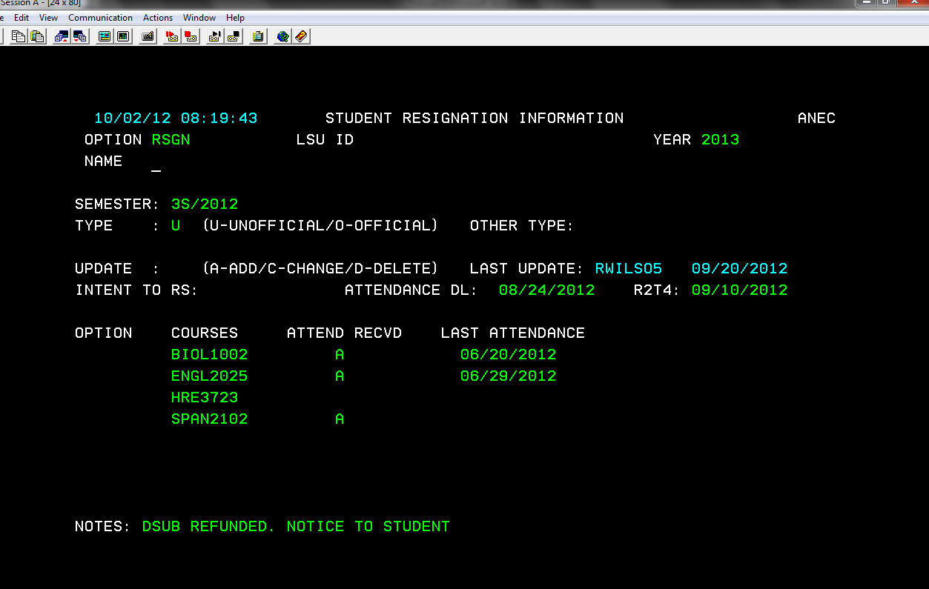

Courses student was taking for that semester for which we need verification of attendance

Date given by teacher as the last date the student attended class

Deadline given to student to submit attendance verification. The deadline is 2 weeks from the date the student intends to resign (issue date on resignation card).

An A means we have received verification of attendance for that course

* You can view the resignation information by going to RSGN. You must type in the semester the student resigned and U (unofficial) or O (official) depending on the type of resignation.
* If we do not receive attendance verification by the attendance deadline, the student’s aid is returned.

## Policy

To view the Resignation Policy click <http://lsu.edu/financialaid/policies/resignation_policy.php>.

# Repeated Coursework

## Policy

To view the Repeated Coursework Policy click <http://lsu.edu/financialaid/policies/repeated_coursework.php>.

# Enrollment Status

## Policy

To view the Enrollment Status Policy click <http://lsu.edu/financialaid/policies/enrollment_status.php>.

# Class Attendance

## Policy

To view the Class Attendance Policy click <http://lsu.edu/financialaid/policies/class_attendance.php>.

# TOPS

## General Information

TOPS is administered by the Louisiana Office of Student Financial Assistance (LOSFA). This is a state agency that is separate from LSU. LOSFA determines student eligibility for TOPS.

To be eligible for TOPS:

* You must earn a 20 on the ACT
* Have a 2.5 GPA in your core courses
* Graduate from a LA high school
  + There are some exceptions for this, such as if the student attended a boarding school out of state, but LOSFA will determine eligibility
* Complete the FAFSA by July 1st following the one year anniversary of high school graduation

Levels:

* TOPS Opportunity
  + Earn a 20 on the ACT and 2.5 GPA
  + Base level of TOPS that covers tuition for 12 credit hours and certain fees
* TOPS Performance
  + Earn a 23 on the ACT and 3.0 GPA
  + Base level of TOPS plus $200 stipend per semester
* TOPS Honors
  + Earn a 27 on the ACT and 3.0 GPA
  + Base level of TOPS plus $400 stipend per semester

## Retention requirements:

* Maintain continuous full time enrollment
  + Continuous means the student did not resign or sit out for a semester
  + Full time means the student must be registered for 12 credit hours through the 14th class day
* Maintain the required GPA which is checked at the end of the spring semester
  + TOPS Opportunity Award
    - Must maintain a 2.3 cumulative GPA if earned less than 48 hours
    - Must maintain a 2.5 cumulative GPA if earned more than 48 hours
  + Must maintain a 3.0 cumulative GPA for the TOPS Performance or Honors award
    - If a student loses their stipend, they cannot get it back
  + Must have a cumulative 2.0 GPA at the end of each fall semester
* Complete 24 hours within an academic year
  + An academic year begins with the fall semester and includes fall, winter intercession, spring, spring intercession, summer and summer intercession

**NOTE:** If students fail to meet the GPA requirement, they have up to 4 semesters (2 years) in order to earn the required GPA to have their TOPS reinstated. Students cannot receive TOPS while on probation for not meeting the GPA requirement. If students fail to earn the required hours or maintain continuous enrollment, their TOPS is permanently cancelled.

## Using TOPS for the summer semester:

* Students can use their TOPS award for the summer semester if
  + They have earned 60 credit hours
  + They will be enrolled in at least 6 credit hours for the summer
* **Using TOPS for the summer counts as a semester of eligibility**
  + Students are awarded TOPS for 8 semesters and using TOPS for the summer counts as one of those semesters. Students typically do not use TOPS for the summer unless they are graduating early.
* The TOPS award will be the amount of tuition for the hours the student is enrolled (so not the amount it would normally be during a regular semester)
* Students will need to complete the Summer Session Payment Request Form which will be available April/May prior to the start of the summer semester and turn the form into our office

Additional Information:

* TOPS will not show as an anticipated credit on a student’s fee bill if they are not enrolled full time. Even if they are waitlisted for classes, they must actually be enrolled in 12 credit hours for TOPS to apply as an anticipated credit.
* Graduating students can receive TOPS as long as they are in at least 6 credit hours and they have diploma fees charged on their fee bill.
* If a student graduates early, they can use their remaining semesters of TOPS for graduate school.
* Students are only required to complete a FAFSA their freshman year in order to receive TOPS. However, the LOSFA strongly suggests that you complete a FAFSA each year as they have indicated that should there be a funding shortfall, the students with a FAFSA on file will be the first to get the funds.
* Students who attended an out of state university after graduating high school and are now returning in state will need to complete the Returning from Out of State form and submit to LOSFA before they can receive TOPS.
* Our office receives a report every Monday from LOSFA with any change to a student’s eligibility
* We bill for students’ TOPS after the 14th class day. The funds typically come in around the middle of the semester. We do not have a specific date as it depends on when LOSFA sends the funds.
* Our office puts an anticipated credit for TOPS (S513) for freshmen if it looks like they are eligible but we must get official notification from LOSFA that the student has the award (F950)
* Even if a student is able to declare residency with the university, it does not mean the student can receive TOPS

Students will need to contact LOSFA at 1-800-259-5626 ext 1012 for the following:

* To file an exception for not meeting retention requirements
* If LSU has not been notified of the student’s eligibility

## Screen Shot

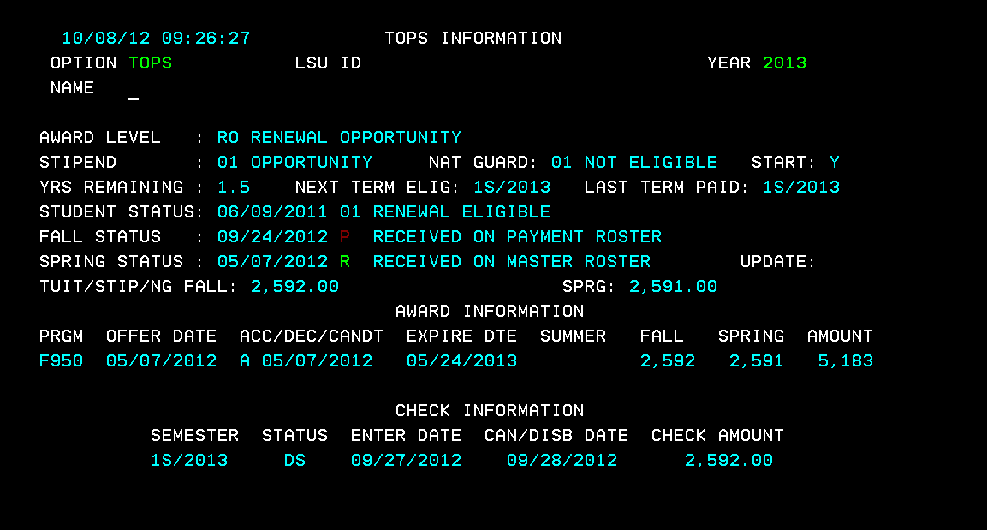

Shows the semester for which the student has been paid and the date the funds disbursed

Status will be R = received on master roster from LOSFA, I = sent on invoice meaning we billed LOSFA for the student’s funds, or P = received on payment roster meaning we have received the student’s funds

Years of TOPS student has remaining

Level of TOPS the student is receiving

## TOPS Brochure

The TOPS Brochure can be viewed <http://www.osfa.la.gov/MainSitePDFs/TOPS_OPH_brochure_11-17.pdf>.

## TOPS Summer Form

The TOPS Summer Form can be viewed <http://www.osfa.la.gov/MainSitePDFs/2018_Summer_Session_Payment_Request.pdf>.

## TOPS Exception Form

The TOPS Exception Form can be viewed <http://www.osfa.la.gov/MainSitePDFs/exceptionrequestform.pdf>.

# Scholarships

## General Scholarship Information

(For entering freshmen, see 2nd page for transfer and international student info.)

* The application for admission is also the application for scholarships so there is no additional application to complete
* Students can take the ACT/SAT to get a higher score to qualify for a scholarship or a higher level scholarship
  + If a student is awarded a scholarship and then submits a score qualifying them for a higher level scholarship, we will automatically bump them up to the higher level scholarship (if we still have funding)
* We do not super score so scholarships are awarded based on the student’s highest composite score
* The GPA for scholarships only looks at the student’s GPA from their freshman through junior year of high school. LSU computes its own 6 semester, core unit, weighted GPA. This GPA is not computed at the high school level.
* Students must meet the GPA **and** test score requirement in order to be awarded a scholarship
* LSU does not offer an out of state fee waiver nor in state tuition for bordering states

ADM Category should be either a 2 or 3. If not, please direct student to Admissions.

Residency should be 1 (resident) or 2 (nonresident). If it is a 3, an award cannot be made as a residency determination has not been made and student should speak to Admissions.

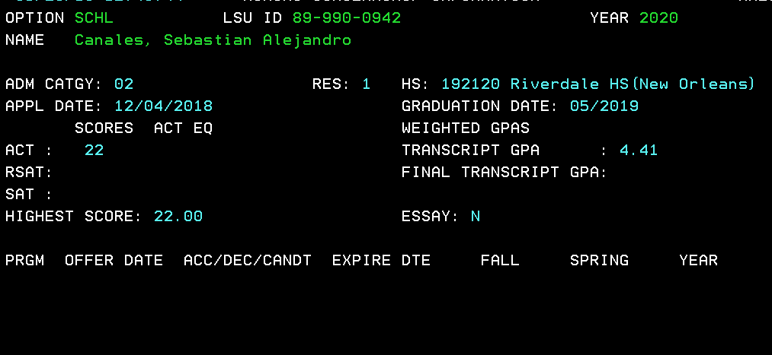

Transcript GPA is highest GPA taken from stu’s high school transcript.

ACT = ACT score

RSAT = SAT score for new SAT

SAT = SAT score for old SAT

ACT EQ column shows SAT converted to ACT

Indicates student’s HS Graduation Date.

Additional Information:

* If a student’s scholarship was cancelled due to not meeting requirements and they are now meeting requirements to have their scholarship reinstated, they must contact our office. Reinstatement is not automatic. They can also email [scholarships@lsu.edu](mailto:scholarships@lsu.edu) to request their scholarship be reinstated.
* Expiration dates for scholarships cannot be extended.
  + The only exception is for architecture students as architecture is a 5 year program.
* There is a Scholarship Hold Form for students needing to sit out for a semester. This is not guaranteed to be approved and is reviewed on a case by case basis. Reasons for completing this form may include an internship, medical necessity, etc.
* We currently do not offer any scholarships specifically for international students. For international students to be considered for entering freshman scholarships they must have an ACT or SAT score and they must have a US based high school transcript. Students can check with international admissions to determine if their transcript can be evaluated on a US basis for scholarships.

## How to Apply for a Scholarship

The application process for entering freshment scholarships is the application for admission; no additional applications need to be completed. Scholarships are awarded based on a holistic review process within our office. There are merit scholarships for in state and out of state students. There are need based scholarships for in state students who complete a FAFSA.

## *Additional Scholarship Opportunities*

### LSU Senior College Scholarships

Each year, the LSU academic colleges review the information of those entering freshmen who intend to major in a curriculum within their college for scholarships available to those specific areas of study. Scholarships vary by academic college. The application for admission also serves as the primary application for all academic college scholarship opportunities. Students selected for one of these scholarships are notified directly by the academic college. Please contact the academic college of your intended major regarding questions about their specific scholarships.

### Board of Supervisors Scholarship

Scholarships are awarded at the discretion of individual members of the LSU Board of Supervisors for undergraduate students. Students receiving a TOPS award are not eligible for the Board of Supervisors Scholarship during the fall and spring semesters. For more information on the scholarship program or for an application, please visit the Board of Supervisors website at[http://www.lsusystem.edu/index.php/board-of-supervisors/scholarship-information](http://www.lsusystem.edu/index.php/board-of-supervisors/scholarship-information/).

### Fee Exemptions for Sons and Daughters of Deceased Faculty Members

This award includes an exemption from all University assessed undergraduate fees for sons and daughters of faculty members who had five or more years of service in the LSU System at the time of death. To apply for this assistance, please contact the Human Resource Management Office at 225-578-8200.

### 

### Legislative Act 353

Under Legislative Act 353, children of policemen and firemen killed or permanently disabled in the line of duty in Louisiana receive an exemption from tuition, an exemption from on-campus room and board, and a book allowance. Students are required to enroll full-time to receive this benefit. Complete the [Legislative Act 353 Initial Eligibility Form](http://www.lsu.edu/departments/scholarships/files/item14543.pdf) and return it to the Office of Undergraduate Admissions and Student Aid to begin the application process.

### ROTC Scholarships

Students contemplating military careers should request from ROTC information about the scholarships offered through the ROTC program. Students can enroll in the Army or Air Force ROTC programs at LSU or cross-enroll in the Navy ROTC program at Southern University.

### City-Year Program Undergraduate Application Fee Waiver

Criteria:  Undergraduate students who have participated in City Year Program are eligible for the LSU admissions application fee waiver.  This award is available on a first-come, first-served basis limited to availability of funds.

Award: Students receive an admissions application fee waiver.

Applying for program:

1. Begin an application for admission at <http://www.lsu.edu/departments/admissions/>
2. Save the application prior to submission.
3. Contact City Year’s National Alumni Affairs office to request a verification letter. Verification should be sent from the National Alumni Affairs office directly to [admissions@lsu.edu](mailto:admissions@lsu.edu). Once City Year affiliation has been confirmed, the application fees will be paid.
4. Submit official high school transcript and official ACT/SAT test scores to complete application process.

### The Chafee Educational and Training Voucher

The Chafee Educational and Training Voucher (ETV) Program is awarded to students who have been in the foster care system so they can pursue an academic college education or technical and skill training in college to be prepared to enter the workforce meeting the following criteria:

* Be ages 15 to 21, unless you were participating in the Chafee ETV Program at age 21 in which case you can receive ETVs until you are 23; and
* Be in the foster care system, or aged out of the foster care system, or have been under the care of a legal guardian; or
* Have been in the foster care system or under the care of a legal guardian and adopted after age 16; and
* Be enrolled in an eligible postsecondary institution; and
* Submit a Free Application for Federal Student Aid (FAFSA) for each year you are in college.

## Retention Requirements

The information listed below can also be found <http://lsu.edu/financialaid/policies/university_scholarship_retention_requirements/index.php>.

The following retention requirements apply to the Chancellor’s Alumni Scholars (awarded Fall 2011 and after), LSU Alumni Association’s Global Leaders, Flagship Scholars Award, LSU Academic Scholars Award, Tiger Excellence Scholars Award and the Tiger Transfer Award.

* All major University merit scholarships require students to maintain full-time status each fall and spring semester, maintain a 3.0 cumulative GPA and earn 24 credit hours per academic year. Hours earned during the fall semester, winter intersession, and the spring semester can be utilized to fulfill the 24 credit hours earned requirement. Scholarship amounts are awarded based on residency status. If a student’s residency changes during their enrollment, the scholarship offer will also be changed.
* All cash scholarships shall be withdrawn for any semester in which the recipient drops to part-time status prior to the completion of the 14th class day unless it is the student’s graduating semester. The student will be eligible for funds in the subsequent semester provided all other criteria are met. The scholarship’s original expiration date will not be extended.
* All exemption scholarships shall be withdrawn for any semester in which the recipient drops to part-time status prior to the completion of the University refund period.  The student will be eligible for funds in the subsequent semester provided all other criteria are met. The scholarship’s original expiration date will not be extended.
* The required 3.0 cumulative GPA and the required 24 credit hours earned are checked at the end of each spring semester.
* Students who do not maintain the required 3.0 cumulative GPA and/or the required 24 credit hours earned at the end of each spring semester will be placed on scholarship probation. When a student is placed on scholarship probation, the student will be given the opportunity to submit an appeal to the Office of Undergraduate Admissions and Student Aid if they demonstrate exceptional circumstances. Appeals will be evaluated on an individual basis.
* Students will not receive funding from their scholarship while on scholarship probation.
* Students placed on scholarship probation for not fulfilling the GPA requirement will be given one full academic year beginning spring intersession through the end of the spring semester to bring their cumulative GPA to the required 3.0. If a student achieves the required 3.0 cumulative GPA while on scholarship probation, the student can contact the Office of Undergraduate Admissions and Student Aid after all official grades have posted for the semester to request a review for reinstatement for future semesters. Students approved for reinstatement will not have their scholarship’s original expiration date extended.
* Students who fail to attain the required 3.0 cumulative GPA following the one academic year defined as beginning spring intersession through the end of the spring semester of the year immediately following their placement on probation will have their scholarship permanently cancelled.
* Students placed on scholarship probation for not meeting the 24 earned credit hours requirement will be given the spring intersession, summer, and summer intersession to earn the required 24 credit hours. If the student earns the required 24 credit hours by the end of the summer intersession immediately following their placement on scholarship probation, the student can contact the Office of Undergraduate Admissions and Student Aid after all official grades have posted to request a review for reinstatement for future semesters. Students approved for reinstatement will not have their scholarship’s original expiration date extended.
* Students who fail to earn the required 24 credit hours by the end of the summer intersession immediately following their placement on scholarship probation will have their scholarship permanently cancelled.
* Continuous enrollment is required therefore resignation during any major semester (defined as Fall or Spring) results in permanent cancellation of the scholarship for all future semesters.
* The LSU Alumni Association’s Global Leaders Award is the only program that can be applied to the summer semester. None of these scholarship programs are applicable for intersession.

**Legislative Act 353 Scholarship**

The student must be enrolled full-time through the university refund period to be eligible for the award for that semester.  The scholarship will be cancelled if the GPA requirement is not met at the end of the fall or spring semester.  The scholarship may be reinstated and extended the appropriate number of semesters at anytime the student regains a 2.0 cumulative GPA.  It is the student’s responsibility to request reinstatement through the Office of Undergraduate Admissions and Student Aid.

*This award may be used for the summer semester provided the student is full-time (6 hours) through the university refund period and met the GPA requirement at the end of the preceding spring semester.  In order to use the scholarship for the summer semester, the student must complete the Summer Legislative Act 353 form.  Summer semesters for which the scholarship is used do count against the number of semesters of eligibility for this award.

**Chancellor’s Student Aide Program and Chancellor’s Future Leaders in Research**

The student must remain full-time (12 hours) throughout the semester to participate in this program.  If a student fails to meet the GPA requirement at the end of the spring semester, he or she will be unable to participate in the program until a 2.0 cumulative GPA has been regained.  It is the student’s responsibility to request reinstatement/reassignment through the Office of Undergraduate Admissions and Student Aid after the requirement has been met.

## Transfer Scholarships

Priority Deadline & Application

All applicants are urged to apply for admission by the priority deadline of April 15 for full consideration, as funding is limited for this award. No additional scholarship application is required. Award notification will begin after the priority deadline.

Award Levels

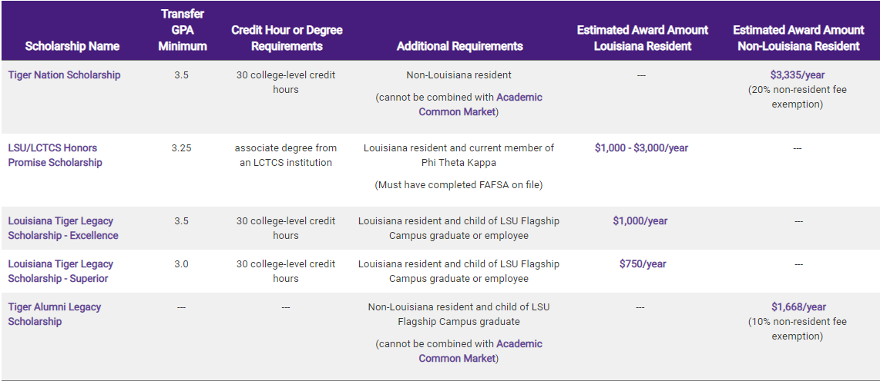

Additional Requirements

GPA & Credit Hours

Each student’s GPA will be calculated based on the most recently completed semester prior to the April 15 priority date. Credit hours in progress will be calculated into total credit hours.

Semester of Entry

Students must be admitted as a full-time undergraduate degree-seeking transfer student for the fall semester. Priority will be given to applicants for the fall semester. As funding is available, scholarships will be awarded for other semesters.

Prior Degrees

Students who have received a bachelor’s degree are not eligible for any of the above awards.

Phi Theta Kappa Award

Recipients of the Tiger Transfer: Phi Theta Kappa Award must enroll at LSU immediately following their current two-year college.

Semesters of Eligibility

Students will be awarded the appropriate number of semesters below depending on how many hours of college-level transferable coursework have been earned. Please note that students enrolled in a university-approved five-year undergraduate program may request review for two additional semesters of eligibility, pending no bachelor’s degree has been earned.

|  |  |
| --- | --- |
| **Hours Earned** | **Scholarship Duration** |
| 30-44 | 6 semesters |
| 45-59 | 5 semesters |
| 60-74 | 4 semesters |
| 75-90 | 3 semesters |
| 91-105 | 2 semesters |
| 106-120 | 1 semester |

## Federal Aid:

* To qualify for Federal Aid, such as student loans and grants, the Federal Government requires that all students complete the FAFSA.  The FAFSA is a free application issued by the Department of Education, which uses the student’s information as well as their parents, if they are a dependent. Here is a link of the application.

<http://www.fafsa.ed.gov/index.htm>

* As an international student, you will need to meet the requirements of an eligible non-citizen to complete the FAFSA Application and receive Federal Aid.  I have attached the link, which lists the requirements for an eligible non-citizen:

<http://www.fafsa.ed.gov/help/fotw15a.htm>

Generally, you are an eligible noncitizen if you are one of the following:

* U.S. permanent resident, with a Permanent Resident Card (formerly known as an Alien Registration Receipt Card or "Green Card")
* Conditional permanent resident (I-551C)
* Other eligible noncitizen with an Arrival-Departure Record (I-94) from the Department of Homeland Security showing any one of the following designations: "Refugee," "Asylum Granted," "Indefinite Parole," "Humanitarian Parole," or "Cuban-Haitian Entrant"
* A citizen of the Republic of Palau (PW), the Republic of the Marshall Islands (MH), or the Federated States of Micronesia (FM).

You can receive federal student aid if you are an eligible noncitizen. You must enter your eight or nine digit Alien Registration Number (ARN) on the FAFSA.

If your citizenship status has changed from an eligible noncitizen to a U.S. citizen, you should contact the Social Security Administration (SSA) to update your citizenship status. If you do not update your citizenship status with the SSA, it could delay processing your student financial aid. To contact the SSA call **1-800-772-1213** or visit the Social Security Administration's Web site at [www.ssa.gov](http://www.fafsa.ed.gov/help/fotw15a.htm).

## International Services at LSU:

You may also want to contact the International Services within campus about any other scholarship opportunities:

International Services  
101 Hatcher Hall  
Baton Rouge, LA 70803  
Telelogin

: 225-578-3191  
Fax: 225-578-1413